eS/N | Author | Date | Version | Description
1 | CM Eng / SS Yap | Feb 17, 2012 | 01.00-D01 | Initial release
2 | Eng Chong Meng | Apr 02, 2012 | 01.10-D01 | Added Reverse Proxy Setup and enhance other sections
3 | Eng Chong Meng | May 10, 2012 | 01.10-D02 | Update procedures for self-built ejabberd based on latest version v2.1.11.
4 | Eng Chong Meng | Jun 12, 2012 | 01.20-D01 | Added Jabber Mail Component Installation and document clean up.  Add instruction to use MySQL password feature for JID user password encryption.
5 | Eng Chong Meng | Jun 15, 2012 | 01.30-D01 | Add JMC Mail Account Password AES-128 Encryption
6 | Yap Swee Swee | Aug 03, 2012 | 01.40-D01 | Add Skype Relay Server
7 | Eng Chong Meng | Nov 16, 2012 | 01-41-D01 | Installation verification and update based on Ubuntu 12.10 release
8 | Eng Chong Meng | Feb 05, 2013 | 02-00-D01 | Revamp the whole document for easy implementation based on Ubuntu 12.10 release
9 | Eng Chong Meng | Feb 13, 2013 | 02.01-D01 | Add section for Jingle Nodes setup
10 | Eng Chong Meng | Oct 22, 2013 | 02.10-D01 | Update instruction to use ejabberd version 2.1.13 and ejabberd-contrib (previously: ejabberd-modules)
11 | Eng Chong Meng | Aug 27, 2014 | 02.11-D01 | Update tls certification section.
12 | Eng Chong Meng | Sep 26, 2014 | 03.00-D01 | Update manual per the latest version ejabberd-14.07 system setup and configurations on Ubuntu 14.04
13 | Eng Chong Meng | Oct 20. 2014 | 03.10-D01 | Add section on mod_archive2 setup for ejabberd 14.07
14 | Eng Chong Meng | Feb 10. 2016 | 04.00-D01 | Update for ejabberd 18.03 source build installation.  Add sections on Jitsi-windows, Jitsi-meet, VideoBridge & Components  Removed section on “MySql Workbench Installation” and “Ejabberd JID User Password Encryption” as they interfere with scram password support.
15 | Eng Chong Meng | Jul 01, 2016 | 04.10-D01 | Update for ejabberd version 18.xx (latest 18.04+)
16 | Eng Chong Meng | Nov 14, 2018 | 04.20-D01 | Update for ejabberd v18.09 and Ubuntu 18.04 with erlang OTP-20 (erts-9.2), https and letsencrypt CA certificate
17 | Eng Chong Meng | Feb 12, 2020 | 04.21-D01 | Update for ejabberd v18.12.1
18 | Eng Chong Meng | May 15, 2024 | 04.22-D01 | Update info for Ubuntu 20.04 and ejabberd v23.01
19 | Eng Chong Meng | Aug, 06, 2026 | 05.00-D01 | Update info for Ubuntu 22.04 and ejabberd v26.04  Add LibreTranslate installation  Remove ‘Setup Crypto Server’ and ‘Skype Relay Server’

Table of Contents
1. Introduction 6
1.1 Purpose 6
1.2 Scope 6
1.3 Definitions, Acronyms and Abbreviations 6
1.4 Reference Document 7
2. Hardware & Software Requirements 8
2.1 Hardware System 8
2.2 Linux & Applications Requirements 8
3. Linux Ubuntu Installation 8
3.1 Ubuntu 22.04 Gnome Classic Installation 8
3.2 Ubuntu-SSH Access Setup 8
3.2.1 Ubuntu SSH Server Installation 8
3.2.2 Windows SSH Client Installation 9
3.3 Remote Desktop Sharing 9
3.4 Ubuntu-Windows NetBIOS Support 10
3.5 Server Time Synchronization 10
3.6 Ubuntu Environment Variables 10
3.7 Ubuntu Taskbar – Network Manager 11
3.8 Linux Recovery Mode 11
4. LAMP Package Installation 12
4.1 Installing LAMP Package 12
4.2 MySQL Configuration 13
4.2.1 Upgrading MySQL with the MySQL APT Repository 13
4.3 PHP Installation 14
4.4 Phpmyadmin Installation 15
4.4.1 Phpmyadmin Import File Size 16
4.4.2 Phpmyadmin Configuration 16
4.5 Apache Configuration 17
4.5.1 Apache 2.4 FQDN 17
4.5.2 Apache Remote Access 17
4.5.3 Apache Common Commands 17
4.6 Apache Subversion Installation 17
5. Ejabberd Build & Development Environment 18
5.1 Ubuntu Build Environment Setup 18
5.2 Ejabberd Build Environment Setup 18
5.2.1 Install Dependencies 18
5.2.2 Install OTP and Elixir from deb package. 18
5.2.3 Install using asdf 18
5.2.4 Add the Erlang Plugin and Set Default 19
5.2.5 Install rebar3 19
6. XMPP Ejabberd Ubuntu Installation 20
6.1 Ejabberd Installation Preparation 20
6.2 Ejabberd Source Build 20
6.2.1 Source build – latest release from online repository 20
6.2.2 Project configuration and build process 21
6.2.3 Ejabberd post installation files & directories 22
6.2.4 Ejabberd commands 22
6.3 Creating an XMPP Account for Administration 22
7. Using ejabberd with Relational Database - MySQL 23
7.1 Erlang MySQL Installation 23
7.2 MySQL Database Scheme Creation 23
7.2.1 MySQL Database Scheme Import 23
7.3 MySQL Database Structure Upgrade 23
8. Generate Certificate for Ejabberd 24
8.1 Let's Encrypt CA certificate 24
8.1.1 Ubuntu Certificate Generation 24
8.1.2 DNS Plugins Installation 24
8.1.3 DNS Plugin Installation 25
8.2 Self-Signed Certificate 26
9. Ejabberd Server Configuration 27
9.1 MySQL Configuration Setting 27
9.2 File Transfer Configuration Setting 28
9.3 Multi-User Chat 29
9.4 Custom Features Subscription Configuration 30
9.5 Ejabberd Misc Configuration 31
10. Ejabberd Message Archive 32
10.1 Message Archiving Features 32
10.1.1 Features Supported 32
10.1.2 Feature Enhancement – Mod_Archive2 32
10.1.3 Features Not Supported 32
10.2 Module Mod_Archive2 32
10.2.1 Mod_Archive2 Installation 33
10.2.2 Install MySQL Database Schema – Mod_Archive2 34
10.2.3 Ejabberd Configuration – Mod_Archive2 34
10.2.4 Configuration Options – Mod_Archive2 34
10.3 Module Mod_Archive 35
10.3.1 Mod_Archive Installation 35
10.3.2 Install MySQL Database Schema – Mod_Archive 36
10.3.3 Ejabberd Configuration – Mod-Archive 36
10.3.4 Configuration Options – Mod_Archive 36
10.3.5 Mod_Archive_Webview 37
11. Start Ejabberd Server 38
11.1 Ejabberd User Admin Registration 38
11.2 Ejabberd Web Admin Access 38
11.3 Ejabberd Users 39
11.4 Ejabberd Shared Roster Groups 40
12. Ejabberd Start-Up Problem 41
12.1 Ejabberd Configuration Syntax Checking & Startup 41
12.1.1 Terminated Ejabberd Stray Process 41
12.2 Erlang Cookie 42
12.3 Ejabberd Database Corruption 42
13. Jingle Nodes 43
13.1 Environment Setup - Ejabberd External Services 43
13.2 Exmpp installation 44
13.3 Erlang Jingle Nodes Relay Service Installation 44
13.3.1 Building Jingle Service Code 44
13.3.2 Jingle Nodes Service Configuration 45
13.3.3 Ejabberd Jingle Nodes Service Configuration 45
13.3.4 Jingle Nodes Launching 45
13.4 Jingle Nodes Relay Verification 45
13.5 Auto-Launch Jingle Nodes Relay 46
13.6 Ejabberd Module Jinglenodes installation 47
13.6.1 Ejabberd JingleNodes Configuration Setup 47
14. Jitsi-videobridge Component 48
14.1 Jitsi-videobridge client & implementation 48
14.2 Ejabberd & Jitsi-videobridge component installation 48
14.3 Jitsi-videobridge source build 48
14.3.1 Maven tool installation 48
14.3.2 Jitsi-videobridge build.xml modifications 49
14.3.3 Jitsi-videobridge deb build process 50
14.4 Jitsi-videobridge service configuration 50
14.4.1 Jitsi-videobrige sip-communicator.properties setup 51
14.4.2 Ejabberd PubSub Configuration 52
14.5 Starting Jitsi-videobridge Service 52
14.5.1 Jitsi-videobridge daemon 52
14.6 Jitsi-videobridge Remote Debug 52
14.7 Jitsi-videobridge manual start 53
15. Jitsi-meet Installation & Setup 54
15.1 Jitsi-meet Supporting Components Installation 54
15.1.1 Jitsi-videobridge Installation 54
15.1.2 Jitsi Conference Focus (jicofo) Installation 54
15.1.3 Jicofo Ping and Other settings 56
15.2 Jitsi-meet WebRTC 58
15.2.1 Jitsi-meet WebRTC Deployment with pre-compiled CSS & Lib 58
15.2.2 Jitsi-meet Patches 59
15.2.3 Jitsi-meet WebRTC Deployment with Source Build 59
15.2.4 Working with the library sources (lib-jitsi-meet) 59
15.3 Jitsi-meet Apache Setup 60
15.3.1 Create Apache SSL certificate 60
15.3.2 Apache SSL, RewriteRule and Reverse Proxy Configuration & Setup 61
15.3.3 Jitsi-meet sites-available Setup 61
15.3.4 Jitsi-meet conf-available Setup 62
15.4 Launch Jitsi-meet conference 63
15.5 Jitsi Gateway to SIP – Jigasi Installation 63
15.5.1 Reload Jitsi-meet 63
15.6 Basic Jitsi-meet installation (nginx and prosody) 63
15.7 Jitsi-meet Uninstall 63
16. Jitsi Client Source Build Setup 64
16.1 Jitsi Project Setup 64
16.1.1 Jitsi scripts Update 64
16.2 Jitsi-Debian (Ubuntu) 66
16.2.1 Jitsi Project Installation & Setup 66
16.2.2 Jitsi Ubuntu deb-64 Build 66
16.2.3 Jitsi Client Remote Debug 66
16.3 Jitsi Windows 68
16.3.1 Jitsi Project Installation & Setup 68
16.3.2 Jitsi Wix-64 Build 70
16.3.3 Jitsi Client Remote Debug 70
17. Jabber Mail Component 71
17.1 Python Environment Setup 71
17.2 JMC installation 71
17.2.1 Debian package Installation 71
17.2.2 Source Installation 71
17.3 Ejabberd Configuration Setup 72
17.4 JMC Configuration Setup 72
17.5 JMC MySQL Database Schema 72
17.5.1 JMC Auto-Created MySQL Database Tables 72
17.5.2 JMC Manual-Created MySQL Database Tables 75
17.5.3 Account_sqlite.sql 75
17.5.4 LegacyJID_sqlite.sql 75
17.6 Start/Stop JMC 75
17.7 JMC Password AES-128 Encryption 75
17.7.1 Account.py Delta Modification 75
17.8 JMC Verification 76
18. LibreTranslate Installation 78
18.1 Native Installation (Using Pip) 78
18.1.1 Install System Dependencies 78
18.1.2 Install LibreTranslate via Pip 78
18.1.3 Run and Download Language Models 78
18.2 Run as a Background System Service (Systemd) 78
18.2.1 Create the Service Configuration File 78
18.2.2 Add Configuration Text 78
18.2.3 Start and Enable the Service 78
18.2.4 Check Status 78
18.3 Apache configuration 79
19. Clustering 80
19.1 Clustering Node Setup 80
19.1.1 Synchronize Database 81
19.1.2 Configure Ejabberd Cluster Script 81
19.1.3 Cluster Node Database Replicas 81
19.2 Multi-Node Ejabberd Clustering Database Setup Considerations 82
19.3 Master Host / Cluster Node Database 83
19.4 Topology and Hardware Setup 84
19.5 Cluster Remote MySQL Access 84
20. Install JLogger (Messages Logger) 86
20.1 Install Cpanminus 86
20.2 Install JLogger 86
20.2.1 Install database schema 86
20.2.2 Configure JLogger Service 86
20.2.3 Start JLogger 87
20.3 Install JLogger-Web 87
20.4 Configure EJabberd 88
21. Reverse Proxy 89
21.1 Uses of Reverse Proxies 89
21.2 HAProxy 89
21.3 HAProxy Installation 89
21.3.1 HAProxy Configuration 89

Introduction

Purpose
The document provides a brief introduction on the setting up of a Linux XMPP Messaging Server based on the following applications:
- Ubuntu 22.04 LTS (Jammy Jellyfish) 64-bit Desktop version.
- LAMP for Apache, MYSQL, and PHP for Linux.
- XMPP ejabberd server for messaging.
This setup uses commercial available applications. The document still retains the old information for the earlier version of Ubuntu installation, which may or may not applied to the latest Ubuntu version. The information is kept as reference for user still running old version.

Scope
The document covers the basic installation/setup of three main applications i.e. Lamp & Xmpp services and management tool on a Linux server machine to support XMPP instant messaging. All the applications are open source under GPL licensing, available from the public or developed by own-self. The setup serves as a base for future implementation of a cost effective home system. Some effort is spent to make modifications/enhancements specific to the final system requirement beyond what the current applications can support. Further work may be required if such system is to be commercialized.

Definitions, Acronyms and Abbreviations
BIND Berkeley Internet Naming Daemon
CPAN Comprehensive Perl Archive Network
DNS Domain Name Server BIND (Berkeley Internet Naming Daemon)
FQDN Fully Qualified Domain Name
HTTP Hypertext Transfer Protocol
IBB In-Band ByteStreams
IBR In-Band Registration
ICE Interactive Connectivity Establishment
IM Instant Messaging
IRC Internet Relay Chat
LTS Long Term Release
MBR Master Boot Record
MUC Multi-User Chat
NAT Network Address Translation
OTR Off The Record
PPM Perl Package Manager
RTP Real-time Transport Protocol
SPM Synaptic Package Manager
STUN Simple Traversal of UDP through NATs
TCP Transmission Control Protocol
UDP User Datagram Protocol
VoIP Voice over Internet Protocol
XEP XMPP Extension Protocols
XML Extensible Markup Language
XMPP Extensible Messaging and Presence Protocol

Reference Document
The following documents/sites are used as a guide in the development of this document. These documents form a part of this document to the extent specified herein.
- http://www.ubuntu.com
- https://help.ubuntu.com/22.04/index.html
- https://help.ubuntu.com/community/GettingUbuntu
- http://www.process-one.net/en/ejabberd/
- http://docs.ejabberd.im/
- http://www.process-one.net/docs/ejabberd/guide_en.html
- http://jbakshi.50webs.com/Linux_tutorial/Hardware_detection/Hardware_Detection.html
- http://skype4py.sourceforge.net/doc/html/
- http://cfa.media.mit.edu/content/sending-sms-skype-w-only-6-lines-code
- http://xmpp.org/xmpp-protocols/xmpp-extensions/
- http://tools.ietf.org/html/rfc5389

Hardware & Software Requirements

Hardware System
Below is the hardware used for the setup:
- GMKtec G11 (AMD Ryzen Embedded R2514) or Intel system.
- Commercial Virtual Server.

Linux & Applications Requirements
Following are the aTalk Linux Server & Applications required for the setup:
- Ubuntu 22.04 LTS
- Lamp - LAMP for Apache, MYSQL, and PHP
- Ejabberd (version 26.04): XMPP Messaging Service
- Erlang/OTP 25 [erts-13.3.3] or higher pending on ejabberd version.

Linux Ubuntu Installation
The installation on the home XMPP Messaging Server is based on Ubuntu Desktop Environment 64-bit version. Ubuntu Desktop Environment is required as some of the applications run on GUI interface.
Ubuntu 22.04 LTS Desktop Edition (64-bit) can be downloaded from:
- https://ubuntu.com/download/alternative-downloads
Following site guides you through how to burn an .iso file to the bootable USB Stick for installation.
- https://rufus.ie/en/
- http://www.pendrivelinux.com/universal-usb-installer-easy-as-1-2-3/
When the Ubuntu installation USB Thumb Drive is ready, simply insert into an USB port; restart your computer and follow the instructions that appear on your screen. The recommended disk partition size for installing Ubuntu is ext4 100GB min, including space for source code compilation and environment setup. Create also a Linux swap partition size that is 2x system memory size, or auto create by Ubuntu during installation. Follow section 4 to install Lamp and configuration settings.

Ubuntu 22.04 Gnome Classic Installation
Ubuntu 22.04 uses default Ubuntu desktop UI. Follow the steps below to change the desktop environment to Gnome-Classic. To install Gnome Classic on Ubuntu 22.04 just run the following command in terminal.
- $ sudo apt update
- $ sudo apt install gnome-session-fallback
After installation, logout and re-login with “GNOME Classic” or “GNOME Flashback (Metacity)”.
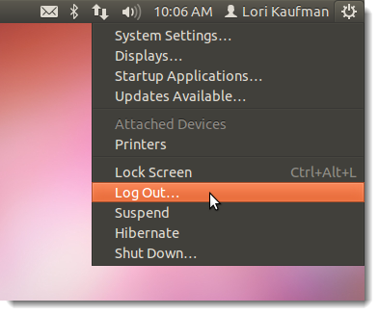

Ubuntu-SSH Access Setup
There are a couple of ways that you can access a shell (command line) remotely on most Linux/Unix systems. SSH, which is an acronym for Secure SHell, was designed and created to provide the best security when accessing another computer remotely. Not only does it encrypt the session, it also provides better authentication facilities, as well as features like secure file transfer, X session forwarding, port forwarding and more so that you can increase the security of other protocols.
http://support.suso.com/supki/SSH_Tutorial_for_Linux

Ubuntu SSH Server Installation
To support SSH login, you need to install SSH Server on the Ubuntu 22,04.
- $ sudo apt install openssh-server -y
On an old Ubuntu OS. Install and/or Launch tasksel and proceed to select [x] OpenSSH server:
- $ sudo tasksel
- 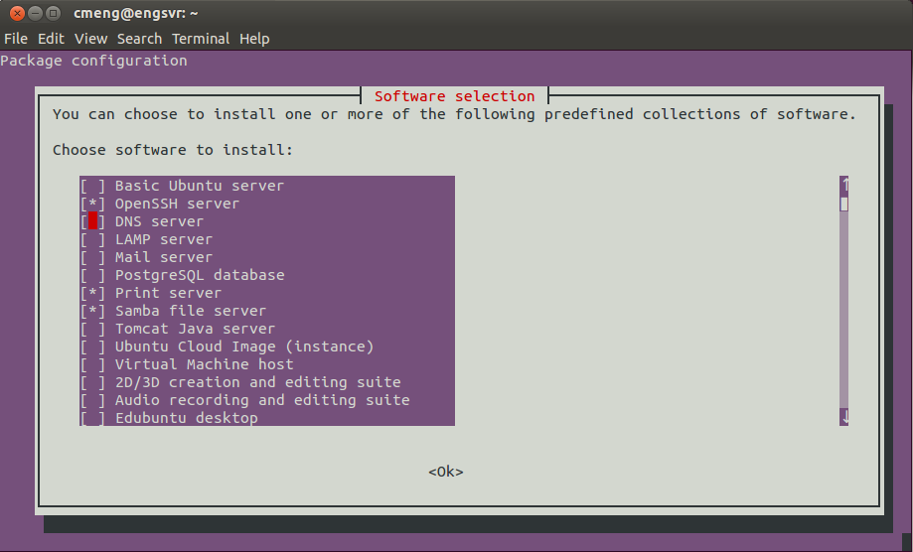

Windows SSH Client Installation
Following two SSH clients, either one is recommended to be installed on Windows; for easy SSH access to the server for remote maintenance.
- MobaXterm SSH Client with X11 server: Download and install MobaXterm_Setup_.2.msi on Windows (recommended).
- http://mobaxterm.mobatek.net/
- Bitvise SSH Client: Download and install Bitvise SSH Client on Windows.
- http://www.bitvise.com/ssh-client-download

Remote Desktop Sharing
You may share your Ubuntu Desktop with a remote client using VNC. Open the ‘Desktop Sharing’ and configure the setting as shown below.
Note: VNC service is pruned to network hackers’ attacks. Enable it for local LAN access only. If access over internet is required, ensure proper security is installed; or if firewall permit, allows only a specific source IP for VNC access only.
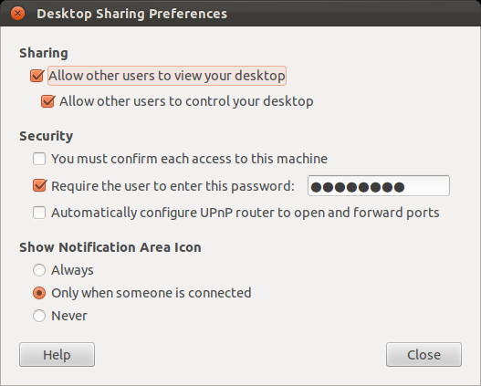
On a remote Windows system install the vnc client e.g. VNCViewer or TightVNC.

Ubuntu-Windows NetBIOS Support
Users in the Windows world are very used to referencing PC’s via their NetBIOS names instead of their IP address. If your Ubuntu host is not configured with a “hosts” file entry on your local PC or a DNS entry to associate a name with an IP address, Ubuntu can only use the IP address of that PC to communicate with it. Likewise, Ubuntu will not respond to a Windows PC ping its NetBIOS name because Ubuntu does not use NetBIOS at all by default and so it will ignore such requests. Refer to the following sites for more information.
- http://www.serenux.com/2009/09/howto-configure-ubuntu-to-be-able-to-use-and-respond-to-netbios-hostname-queries-like-windows-does/
Follow steps below to setup Ubuntu to resolve NetBIOS names like Windows:
- $ sudo apt install winbind
Once installed, we need to tell Ubuntu to use WINS (as provided by winbind) to resolve host names by editing “nsswitch.conf” file. Scroll down to the line that starts with “hosts:” and change as shown below:
- $ sudo gedit /etc/nsswitch.conf
- hosts: files mdns4_minimal [NOTFOUND=return] dns mdns4 wins
To allow Windows to ping Ubuntu NetBIOS names, this requires Ubuntu to recognize and respond to that request. We need to setup a server daemon i.e. Samba to do this.
- $ sudo apt install samba
To enable the share option on Ubuntu nautilus.
- $ sudo apt install nautilus-share
- $ nautilus -q

Server Time Synchronization
Except for the delayed offline messages, xmpp server normal message sending does not contain any timestamp information. Any time differences between the server and client can lead to offline & normal messages display out of time sequence and lead to confusion. Therefore it is necessary that the server time is synced using the NTP protocol, matching server’s time to a reference time that servers around the world agree upon. This can be set up by installing the ntp daemon on the VPS - the program will automatically, slowly shift the server clock to match the reference time.
To install NTP daemon:
- $ sudo apt install ntp
- $ sudo gedit /etc/ntp.conf
Find the section within the configuration that lists the NTP Pool Project servers. The section will look like this:
- server 0.ubuntu.pool.ntp.org
- server 1.ubuntu.pool.ntp.org
- server 2.ubuntu.pool.ntp.org
- server 3.ubuntu.pool.ntp.org
Each line then refers to a set of hourly-changing random servers that provide your server with the correct time. The servers that are set up are located all around the world, and you can see the details of the volunteer servers that provide the time with the command with the following information.
- ntpq –p
- 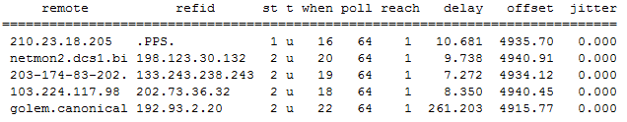
Although these servers will accomplish the task of setting and maintaining server time, you set your time much more effectively by limiting the ntp to the ones in your region. Once all of the information is in the configuration file, restart ntp:
- $ sudo service ntp restart

Ubuntu Environment Variables
Unlike windows, Ubuntu environment variables are set inside several text files based on what you want to accomplish; like in ~/.profile for the user, /etc/profile as a default for users, /etc/environment for the system or /etc/bash.bashrc for system wide interactive bash shells. Some of these are also defined in /etc/profile.d or even $PATH is set as part of some coding. Refer to the following site on more information.
- https://help.ubuntu.com/community/EnvironmentVariables

Ubuntu Taskbar – Network Manager
In case Network Manager Icon does not display on the task bar, the do the following:
Open up a terminal command. Navigate to /etc/NetworkManager/ directory by this command:
- $ cd /etc/NetworkManager/
Then edit NetworkManger.conf file:
- $ sudo gedit NetworkManger.conf
Change “managed=false” into “managed=true” and save the file. The icon should appear the next time you start the machine.

Linux Recovery Mode
If for any reason you need to go into Linux Recovery Mode to edit or change some system setting e.g. delete /etc/X11/xorg.conf due to display configuration error, the disk mount may be in read-only File System. Use the following command in the root prompt to enable read-write File System mode.
- $ sudo mount –o remount,rw /dev/sdax
Where sdax is the Ubuntu installed partition; you can find out by using the command below.
- $ lsblk or
- $ sudo fdisk –l

LAMP Package Installation
LAMP (Linux, Apache, MySQL and PHP) is an open source Web development platform that uses Linux as operating system. Apache is the Web server, MySQL is the relational database management system and PHP is the object-oriented scripting language. Refer to the following link to install LAMP on Ubuntu 22.04
How To Install LAMP Stack (Apache, MySQL, PHP) on Ubuntu
- https://www.digitalocean.com/community/tutorials/how-to-install-lamp-stack-on-ubuntu
On complete installation of mysql and php:
- $ login with mysql -u username -p
- Changing Apache’s Directory Index (Not required)
- Proceed to section 4.3 PHP Installation and etc.

Installing LAMP Package
On old Ubuntu, tasksel command is a software installation application that is an integral part of the Debian installer and works under Ubuntu Linux too. It groups some packages by tasks and offers the user an easy way to install the packages for that task. It provides the same functionality as using conventional meta-packages. Perform the step below to install the tasksel tool if it does come with the Ubuntu distribution package.
- $ sudo apt install tasksel
Open terminal and enter the command:
- $ sudo tasksel
And select LAMP Server to install.
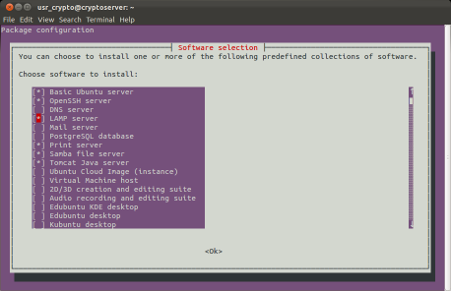

MySQL Configuration
During the installation you are required to enter mysql root password. Do so as requested.
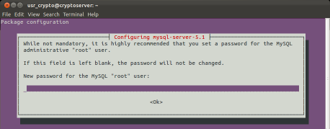
To enable the mycrypt extension for PHP, execute the following:
- $ sudo phpenmod mcrypt

Upgrading MySQL with the MySQL APT Repository
Ubuntu 22.04 comes with mysql version that is good for ejabberd. If you really need to upgrade mysql version, please refer to the site for more information. Starting by “Adding the MySQL APT Repository (mysql-apt-config_0.7.3-1_all.deb)”, then select the appropriate package version you wish to upgrade.
http://dev.mysql.com/doc/mysql-apt-repo-quick-guide/en/#repo-qg-apt-upgrading
http://dev.mysql.com/downloads/repo/apt/

PHP Installation
PHP should be installed during the LAMP installation. Create the following file to check if php is working:
- $ sudo gedit /var/www/html/info.php
And enter the following text:
- <?php phpinfo(); ?>
Save the file and restart apache2:
- $ sudo systemctl reload apache2
Now open browser and type:
- http://localhost/info.php
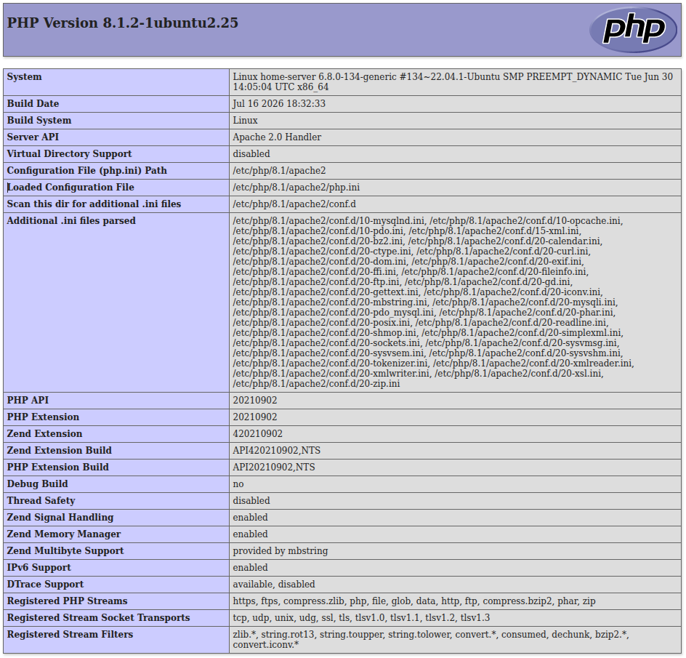

Phpmyadmin Installation
To ease managing the LAMP Server MySQL database, install phpmyadmin
- $ sudo apt install phpmyadmin
Phpmyadmin installation will proceed to “configuration phpmyadmin” setup; select apache2 for web server.
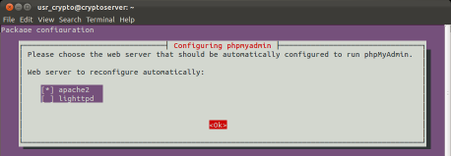
Answer <Yes> to when prompted database for ‘Configuring phpmyadmin’.
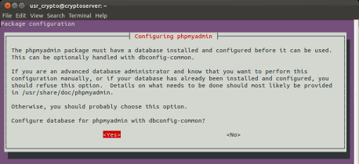

Enter passwords for both the phpmyadmin administrator and for MySQL access.
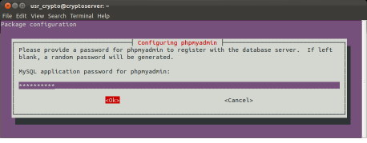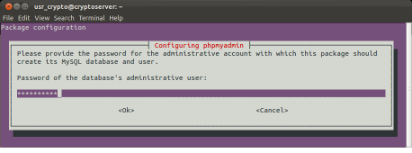
To login to phpmyadmin, open browser and enter:
- http://localhost/phpmyadmin

Phpmyadmin Import File Size
The default maximum file size for import using phpmyadmin is 8M. In most cases, you will need to change this size limit to 200M or higher by editing the file /etc/php/8.1/apache2/php.ini as follow, and restart apache2.
- ; http://php.net/post-max-size
- post_max_size = 200M

- ; Maximum allowed size for uploaded files.
- ; http://php.net/upload-max-filesize
- upload_max_filesize = 200M
On some systems, you may have several copies of php.ini -- only one of which actually affects your system. Make sure you modify the correct one. To determine where your php.ini is, look at the output of phpinfo() for the “Loaded Configuration File” parameter etc.

Phpmyadmin Configuration
If the login to phpmyadmin in the previous section did not complete successfully, you may proceed to perform the following:
- Create a symbolic link to make the config available to Apache:
$ sudo ln -s /etc/phpmyadmin/apache.conf /etc/apache2/conf-available/phpmyadmin.conf
- Enable the configuration using the Apache utility tool:
$ sudo a2enconf phpmyadmin.conf
Now restart Apache:
- sudo systemctl restart apache2
Point your browser to: http://your-domain/phpmyadmin, you should be able to see the phpmyadmin login page. Enter user account and password to login.

Apache Configuration
Refer to section 8.1 on the generation of the letsencrypt CA certificate for the site.

Apache 2.4 FQDN
You may encounter error message "Could not reliably determine the server's fully qualified domain name" in Apache 2.4 or lower. To resolve this error, you have to edit /etc/apaches/apache2.conf to include a line i.e.
- ServerName atalk.sytes.net
To determine the installed apache version:
- $ apache2 -version
- Server version: Apache/2.4.52 (Ubuntu)
- Server built: 2026-07-06T16:41:46
Apache 2.4 introduces major changes in configuration settings; be extra caution when you make changes to apache configuration files. Apache 2.4 no longer uses conf.d directory; all the configuration files are stored inside conf-available directory with *.conf extension

Apache Remote Access
To allow remote web server access, update /etc/apache2/apache2.conf to reflect the following changes:
- # Enable to support jitsi meet
- <Directory /usr/share/>
- Options FollowSymLinks
- AllowOverride None
- Require all granted
- </Directory>

- # Enable to support aTalk web page
- <Directory /var/www/>
- Options FollowSymLinks
- AllowOverride None
- Require all granted
- </Directory>
To redirect all web access to secure https:// access, copy etc/etc/apache2/sites-available/000-default.conf to atalk.conf and include the following two statements.
- ServerName atalk.sytes.net
- Redirect "/" "https://atalk.sytes.net/"
Refer to section 15.3 Jitsi-meet Apache Setup on setup of the default-ssl.conf.

Apache Common Commands
The following commands may be used to enable apache2 conf, sites, modules or restart apache2. Refer to http://httpd.apache.org/docs/2.4/ on the actual configuration settings.
- $ sudo a2enconf atalk => to enable ./conf-available/atalk.conf
- $ sudo a2dissite 000-default => replace by atalk.conf
- $ sudo a2ensite atalk => enable atalk site
- $ sudo a2ensite default-ssl => enable secure site
- $ sudo a2enmod include => enable Include module required by Jitsi-meet
- $ sudo a2enmod ssl rewrite proxy proxy_http
- $ sudo systemctl restart apache2

Apache Subversion Installation
Please refer to the following for installation:
- How to Install Apache Subversion on Ubuntu 26.04, 24.04 and 22.04

Ejabberd Build & Development Environment
Home aTalk ejabberd xmpp server is built from source; it requires a proper build environment to be setup. Please refer to the following sites for more information.
- https://help.ubuntu.com/community/CompilingSoftware/
- https://help.ubuntu.com/community/CompilingEasyHowTo/

Ubuntu Build Environment Setup
The list is not exhausted, and likely requires more pending your compiled applications requirements. If your home server want to support version control with GUI interface, you may install RabbitVCS for SVN & Git from http://rabbitvcs.org/
- MySQL version 14.14 or higher
- GNU Make & GCC
- OpenSSL 1.1.1 or higher, for STARTTLS, SASL and SSL encryption.
- GNU Iconv 1.8 or higher.

Ejabberd Build Environment Setup
To compile ejabberd running on Ubuntu operating system, below are some of the packages required, of which versions may vary depending on ejabberd version install. You can perform the configure to find out what are the missing packages to be installed.
Ubuntu 22.04 is bundled with Erlang/OTP-22. You are required to upgrade Erlang/OTP development environment and all its related tools to support ejabberd 25+ source build.
See Install ejabberd from Source Code
- Erlang/OTP >= 25.0. (need by ejabberd > 25.0 or higher). It is recommended Erlang/OTP 27.3, which is the version used in the binary installers and container images.
- Elixir (compile with the current Erlang/OTP 25.0 or higher)
- PAM library. Optional. For Pluggable Authentication Modules (PAM). See section 3.1.5.
- Zlib 1.2.3 or higher, for Stream Compression support (XEP-0138).
- ImageMagick’s Convert program. Optional. For CAPTCHA challenges. See section 3.1.9.
- wxWidgets 3.0.5 (./configure --with-gtk --enable-compat30 --enable-webview)
- erlang-dev erlang-tools erlang-parsetools
- libexpat1-dev libkrb5-dev
- libpam0g-dev
- libssl-dev zlib1g-dev
- libyaml-dev
- libgd-dev for graphics conversion

Install Dependencies
First, ensure your system has the required build tools for Erlang:
- $ sudo apt install build-essential automake autoconfig autogen checkinstall make gcc git
- $ sudo apt install git-core subversion
- $ sudo apt install erlang-dev erlang-nohup erlang-tools erlang-syntax-tools libexpat1-dev libkrb5-dev openssl libssl-dev zlib1g-dev libyaml-dev wxWidgets Zlib rebar3
- $ sudo apt install -y libssl-dev libncurses5-dev libwxgtk3.0-gtk3-dev libgl1-mesa-dev libglu1-mesa-dev libpng-dev libssh-dev unixodbc-dev xsltproc fop libxml2-utils libxslt1-dev libpam0g-dev libgd-dev

Install OTP and Elixir from deb package.
Home server is installed with ejabberd 27.3.4 using deb packages. Download the required erlang and elixir .deb for ubuntu 22.04 (jammy) from:
- Downloadable packages
- $ sudo apt install elixir_1.14.3...deb // need to save in /tmp dir for _apt access permission
- $ sudo apt install esl-erlang_27.3.4...deb

Install using asdf
If you intend to use asdf to install, see Specific notes
To set Erlang/OTP 27 as the default version on Ubuntu 22.04, the cleanest method is to use the asdf version manager. aTalk does not recommend this method; found erlang is unable to find the tools installed in the global /usr/lib/erlang/lib.
Clone the asdf repository and add it to your shell (assuming Bash):
- $ git clone https://github.com/asdf-vm/asdf.git ~/.asdf --branch v0.15.0
- $ echo '. $HOME/.asdf/asdf.sh' >> ~/.bashrc
- $ echo '. $HOME/.asdf/completions/asdf.bash' >> ~/.bashrc
- $ source ~/.bashrc

Add the Erlang Plugin and Set Default
Add the Erlang plugin, install OTP 25, and set it as the global (default) version:
- $ asdf plugin add erlang https://github.com/asdf-vm/asdf-erlang.git
- $ asdf install erlang 27.3.4
- $ asdf global erlang 27.3.4
Install elixir
- $ asdf plugin add elixir https://github.com/asdf-vm/asdf-elixir.git
- $ asdf install elixir
Verify your default is active:
- $ erl -version

Install rebar3
If you need to install rebar3, do not use $ sudo apt install rebar3; this will downgrade the erlang/OTP to 24. Use the following methods instead.
- $ wget https://github.com/erlang/rebar3/releases/latest/download/rebar3
- $ chmod +x rebar3
- $ sudo mv rebar3 /usr/local/bin/rebar3
- $ rebar3 version =>ebar 3.27.0 on Erlang/OTP 27 Erts 15.2.7

XMPP Ejabberd Ubuntu Installation
Ejabberd is a distributed, fault-tolerant Jabber/XMPP server written in Erlang. Its features contain:
- Full XMPP-compliant
- Web based administration
- Load balancing: can run in a cluster of machines
- Fault-tolerance: database can be replicated and stored on multiple nodes (nodes can be added or replaced ‘on the fly’)
- Virtual hosting: several virtual domains can be served using single ejabberd instance – SSL/TLS support
- Multi-User Chat (MUC/conference)
- Service Discovery
- Shared roster etc

Ejabberd Installation Preparation
You are strongly advice to read the relevant ejabberd Installation and Operation Guide before attempt to install ejabberd xmpp server.
Distribution ejabberd latest package for Ubuntu 22.04 is version 17.07. At the time of this write-up update, ejabberd latest version is 26.04. The official release version may be downloaded from ejabberd 26.04.
By default, ejabberd automatically creates and uses an internal Mnesia database when it starts up. However, if you are moving away from Mnesia to set up an external relational database like MySQL for production scale, you must manually create the database, assign permissions, and structure the schema. See Database Schema.
Prior to launching of the ejabberd, you are required to setup mysql database. The database creation is required by ejabberd when you have mysql option enabled. Please use mysql scheme “ejabberd-26.04\sql\mysql.sql” to create mysql database for single-host on your xmpp server.
You can login to localhost/phpmyadmin. Create the new database, then import mysql.sql scheme.

Ejabberd Source Build
Please Refer to Install ejabberd from Source Code for latest info on ejabberd installation from source. For aTalk home xmpp server, it is based on the latest version 26.04 ejabberd github repository.
For reference, the original ejabberd source master version can be found in the link below.
- https://github.com/processone/ejabberd
- http://www.process-one.net/en/ejabberd/downloads for more info.

Source build – latest release from online repository
For ejabberd xmpp server with source from online repository, then follow the steps below:
From ejabberd download site, selects the tag version that you need e.g. 26.04. Click “Download ZIP” to fetch the archived ejabberd version in zip format (this is the prefer method) and unpacked into the workspace directory e.g. ~/workspace/xmpp/ejabberd-26.04 directory.
- Refer to Default and New Schemas on selection which of the database schema to use; and to upgrade from Default to New Schemas database.
- If you are upgrading the current installed ejabberd, you must perform existing mysql database upgrade before making the new ejabberd release installation. Compare the new mysql.sql data structure with the current database in use. Upgrade existing mysql databases if necessary i.e. create a mysql_upgrade.sql file with reference to the new mysql.sql file; and perform a phpmyadmin import to each of the existing ejabberd mysql tables created earlier. Use http://localhost/phpmyadmin to perform any SQL data changes.
- If this the new ejabberd installation, then you should use mysql.new.sql file to create a new ejabberd mysql database.
- You also need to update the /usr/local/etc/ejabberd.yml to confirm to the latest format or add new features if any by checking against the ejabberd.yml.example file.
- Note: This is not necessary any more for ejabberd v18+ installation
During install process, ejabberd later versions will copy all the compiled *.beam files into its individual sub-directory under /usr/local/lib/sub-dir*. It appears that this has created problem when running ejabberd. To make latest ejabberd copies all its compiled *.beam to /usr/lib/ejabberd, update Makefile.in to reflect the changes from (-) to (+) as shown below:
- + spec:
- + $(ERL) –noinput +B –pa deps/*/ebin –eval ‘case fxml_gen:compile(tools/xmpp_codec.spec”) of ok -> halt(0); end.’
- JOIN_PATHS=$(if $(wordlist 2,1000,$(1),$(firstword $(1))/$(call JOIN_PATHS,$(wordlist 2,1000,$(1))), $(1)
- # cmeng - force all *.beam to be copied to /usr/lib/ejabberd/ebin
- - VERSIONED_DEP=$(if $(DEP_$(1)_VERSION),$(DEP_$(1)_VERSION),$(1))
- + VERSIONED_DEP=$(if $(DEP_$(1)_VERSION),ejabberd,ejabberd)

Project configuration and build process
The ‘configure’ file is required to define the ejabberd options before the build process. If your source repository does not come with a configure script or when there is a change in the project options/features with new source update; perform the following steps from within the downloaded ejabberd root directory. The command relies on automake and autoconf programs and will automatically build the configuration files.
- $ cd ~/workspace/xmpp/ejabberd-26.04
- $ ./autogen.sh ### required if missing configure or after new source update
This "configure" is a script when executed, it checks and verifies that the system development environment has all the necessary tools installed to properly compile the project; also to define the project optional parameters for use during project build/installation process. If this is the first installation, likely it will show error messages on needing tools missing. You need to fix each error before running the configure command again.
If you perform configure without any options, you will use the default settings for the build. Ejabberd build has a range of settings that you can enable or disable, if you are interested in this, check the README and INSTALL files found in the directory. You can check the developer documentation and in many cases “configure –-help” will list the key configuration options you can specify.
An example is to use “configure --prefix=/usr” which will install your application into /usr instead of /usr/local as specified as default. Advice to use the default installed directory, as any OS repair or upgrade later will leave the /usr/local/ intact.
- # to show all available options
- $ ./configure –-help
Configure ejabberd options and update dependency source as below. The configure options redefines some of the project install options. Add -–enable-latest-deps to use the latest instead the version updated specified in rebar.config. Omit this option if you see the latest source is not compatible with ejabberd current source.
Note: Run checkinstall --install=no option; since install deb package requires root access, and will failed if without the option. The checkinstall will copy and setup properly for running ejabberd, hence it is not necessary to install again. You can safely ignore “WARN: Missing plugins: [rebar3_hex]” in any of the scripts below.
- $ ./configure --enable-mysql --enable-pam --enable-stun --enable-elixir –enable-zlib –with-rebar=rebar3 /* –-enable-latest-deps */
- $ make clean // This will force the build to update all deps library if any
- $ ./rebar3 get-deps (ensure that chmod +x ./rebar has been performed before using rebar command)
- $ make update (update deps sources for compilation – if there are new added deps). May not be necessary if make clean process has been performed.
- $ make all –jx (make all including deps and and x is the number of cpu processors/core)
- $ checkinstall --install=no
recommended: generate deb package without installation;
see https://wiki.debian.org/CheckInstall
Upon checkinstall launch, you need to specify the parameters used in generating deb package:
- [1] summary: ejabberd 26.04. Alternatively you can define this in description-pak in root directory. The information is being displayed when you install wit.
- [2] 26.04: deb package version number.
The command ‘make update’ will fetch all the latest dependency modules into “./deps” directories, when the configure option –enable-latest-deps is enabled. In case of any error in fetching the deps depository or the latest deps is not compatible with the current ejabberd source e.g missing macro, you may manually download using the following command after removing the existing deps e.g.
- $ git clone -b '1.2.8' --single-branch https://github.com/processone/xmpp ./xmpp
Followings are other useful commands during build are as below:
- To fetch new dependencies as specified in rebar.config. Note: The version in the ./rebar.config may be overridden by an earlier version dependency specified in other deps packages; use –enable-latest-deps if necessary. It is found that the command below may sometime fail to fetch the missing files:
- $ ./rebar get-deps (type ./rebar help for more info on rebar options)
- To update deps directory manual:
- $ make deps/.got
The checkinstall will put the program in the package manager for clean and easy removal later. This replaces the old make install command. See the complete documentation at checkInstall. The installed package can then easily be removed via the terminal: sudo dpkg -r <packagename>. The checkinstall process also creates the deb package for distribution. It also clean up the installed directory of any obsoleted files.
Note: you may need to delete both the .got & .built files in “./deps” directory; if for reason that the make command does not checkout the required dependency modules.

Ejabberd post installation files & directories
Note The default installed directory root path for ejabberd 18.xx+ is /usr/local/, and you should be able to install ejabberd without the need of an administrative privileges.
- ./etc/ejabberd/: configuration directory:
- ejabberd.yml: ejabberd configuration file
- ejabberdctl.cfg: Configuration file of the administration script
- inetrc: Network DNS configuration file for Erlang
If you have captcha option enabled, do remember to change the actual path for captcha.sh
- ## Full path to a script that generates the image.
- captcha_cmd: "/usr/local/lib/ejabberd-xx.xx/priv/bin/captcha.sh"
- $ sudo apt install imagemagick
- ./lib/ejabberd/:
- ebin/: Erlang binary files (*.beam)
- include/: Erlang header files (*.hrl)
- priv/: Additional files required at runtime e.g. captcha.sh
- bin/: Executable programs
- lib/: Binary system libraries (*.so)
- msgs/: Translation files (*.msgs)
- ./sbin/ejabberdctl: Administration script (see section ejabberdctl)
- ./share/doc/ejabberd/: Documentation of ejabberd
- ./var/lib/ejabberd/: Spool directory:
- .erlang.cookie: Erlang cookie file (see section cookie)
- acl.DCD, ...: mnesia database spool files (*.DCD, *.DCL, *.DAT)
- ./var/log/ejabberd/: Log directory (see section [logfiles]):
- ejabberd.log: ejabberd service log
- erlang.log: Erlang/OTP system log

Ejabberd commands
Following commands work dealing with ejabberd 21.01+. See actual ejabberdctl for more options.
- ejabberdctl start | stop | live

Creating an XMPP Account for Administration
See section 11 Start Ejabberd Server.
Ejabberd binary installer prompts you for an admin account. However, if you use another way of installing ejabberd you may need to create an admin XMPP account. You need an XMPP account with administrative privileges to log into ejabberd Web Admin. Here are the steps to create it:
- Specify the admin account e.g. admin@example.org in the ejabberd.yml configuration file. You need only one admin account to manage databases for all other virtual hosts on the same server.
- Open the Web Admin i.e. http://localhost:5280/admin in your favourite browser. Make sure to enter the full Jid as username e.g. admin@example.org.
- Or Open the Web Admin i.e. https://localhost:5443/admin if you install with https in your favourite browser. Make sure to enter the full Jid as username e.g. admin@example.org.

Using ejabberd with Relational Database - MySQL
Ejabberd uses its internal mnesia database by default. However, it is possible to use a relational database, key-value storage or an LDAP server to store persistent, long-living data. Ejabberd is very flexible: you can configure different authentication methods for different virtual hosts, set different storage systems for modules and so forth.
The following databases are supported by ejabberd:
- Internal database for fast deployment (mnesia)
- Native MySQL
- Any ODBC compatible database
- Native PostgreSQL
- Microsoft MS SQL Server/SQL Azure
- SQLite
- Riak database
- Redis (only for transient data)

Erlang MySQL Installation
The default ejabberd installation supports only internal distributed storage mnesia. To use MySQL relational database, you need specify “-–enable-mysql” during configuration and source compilation; also specified in the ejabberd.yml configuration file.
Please refer to sections 5, 6 and 6.2 for detailed information on how to perform source build. There should have a “./deps/p1_mysql” directory for mysql database support.

MySQL Database Scheme Creation
The ejabberd mysql database must be created first before its use. Each individual virtual host supported by ejabberd requires its own separate database.

MySQL Database Scheme Import
As a start, we will create and use ‘ejabberd’ as database name. To simplify MYSQL database setup for home xmpp ejabberd server, you may use the home svn checked out “.\sql\mysql.sql” table structure to create the database.
Open the browser and start the phpmyadmin. Create a database name ‘ejb_main’. Import the table structures into the ‘ejb_main’ database with scheme using the ‘mysql.sql’ file.
Perform the above steps for individual new database creation e.g. ejb_atalk etc for each virtual host that you want to support.
After the database creation, update ejabberd.yml configuration to reflect the newly created database name and password for access by ejabberd xmpp server as given in section 9.1.

MySQL Database Structure Upgrade
Note: Following steps are not necessary if you install ejabberd and use MySQL database support for the first time.
For ejabberd version upgrade that also requires changes to the MySQL database structure. Compare the new and old sql scheme and create the delta scheme sql file; then import the new tables into the existing MySQL databases.

Generate Certificate for Ejabberd

Let's Encrypt CA certificate
- You may use the certbot tool for the generation of letsencrypt certificate. Please refer to the following site for more info: https://certbot.eff.org/lets-encrypt/ubuntubionic-apache
- Install Certbot and your web server plugin via apt
$ sudo apt install certbot python3-certbot-apache -y
- Run the Certbot command for your specific web server, replacing example.com with your real domain:
$ sudo certbot --apache -d example.com -d www.example.com
- Test that the renewal system works properly with a dry run:
$ sudo certbot renew --dry-run
That is all for Ubuntu 22.04.

Ubuntu Certificate Generation
Older Ubuntu version may need to proceed to complete the rest of the section:
Then use any of the methods below to install the atalk.sytes.net CA certificate. The first method provides option to also update apache setup (prefer method).
For certification generation, refer to https://certbot.eff.org/docs/using.html for more info.
- $ sudo certbot –apache
- $ sudo certbot --apache certonly
- $ sudo certboot –standalone -d atalk.org -d www.atalk.org => need to stop apache2 for port binding
If you want to obtain a wildcard certificate using Let's Encrypt's new ACMEv2 server, you'll also need to use one of Certbot's DNS plugins. You'll need to use a <dns-plugin> e.g. dns-digitalocean as an authenticator. All domain names must be accessible via internet.
- $ sudo certbot certonly --dns-digitalocean --dns-digitalocean --dns-digitalocean-credentials ~/.secrets/certbot/digitalocean.ini -d "*.atalk.org" -d atalk.org --server https://acme-v02.api.letsencrypt.org/directory
- From the install docs https://certbot.eff.org/docs/install.html#certbot-auto. Alternatively, you may use the certbot-auto wrapper script installs certificate, obtaining some dependencies from your web server OS and putting others in a python virtual environment. You can download and run it as follows:
- user@webserver:~$ wget https://dl.eff.org/certbot-auto
- user@webserver:~$ chmod a+x ./certbot-auto
- user@webserver:~$ ./certbot-auto –help all

DNS Plugins Installation
If you’d like to obtain a wildcard certificate from Let’s Encrypt or run certbot on a machine other than your target webserver, you can use one of Certbot’s DNS plugins.
These plugins are not included in a default Certbot installation and must be installed separately. While the DNS plugins cannot currently be used with certbot-auto, they are available in many OS package managers and as Docker images. Visit https://certbot.eff.org to learn the best way to use the DNS plugins on your system.
Refer to site: https://certbot.eff.org/docs/using.html#dns-plugins
Once installed, you can find documentation on how to use each plugin at:
- certbot-dns-cloudflare
- certbot-dns-cloudxns
- certbot-dns-digitalocean
- certbot-dns-dnsimple
- certbot-dns-dnsmadeeasy
- certbot-dns-google
- certbot-dns-linode
- certbot-dns-luadns
- certbot-dns-nsone
- certbot-dns-ovh
- certbot-dns-rfc2136
- certbot-dns-route53

DNS Plugin Installation
You may install certbot DNS plugins using either pip/pip3, or via source fetched from the online git repository. The git clone repository contains multiple plugins for installation:
$ git clone https://github.com/certbot/certbot.git
Before install plugin, you need to determine which python version is certbot using:
- $ type certbot => certbot is /usr/local/bin/certbot
- $ head /usr/local/bin/certbot => #!/usr/bin/python3
If you need to get pip3 to install Python3 packages instead, follow the instructions below:
- cd /tmp
- curl -O https://bootstrap.pypa.io/get-pip.py
- python3 get-pip.py
- rm get-pip.py
To install e.g. certbot-dns-digitalocen using pip3 (prefer method)
- $ pip3 install certbot-dns-digitalocean
OR via source setup
- $ cd certbot/certbot-dns-digitalocean/
- $ python3 setup.py install
To check installed plugin is OK :
- # certbot plugins
- Saving debug log to /var/log/letsencrypt/letsencrypt.log

- -------------------------------------------------------------------------------
- * dns-digitalocean
- Description: Obtain certs using a DNS TXT record (if you are using DigitalOcean for DNS).
- Interfaces: IAuthenticator, IPlugin
- Entry point: dns-digitalocean =
- certbot_dns_digitalocean.dns_digitalocean:Authenticator

Self-Signed Certificate
Note: ejabberd seems to not accept a self signed certificate.
You can use the following steps to generate a simple self-signed Certificate for ejabberd using make-ssl-cert:
- $ sudo apt install ssl-cert
Modify the template located in /usr/share/ssl-cert/ssleay.cnf; add this line “days = 7000”, to generate a 20 years duration certificate. Leave commonName = @HostName@ as it is being substituted during generation prompt.
- #
- # SSLeay example configuration file.
- #
- RANDFILE = /dev/urandom

- [ req ]
- default_bits = 2048
- default_keyfile = privkey.pem
- distinguished_name = req_distinguished_name
- prompt = no
- policy = policy_anything
- days = 7000
- req_extensions = V3_req
- x509_extensions = V3_req
- [ req_distinguished_name ]
- commonName = @HostName@
- [ v3_req ]
- basicConstraints = CA:FALSE
- subjectAltName = IP:192.168.1.8

Finally generate the ssl certificate using the command below. Enter the virtual “Host Name:” .e.g. atalk.org; and “Alternative name(s):” leave blank or enter e.g. DNS:atalk.sytes.net when prompted.
- $ sudo make-ssl-cert /usr/share/ssl-cert/ssleay.cnf /etc/ejabberd/ssl-cert/atalk.org.pem
- $ sudo make-ssl-cert /usr/share/ssl-cert/ssleay.cnf /etc/ejabberd/ssl-cert/atalk.sytes.net.pem
You need to generate individual ssl-certificate for each virtual host. This is required as the xmpp client will check the validity of the ssl certificate CN against his jid ServiceName e.g. atalk.org, atalk.sytes.net etc.
If need to, use the command below to decrypt and confirm the pem file generated is OK. Ensure both the CN variables in the certificate reflect the actual virtual host name that it is applied to.
- $ sudo openssl x509 -in atalk.org.pem -text -noout
The certificate for each virtual host is specified in the ejabberd.yml config file under section:
- certfiles:
- - ‘/usr/local/etc/ejabberd/ssl-cert/atalk.org.pem’
- - ‘/usr/local/etc/ejabberd/ssl-cert/atalk.sytes.net.pem’
You may need to change the access right and owner for the .pem files as below; then restart ejabberd
- $ sudo chmod 640 /usr/local/etc/ejabberd/atalk.org.pem
- $ sudo chown root:ejabberd /usr/local/etc/ejabberd/atalk.org.pem

Ejabberd Server Configuration
In earlier ejabberd version 2.x., the configuration file is written in Erlang terms. This format is still supported in 18.09, but it is highly recommended to convert it to the new yaml format. The configuration file will be loaded the first time you start ejabberd. The configuration file name must have “.yml” extension. Note that ejabberd never make changes to the configuration file. Any new service update are reflected in the SQL database.
The example given here is only for reference, you should always refer to ejabberd online help for the latest change. The online documentation may not necessary reflect the final actual implementation. When an invalid parameter is encountered during live run, ejabberd throws error and indicates the valid available options for the configuration parameter that has errors.
- https://docs.ejabberd.im/
The configuration file is written in yaml and resided in /usr/local/etc/ejabberd/ejabberd.yml. Format indentation is very important and must only contain <space>, Tab is not allowed.
- $ gedit /usr/local/etc/ejabberd/ejabberd.yml
Make the following min changes.
- Define the FQDN – required by DIGEST-MD5 authentication
- fqdn: "atalk.sytes.net
- Domains served by ejabberd. Note: each virtual host requires separate database
- hosts:
- - "localhost"
- - "atalk.sytes.net”
- ## The 'admin' ACL grants administrative privileges to XMPP accounts.
- Acl:
- admin:
- user:
- - "admin@atalk.sytes.net"
- In order to support PING feature for client keep-alive, make the following change:
- mod_ping:
- send_pings: true
- ping_interval: 240
- timeout_action: none
- home crypto message service allows in-band registration and is enabled for home xmpp server:
- Listen:
- -
- Port: 5280
- Register : true
- Captcha: true

- access-rule:
- register:
- - allow

- mod_register:
- ## Protect In-Band account registrations with CAPTCHA.
- captcha_protected: true
- ip_access: all
- captcha_cmd: “/usr/local/lib/ejabberd-26.04/priv/bin/captcha.sh”
- captcha_host: “atalk.sytes.net:5280”

MySQL Configuration Setting
The ejabberd.yml must be configured to support mySQL database, as with the following changes:
- Setup the authentical method by uncomment the following line:
- auth_method: sql
If you have more than one virtual host, then each virtual host must have its own database e.g. “localhost”, “home.com” & “atalk.sytes.net”; then host_config should be used to define the odbc_server as follow:
- host_config:
- "localhost":
- sql_type: mysql
- sql_server: "localhost"
- sql_database: "ejb_local"
- sql_username: "usr_local"
- sql_password: "secrectpwd1"
- host_config:
- "home.com":
- sql_type: mysql
- sql_server: "localhost"
- sql_database: "ejb_home"
- sql_username: "usr_home"
- sql_password: "secrectpwd2"
- host_config:
- "atalk.sytes.net":
- sql_type: mysql
- sql_server: "localhost"
- sql_database: "ejb_atalk"
- sql_username: "ejabberd"
- sql_password: "secrectpwd3"
Define the parameters that you want to store in MySQL and update the modules used in ejabberd.yml to change storage persistence from mnesia database to MySQL. Ejabberd 18.xx+ supports the storage of the following parameters in MySQL database with module option “db_type: sql”.
- mod_announce: Manage announcements
- mod_irc: IRC transport (obsoleted in ejabberd v18.09)
- mod_last: User Last Activity date and time
- mod_muc: Multi-user chats
- mod_offline: Offline messages
- mod_privacy: User rules for blocking communications
- mod_private: Private XML storage
- mod_pubsub: Pub-Sub nodes, items and subscriptions
- mod_roster: Rosters contact lists
- mod_shared_roster: Shared Rosters
- mod_vcard: Users’ profile
- mod_vcard_xupdate: vCard-Based Avatars

File Transfer Configuration Setting
home xmpp server supports file transfer via IBB and proxy65 only, configure settings as follow:
- ## TRAFFIC SHAPERS to 200 Kbytes/sec
- shaper:
- proxyrate: 204800
- ## define proxy users/hosts
- acl:
- proxy_users:
- server:
- - "home.com"
- - "atalk.sytes.net"
- ## Only proxy users are allowed to use proxy service:
- access-rule:
- proxy65_access:
- - allow
- proxy_shaper:
- none: admin
- proxyrate: proxy_users
- ## proxy module setup
- mod_proxy65:
- host: "atalk.sytes.net"
- name: "File Transfer Proxy"
- ip: "0.0.0.0"
- port: 7778
- max_connections: 5
- access: proxy65_access
- shaper: proxy65_shaper

Multi-User Chat
In the case of Multi-User-Chat (muc), it uses the access control list to enable or disable the function.
- modules:
- mod_muc:
- db_type: sql
- host: "conference.@HOST@"
- access: muc_access
- access_create: muc_access
- access_persistent: muc_access
- access_admin: muc_admin
- history_size: 0
- ## max_users: 500
- default_room_options:
- - allow_private_messages: true
- - anonymous: false
- - public: false
- - public_list: false
- - max_users: 50
- - persistent: false
- mod_muc_log:
- access_log: muc_admin
- timezone: universal
Then define the acl for both muc_admin and muc_customer for virtual hosts e.g. ‘home.com’ and ‘atalk.org’ that are allowed to access muc:
- acl:
- server:
- - "home.com"
- - "atalk.org"
- muc_customer:
- server:
- - "home.com"
- - "atalk.org"
Enable the muc service using access control function:
- ## Admins of this server are also admins of the MUC service:
- access:
- muc_admin:
- -allow: muc_admin
- ## Only accounts of the local ejabberd server can create rooms:
- muc_create:
- allow: local
- ## All users are allowed to use the MUC service:
- muc_access:
- allow: muc_customer

Custom Features Subscription Configuration
Some of the ejabberd features can be enable/disable per virtual host using the configuration setting below:
- host_config
- access control list

Ejabberd Misc Configuration
Note: Not required when ejabberd is run without root user account.
You need to do the following steps in order to make ejabberd run properly on Ubuntu.
- /etc/ejabberd/ejabberdct.cfg
Edit the /etc/ejabberd/ejabberdctl.cfg as give below. It seems that running node at ejabberd@localhost does not get properly resolved to ejabberd@cryptoserver where cryptoserver is the name of the server hosting ejabberd.
Without the change, you will not be able to manually restart ejabberd or check the status of the ejabberd
i.e. $ ejabberdctl status.
- #' ERLANG_NODE: Erlang node name
- …
- # Default: ejabberd@localhost
- ERLANG_NODE=ejabberd@cryptoserver
- /usr/sbin/ejabberdctl
- /usr/sbin/ejabberdctl
Starting with ejabberd 18.xx+, it has changed ejabberdctl.template form using shell script sh to bash, this seems to cause problem in starting up ejabberd. You may edit the new ejabberdctl.template so it is similar to earlier ejabberd 15.11 or just use use earlier release version.
If new installation overrides the /usr/sbin/ejabberdctl file and causes problem in starting ejabberd, then just replace its content from the file in svn db_conf/usr.sbin/ejabberdctl which is based on ejabberd 15.11.

Ejabberd Message Archive
Note: This section has been obsoleted. Use mod_man*.erl from ejabberd repository instead.
Usually Jabber clients can store the conversations in the user hard drive. But sometimes this is not possible or affordable, for example when using a low capacity mobile phone, or in a public access machine. XEP-0136 proposes that the Jabber server archives the messages as they pass through the serve by default or if the Jabber client requests it. Later, client can send request to retrieve history messages from the server. Refer to XEP-0136: Message Archiving requirements as specified on the following site http://xmpp.org/extensions/xep-0136.html for more information.
For crypto security reason, home xmpp server does not enable the chat message archive on server. Hence information given in this section is for future implementation in the event chat history archive is required by customer at a later time e.g. at customer own server.
Currently there are two xep-0136 modules offered by the community for the ejabberd xmpp server.
- mod_archive (https://github.com/processone/ejabberd-contrib/tree/master/mod_archive)
- mod_archive2 (https://github.com/ndl/mod_archive2)
Development of the mod_archie module has stopped; further development is in mod_archive2 project. Mod_archive2 is a new version of ejabberd history archiving module supporting XEP-136 standard. It is loosely based on mod_archive_odbc. See following site for more:
- https://www.ejabberd.im/mod_archive
- https://www.ejabberd.im/mod_archive2
- http://www.ndl.kiev.ua/content/modarchive2-status
However both the mod_archive & mod_archive2 modules are designed for ejabberd version 2.1.x, and are not compatible with ejabberd version 14.07. Only mod_archive has been tested and working on ejabberd 2.1.x.

Message Archiving Features
Both modules generally have the following archiving features:

Features Supported
- Automatic archiving
- User may enable/disable automatic archiving for one contact or globally
- Manual archiving
- Retrieve or remove archive
- XEP-0059

Feature Enhancement – Mod_Archive2
- Provide unified support for both Mnesia-based storage and RDBMSes
- Support current version of XEP-136 with all enhancements added
- Improve standard conformity for already present features compared to what mod_archive_odbc had
- Proper automated module testing.

Features Not Supported
- Off the record
- Group chats message

Module Mod_Archive2
With own effort, mod_archive2 has been ported to run on ejabberd verson 14.x. Presently only two commercial xmpp clients are found to support mod_archive XEP-0136; but not all features are implemented.
- Pidgin (https://github.com/danielkraic/Pidgin-XEP-0136-plugin)
- Vacuum-IM (https://github.com/Nikoli/vacuum-im)
Mod_archive2 ported to ejabberd 14.07, was tested with Pidgin XEP-0136 plugin v0.7 (with modifications) which offers most features but still incomplete. Testing of the remaining features not supported by Pidgin are done via xml console using test cases stanza. The additional test cases can be found in mod_archive_Iq_test file under Pidgin-xep136-plugin directory on SVN. Features tested working:
- pref (set & get): auto, default, method, item, session
- pref: itemremove, sessionremove
- Automatic & manual archive with collection support
- Archiving Management: list, retrieve, save, remove (start & end), modified
Features not supported are:
- save = stream; otr; save = message ok but format cannot be confirmed
Following diagram shows that conversion messages between Jitsi and Vaccum-IM clients saved on server were later retrieved using Pidgin client.
Note: Per XEP-0136, utc time are used both in message saving and retrieving. Convert to local time if required.
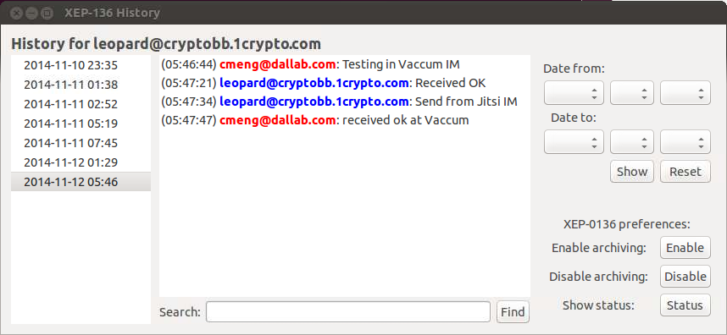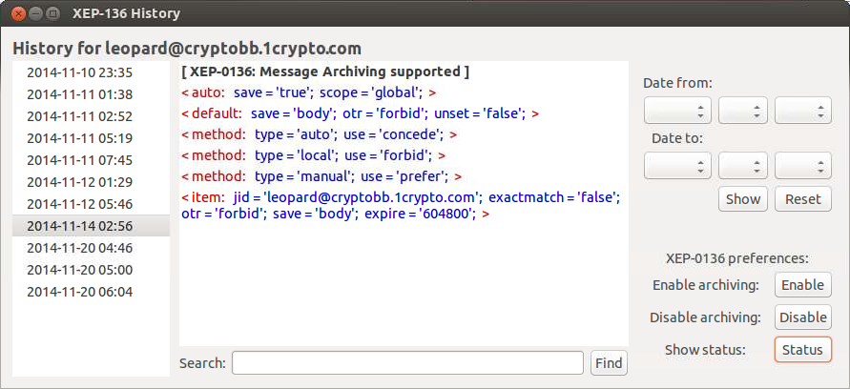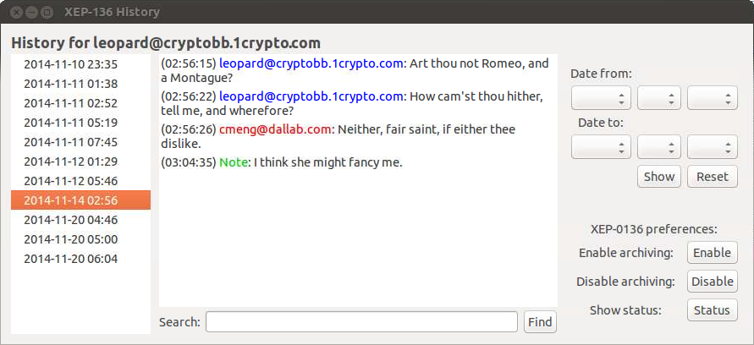

Mod_Archive2 Installation
Mod_archive2 has the following modules; with erl files in ejabberd main src directory and hrl files in ejabberd include directory. Checkout ejabberd files, including the mod_archives files from the svn directory on server into ejabberd workspace. Follow the instructions as in section Error: Reference source not found to “sudo make install” the ejaberd beam files.
Source files:
- dbms_storage.erl
- dbms_storage_mnesia.erl
- dbms_storage_odbc.erl
- dbms_storage_utils.erl
- mod_archive2.erl
- mod_archive2_auto.erl
- mod_archive2_maintenance.erl
- mod_archive2_management.erl
- mod_archive2_manual.erl
- mod_archive2_prefs.erl
- mod_archive2_storage.erl
- mod_archive2_time.erl
- mod_archive2_utils.erl
- mod_archive2_xml.erl
- xmpp_api_ejabberd.erl
- xmpp_api_mock.erl
Include files:
- dbms_storage.hrl
- mod_archive2.hrl
- mod_archive2_storage.hrl
- mod_archive2_utils.hrl

Install MySQL Database Schema – Mod_Archive2
You need to update the ejabberd MySQL database to include the new mod_archive2 tables. The mod_archive2 MySQL database schema i.e. ‘mysql_ma2.sql’ can be found in ejabberd main directory:
- ./sql/mysql_ma2.sql
Open the browser and start phpmyadmin. Import the table structures into each of the virtual host databases e.g. ‘ejabberd’ with scheme ‘mysql_ma2.sql’.
Note: There are differences between mod_archive and mod_archive2 database structures.

Ejabberd Configuration – Mod_Archive2
Ensure you have the following host_config settings for each virtual host e.g. cryptobb.1crypto.com for database setup in ejabberd.yml, with native mysql driver support enabled:
- host_config:
- "cryptobb.1crypto.com":
- sql_type: mysql
- sql_server: "localhost"
- sql_database: "ejb_icrypto"
- sql_username: "usr_icryptotech"
- sql_password: "secrectpwd"
To enable mod_archive2, edit ejabberd.yml and add the below mod_archive2 configuration settings to the 'modules' section:
- mod_archive2:
- rdbms: mysql
- only_in_roster: true
- default_auto_save: body
- read_only: false
- default_expire: infinity
- enforce_min_expire: 0
- enforce_max_expire: infinity
- replication_expire: 31536000
- session_duration: 1800
- wipeout_interval: 86400
Any unspecified options in the ejabberd.yml configuration will have default values set by the mod_archieve2 application; default values are listed as DEFINES in mod_archieve.erlfile.

Configuration Options – Mod_Archive2
- rdbms -> mysql | mnesia (default: mnesia) – select RDBMS database type; this parameter should always be specified.
- only_in_roster -> true | false (default: false) – only save message if sender is in recipient roster member list.
- default_auto_save -> body | false | message | stream (default: false) - is auto-save turned on by default and if yes, what to save exactly i.e. body or message; prefer to save only “body” to minimize disk space usage.
- read_only -> true | false (default: false) - if true, no client modifications either to collections or to archiving settings are allowed.
- time_accuracy -> (defaults: milliseconds) – use to resolve current message time for collection archiving.
- default_expire (time in seconds or infinity atom, default: infinity) -> elapsed time in seconds before collections are wiped or infinity to disable. All collections with their start time satisfying “now() - start() >= default_expire” i.e. elapsed time will be removed, unless expire time is overridden by users in their preferences.
- enforce_min_expire (time in seconds, default: 0) -> minimal time in seconds before collections are wiped out that the user is allowed to set; useful if you would like to enforce some message saving policy.
Note: this parameter is not currently checked in modification commands, such as “upload collection” or “remove collection”, so you cannot enforce the policy completely yet.
- enforce_max_expire (time in seconds or infinity atom, default: infinity) -> maximal time in seconds before collections are wiped out that the user is allowed to set; useful for limiting the amount of collections users may keep on server.
- replication_expire (time in seconds or infinity atom, default: 31536000 %% 1 year) -> time in seconds before 'removed' replication information if wiped out or infinity to disable; all collections with their removal time satisfying “now() - removal_time() >= replication_expire” will be removed completely from the database, thus the server completely forgets they were present once.
- session_duration (default: 1800 %% 30 minutes) -> time in seconds before the timeout of a session; the timeout interval the server uses to decide that conversation is over when performing automated archiving.
- wipeout_interval (default: 86400 %% 1 day) -> time in seconds between wipeout runs (executions of expire routine) or infinity atom to disable.
- prefs_cache_interval (default: 1800 %% 30 minutes) -> time in seconds between prefs cache flushes, infinity to never flush cache (might be heavy on RAM!), zero to disable caching.
- force_utc -> true | false (default: false) – use Coordinated Universal Time (utc) if true, instead of secs in retrieved messages setting. Should set to false for normal message retrieve operation unless otherwise.
- prefs_threads_expiration (default: 1800 %% 30 minutes) -> treat messages as single collection using “thread” timeout interval to differentiate between different conversations, to put them into different collections. There are two levels key schema when treating collection: first key is bare JID (jid without resource), second-level key is the thread. If thread is not present, {no_thread, Resource} is used instead.
- message_filters [{ns, <<"http://jabber.org/protocol/chatstates">>}, {name, <<"thread">>}]) -> messages filters for selective message saving.

Module Mod_Archive
Mod_Archive was tested working in ejabberd 2.1.17 xmpp server, but not enabled. The information given herewith is for reference only. Ejabberd 14.07 xmpp server uses mod_archive2 as outline in section 10.2.
The module mod_archive allows the logging and storing of user chat history text on the server database. It can be included in the modules section for the selected virtual host that requires the history archive service. Mod_archive implements XEP-0136 version 0.6 except OTR (off-the-record). The mod_archive is not in the ejabberd mainline source release, but available in the following site:
- https://github.com/processone/ejabberd-contrib
Refer to the following site for more info.
- http://www.ejabberd.im/mod_archive
There are few variants of modules within the mod_archive directory; the main difference between them is the storage method:
- mod_archive uses mnesia
- mod_archive_sql uses PostgreSQL
- mod_archive_odbc uses MySQL or SQLite3
There is also the mod_archive_webview module which is a web interface to mod_archive_odbc (for vieweing the logs). You can find these modules in ejabberd-contrib\mod_archive.

Mod_Archive Installation
Mod Archive modules are not pre-installed with the source build ejabberd main installation. Following are the beam files required to support message archive:
- mod_archive_webview.beam
- mod_archive_sql.beam
- mod_archive_odbc.beam
- mod_archive.beam
Copy the generated .beam files from the ebin directory to the directory where your ejabberd .beam files are.
- $ sudo cp ./*.beam /usr/lib/ejabberd/ebin/
Check README.txt or use the configuration file example provided in the conf dir to update your ejabberd.cfg configuration file.
Now start ejabberd. If there's a problem, check ejabberd log files for any reported error message.

Install MySQL Database Schema – Mod_Archive
You need to update the MySQL database to include the new mod_archive tables. The MySQL database schema ‘mod_archive_odbc_mysql.sql’ can be found in the following directory:
- ./mod_archive/src/mod_archive_odbc_mysql.sql
Open the browser and start hpmyadmin. Import the table structures into e.g. ‘ejabberd’ database with scheme ‘mod_archive_odbc_mysql.sql’.

Ejabberd Configuration – Mod-Archive
For detail documentation about this module, please refer to:
- http://www.ndl.kiev.ua/typo/articles/2007/11/14/mod_archive_odbc-release
Edit ejabberd.cfg and add the below line to the 'modules' section e.g. when using ODBC MySQL driver:
% Add to modules section:
- {mod_archive_odbc, [{database_type, "mysql"},
- {default_auto_save, true},
- {enforce_default_auto_save, false},
- {default_expire, infinity},
- {enforce_min_expire, 0},
- {enforce_max_expire, infinity},
- {replication_expire, 31536000},
- {session_duration, 1800},
- {wipeout_interval, 86400}]},
% Add somewhere at top level for each virtual host, if you do not have it yet for native MySQL driver:
- {odbc_server, {mysql, "localhost", "ejabberd", "usr_icrptotech", "secrectpwd"}}.

Configuration Options – Mod_Archive
- database_type - selects RDBMS type, currently “mysql”, “sqlite”, and “pgsql” are supported. This parameter should always be specified, all subsequent parameters are optional.
- default_auto_save (true or false, defaults to false) - whether to perform auto-saving by default or not; please note that XEP-136 requires it to be off by default.
- enforce_default_auto_save (true or false, defaults to false) - whether to enforce default_auto_save option by prohibiting users changing it individually in their preferences or not.
- session_duration (time in seconds) - the timeout interval the server uses to decide that conversation is over when performing automated archiving. The default value is 30 minutes.
- default_expire (time in seconds or infinity atom, defaults to infinity) - all collections with their start time satisfying “now() - start() >= default_expire” will be removed, unless expire time is overridden by users in their preferences.
- enforce_min_expire (time in seconds, defaults to 0) - minimal expire time users are allowed to set in their preferences, useful if you’d like to enforce some message saving policy.
Note: this parameter is not currently checked in modification commands, such as “upload collection” or “remove collection”, so you cannot enforce the policy completely yet!
- enforce_max_expire (time in seconds or infinity atom, defaults to infinity) - maximum expire time user is allowed to set, useful for limiting the amount of collections users may keep on server.
- replication_expire (time in seconds or infinity atom, defaults to 31536000, which is one year) - all collections with their removal time satisfying “now() - removal_time() >= replication_expire” will be removed completely from the database, thus the server completely forgets they were present once.
- wipeout_interval (time in seconds or infinity atom, defaults to 86400, which is one day) - interval between executions of expire routine.
Please note that according to XEP-136 only the following auto_save combinations are valid:
- default_auto_save = true, enforce_default_auto_save = true
- default_auto_save = false, enforce_default_auto_save = false

Mod_Archive_Webview
This application works with mod_archive_odbc database. Edit ejabberd.cfg and add the HTTP and module definitions as below to the list of request handler
- {listen, [ {5280, ejabberd_http, [ %...
- {request_handlers, [{["archive"], mod_archive_webview}
- ]} ]} ]}.
Then go to url http://your.server.com:5280/archive; enter your user account <user>@home.com and password to view the message archive. (Note: web view messages still has bugs)

Start Ejabberd Server
When you have done all the required configuration changes above, start the ejabberd service with parameter: start | restart | live.
- $ ejabberdctl start
- Starting jabber server: ejabberd.
You can check the status of the ejabberd service with the command.
- $ ejabberdctl status
- ejabberd 26.xx is running in that node
where 26.xx is the version of the ejabberd that you have installed.
To stop ejabberd while ejabberd is run in live mode; press CTRL-C follows by ‘a’ to stop ejabberd. otherwise:
- $ ejabberdctl stop

Ejabberd User Admin Registration
Upon successful starting the ejabberd server, it is time to register the admin user whom we have configured in the previous steps. Run the following command replacing password placeholders with the actual password and providing user name and domain name from ejabberd.yml file. Scretpwd may only contain alphanumeric, no special character.
- $ ejabberdctl register admin “example.com” “screctpwd”
The registered user account and the extra information are now stored in MySQL ‘ejabberd’ database. You can check the database content via the phpmyadmin using a browser.

Ejabberd Web Admin Access
You have now working XMPP server with one registered user. To verify that everything is OK, in your browser go to the admin page of the server (https://example.com:5443/admin). You will be asked to enter the admin jid e.g. admin@example.com and password, from the information you entered in the previous step. The UI given herewith are based on ejabberd 25.xx+.
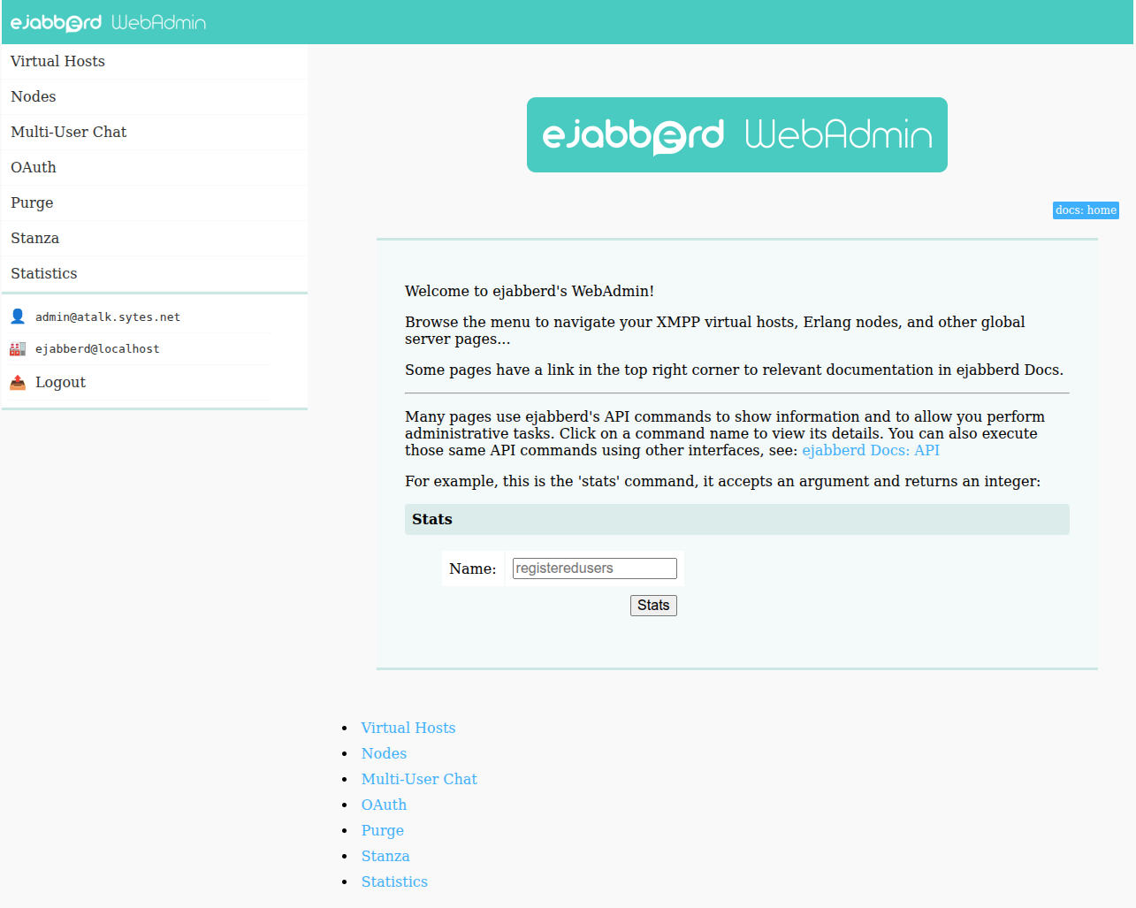
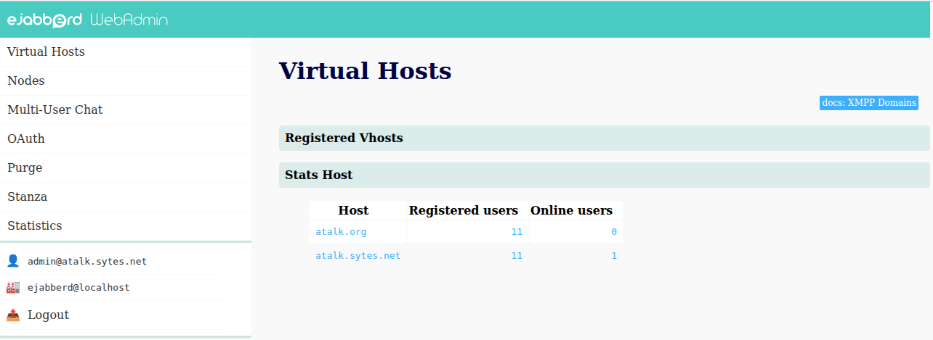
You should see all the defined virtual hosts in ‘vhosts’ page.

Ejabberd Users
You are ready to add new account to your Jabber xmpp server for testing. Navigate to the required virtual host to start adding new user accounts.
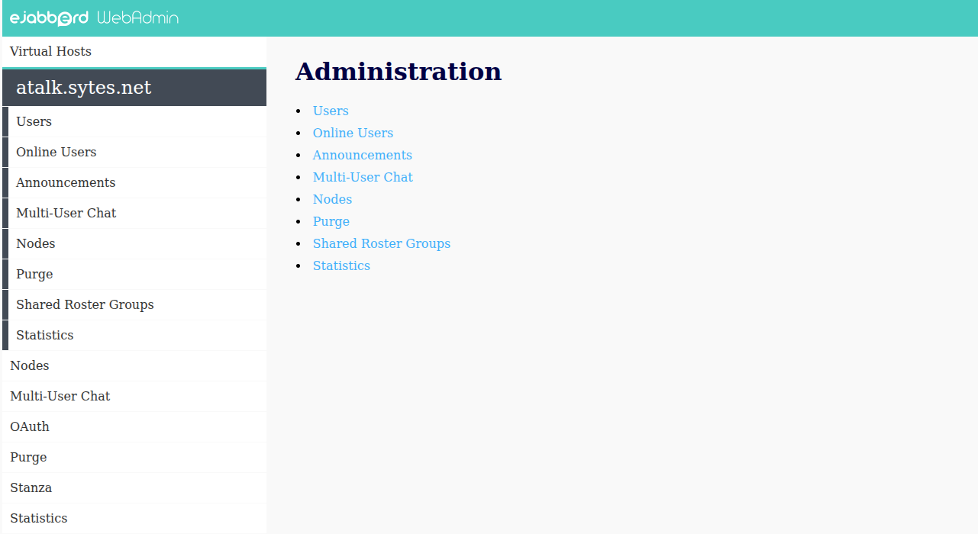
Navigate to ‘users’ page. Enter the info for User: and Password: fields, and click “Add User”
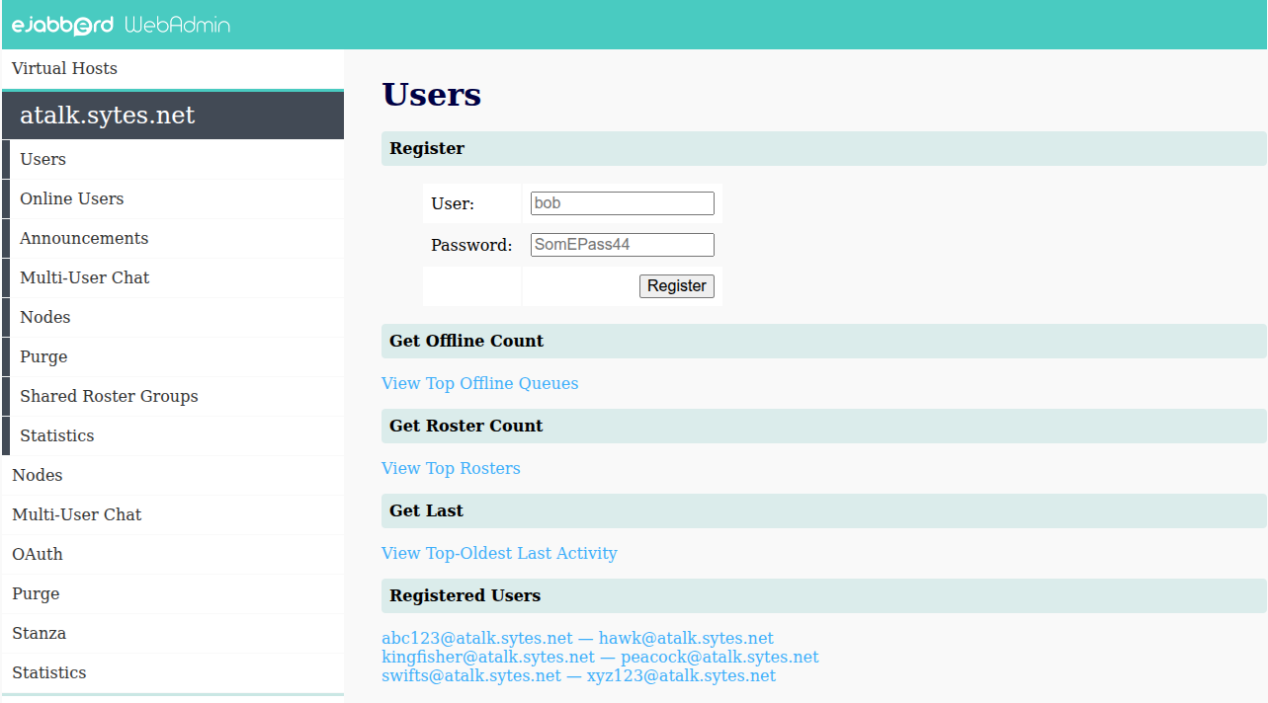

Ejabberd Shared Roster Groups
XMPP ejabberd allows administrator to create shared roster groups to include selected users on each virtual host group. You should enable mod_shared_roster module in ejabberd.yml. When creating a shared roster group on a virtual host in specifying the members, you can put @all@; and ejabberd will add all users on the current virtual host. See links for more info.
- http://www.ejabberd.im/shared-roster-all
To create shared roster group to include all users:
- Login on the web interface and go to 'Virtual Hosts' -> <server> -> 'Shared Roster Groups'
- Create a new Shared Roster: enter new identifier 'atalk_member' and click 'Srg Create'.
- Fill the form with this:
  - Group: atalk_member
  - Label: atalk member
  - Description: atalk members
  - Displayed: atalk_member
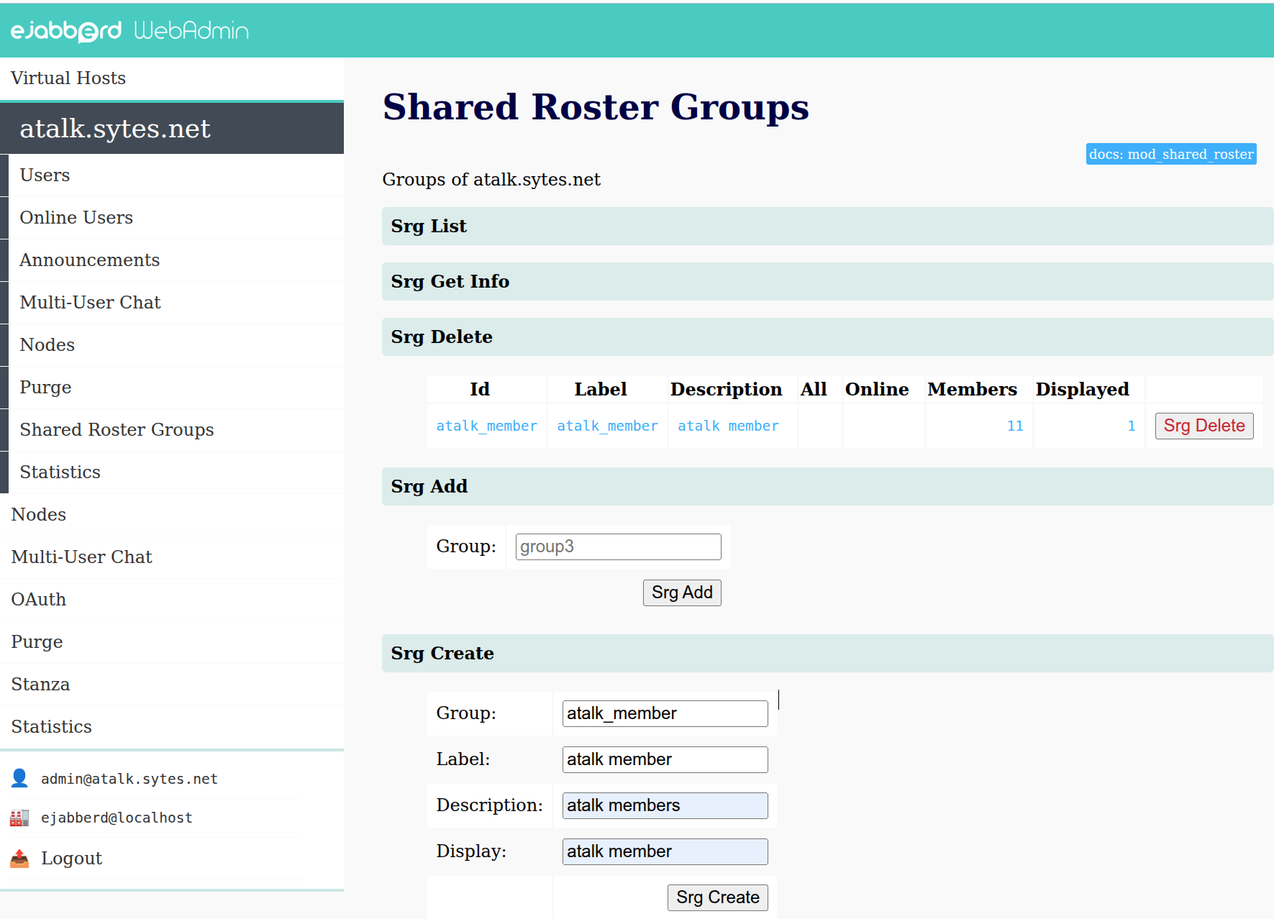
- Using ‘Srg User Add’ to add member.
- After a roster has been created, to add or remove member, just click on the Id item.
When any of the shared roster user logins, he will has a new group called atalk_member, and containing all the other users in the group on the <server>.

Ejabberd Start-Up Problem
You may encounter problem when starting ejabberd. Perform the following steps and refer to the sub-sections for further troubleshooting guides.
- Modify ejabberd.yml for maximum debug information display i.e. loglevel: 5
- $ ejabberdctl live
The debug traces may offer you glue on the exact root cause of the problem. You may also refer the ejabberd.log file for any error. The ejabberd.log file can be found in ./var/log/ejabberd directory.
Sometimes starting ejabberd can be locked out with the following error message due to access rights. For this error, try changing owner of the ejabberd lock file may help.
- ./usr/sbin/ejabberdctl: 273: /usr/sbin/ejabberdctl: cannot create ./var/lock/ejabberdctl/ejabberdctl-1: Permission denied
- $ sudo chown -R ejabberd ./var/lock/ejabberdctl
- $ sudo chmod -R 750 ./var/lock/ejabberdctl
The info below applies only if you specified user in configure option. At time the owner of lock file can get reverted back to root:root, denying access to non-root user causing ejabberd start failure. Verify that the following message appear during the “checkinstall”:
- # Administration script
- [ -d /usr/sbin ] || /usr/bin/install –c –d –m 775 /usr/sbin
- /usr/bin/install –c –m 550 –g ejabberd ejabberdctl.example /user/sbin/ejabberdctl
The last statement should contain “–g ejabberd”; missing this indicates the source build configuration is not setup properly. Refer to section Error: Reference source not found for more information.

Ejabberd Configuration Syntax Checking & Startup
This section applies to case where the ejabberd.cfg is used instead of ejabberd.yml.
Sometimes ejabberd does not start up and you are left wondering what the problem is. This could be because the configuration file ejabberd.cfg has error(s) in it. The reason this particular error is so frustrating is that it never appears in ejabberd.log. You can easily avoid this situation by doing a check that the file is valid before starting or restarting ejabberd. The solution is to run ejabberd.cfg through the Erlang interpreter.
$ cat ./etc/ejabberd/ejabberd.cfg | erl | grep syntax
If that command returns a syntax error line, you know there is a problem in the config file. If there is no output, ejabberd.cfg parses correctly. Use the command without the ‘grep’ to see the actual line that has syntax error; the line number give in the last output grep is cumulative command line numbering without the comment lines.

Terminated Ejabberd Stray Process
If there is no syntax error, but ejabberd still cannot start up properly. One of the possible reasons is that there may be stray process left unclean i.e. ‘epmd’ etc after the ejabberd last terminated. You need to find out process PID (process id) and kill it.
Use ps command or pidof command to find out process ID (PID). Syntax:
- ps aux | grep processName
- pidof processname
For example for processName ‘ejabberd’, use the following command to obtain process ID:
- $ sudo ps aux | grep ejabberd
- ejabberd 2700 0.0 0.0 7500 96 ? S 12:25 0:00 /usr/lib/erlang/erts-8.0/bin/epmd -daemon
- ejabberd 2726 1.1 0.6 1825140 53744 ? Sl 12:25 0:02 /usr/lib/erlang/erts-8.0/bin/beam -K false -P 250000 -- -root /usr/lib/erlang -progname erl -- -home /var/lib/ejabberd -- -sname ejabberd -pa /usr/lib/ejabberd/ebin -s ejabberd -kernel inetrc "/etc/ejabberd/inetrc" -ejabberd config "/etc/ejabberd/ejabberd.yml" log_path "/var/log/ejabberd/ejabberd.log" erlang_log_path "/var/log/ejabberd/erlang.log" -sasl sasl_error_logger false -mnesia dir "/var/lib/ejabberd" -smp disable
- ejabberd 2763 0.0 0.0 4336 656 ? Ss 12:25 0:00 erl_child_setup 1024
- ejabberd 2829 0.0 0.0 7464 872 ? Ss 12:25 0:00 inet_gethost 4
- ejabberd 2830 0.0 0.1 235940 9056 ? S 12:25 0:00 inet_gethost 4
ejabberd 2293 0.2 0.6 2218824 53336 ? Sl 12:06 0:02 /usr/lib/erlang/erts-8.0/bin/beam.smp -K true -P 250000 -- -root /usr/lib/erlang -progname erl -- -home /opt/ejabberd-23.01 -- -sname ejabberd@engsvr -noshell -noinput -noshell -noinput -mnesia dir "//var/lib/ejabberd" -kernel inet_dist_use_interface {127,0,0,1} -ejabberd log_rate_limit 100 log_rotate_size 10485760 log_rotate_count 1 log_rotate_date "" -s ejabberd -smp auto start
Above command indicates the PID (1066 & 23699) of ejabberd process. Kill the processes using the indicated PID; then restart ejabberd:
- $ sudo kill -9 2700

Erlang Cookie
The ejabberd launches erlang first before startup the ejabberd process. To allow cluster setup (section 19), the erlang uses ./var/lib/ejabberd/.erlang.cookie as a signature to allow inter-nodes communications. It has strict rule that the access right and owner of the .erlang.cookie is set exactly as follow:
If encountered problem during either “sudo /etc/init.d/ejabberd live” or “sudo ejabberdctl live” in starting up ejabberd; and for reason the process accesses cookie in ~/erlang.cookie, this cookie content & owner must be the same as /var/lib/ejabberd/.erlang.cookie. It is best just copy from the source /var/lib/ejabberd/.erlang.cookie and ensure/change the access right and owner to ejabberd:ejabberd (when you specified ejabberd as user in configure options) i.e.
- $sudo chown ejabberd:ejabberd ~/.eralng.cookie
Note: use of ~/.erlang.cookie indicates that the environment variable home is not being set to ‘/var/lib/ejabberd’ and exported in /usr/sbin/ejabberdctl.

Ejabberd Database Corruption
Under rare case, the database in ./var/lib/ejabberd may be corrupted. If you are still using ejabberd.cfg, you may try to uncomment the acl override and restart ejabberd.
- %%% ===================================
- %%% OVERRIDE OPTIONS STORED IN DATABASE
- %% Override global options (shared by all ejabberd nodes in a cluster).
- override_global.
- %%
- %% Override local options (specific for this particular ejabberd node).
- override_local.
- %%
- %% Remove the Access Control Lists before new ones are added.
- override_acls.
For system using ejabberd.yml or the above action failed, you may need to delete all the mnesia data files in the ./var/lib/ejabberd directory as the last resort. All the setup user accounts in the mysql database should stay intact.
- $ cd ./var/lib/ejabberd
- $ rm -r *
The above action should only delete the mnesia data files. If you accidentally deleted the .erlang.cookie, you need to update the erlang.cookie in the cluster node with the new .erlang.cookie created.
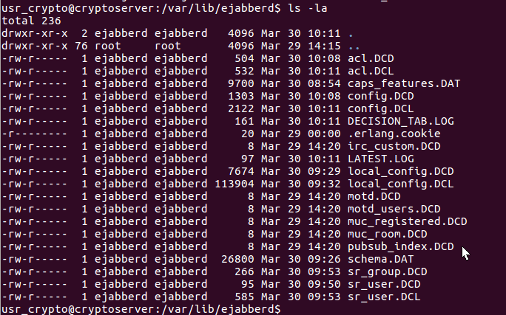

Jingle Nodes
Jingle Nodes is an XMPP Based Relay Service providing standard UDP/TCP Relay, but negotiated via XMPP. Jingle Relay Nodes are intend to provide easy to use Jingle Relay Type Candidates that can be used in ICE-UDP, RAW-UDP, TCP Jingle Sessions. Relay Candidates can provide NAT Traversal for Jingle users that don't have STUN/TURN Support, but also for users with STUN/TURN support that the negotiation failed.
The main benefits of Jingle Relay Nodes is the easy to use candidates, Jingle Clients can became a Node and Jingle Relay Nodes are published via XMPP, meaning every Client or Server can also act as a tracker of another Nodes and STUN Servers.
Jingle Nodes can be seen as the XMPP version of TURN/STUN relay server. Jingle Nodes enables users to share and discover P2P Media Relays that can be used to enable Voice and Video Chat via Jingle.
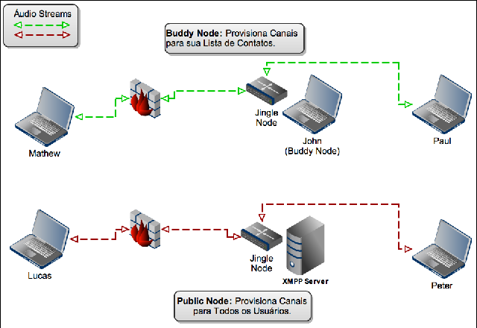
Another similar technologies but with less coverage is STUN/TURN. STUN is very nicely designed technology, and it is responsible for almost all P2P VoIP traffic available nowadays. The idea is very efficient and assertive. TURN has security and assertion, but it doesn't seem like the market already adopted it very widely to serve as the default VoIP relay system. But both lacks badly in simplicity and implementation time frame. TURN RFC is something about 80 pages, which makes it very complex and unpractical for "thin" clients like mobile VoIP clients. Jingle Relay Nodes uses the benefit of the embedded security and flexibility of XMPP to provide the same functionality of Relay, but in a much simpler process and minimal implementation. Jingle Nodes allows XMPP Clients doing VoIP with a pure XMPP Stack Client.
Refer to the following site for more information:
- http://code.google.com/p/jinglenodes/
The site provides two methods of implementation to allow ejabberd xmpp server in offering Jingle Nodes Relay service; only the second method is being used in aTalk home xmpp server Jingle Nodes Relay support i.e.
- Via ejabberd module plugin (tested not working – 14/02/2013)
- Via ejabberd external services

Environment Setup - Ejabberd External Services
You may need to setup the environment and associated development packages on the system that you intend to perform source compilation for Jingle Nodes Relay as below:
- $ sudo apt install autoconf
- $ sudo apt install erlang-nox
- $ sudo apt install libtool
Please refer to the following site for the installation of the Jingle Nodes Relay service. In addition to the service, it also requires the installation of the exmpp package.
- https://github.com/processone/exmpp

Exmpp installation
Exmpp is an extension to erlang application which provides the modules to ease the development of an XMPP/Jabber server or client. Jingle Nodes Relay requires the support and installation of exmpp.
The original site source is not further under maintenance; it fails when build with erlang/OTP 25. Refer to the sites below for installation instruction:
- https://github.com/cmeng-git/exmpp
Proceed to download the relevant installation files from the sites below.
- $ git clone https://github.com/cmeng-git/exmpp.git
Enter exmpp directory and perform the following steps.
- $ autoreconf –vif
- $ ./configure
- $ make
- $ checkinstall --install=no * sudo make install*

Erlang Jingle Nodes Relay Service Installation
Jingle Nodes Relay service needs to be build from source. The original github repository is no longer available. The source for aTalk project can be obtained from the following site; it has been updated to compile under erlang/OTP 27.
- https://github.com/cmeng-git/jnsapi_erlang.git
An alternate site was found; testing shown the required tool is not further available (20260728)
ecomponent, ".*", {git, "git://github.com/pepeyuilop/ecomponent.git", "0.11.7".
- https://github.com/xmppjingle/jinglenodes

Building Jingle Service Code
Clone the Jingle Nodes Relay Service API Code:
- git clone https://github.com/cmeng-git/jnsapi_erlang.git jnsapi_erlang
Enter the jnsapi_erlang directory and execute command make:
- $ make
You should see the following output:
- if test -d ebin; then echo "Existing Dir"; else mkdir ebin; fi
- Existing Dir
- Recompile: src/unit_test
- src/unit_test.erl:35: Warning: variable 'Cover' is unused
- Recompile: src/sup_jn_component
- Recompile: src/p1_loglevel
- Recompile: src/p1_logger_h
- Recompile: src/mod_monitor
- Recompile: src/jn_component
- Recompile: src/jingle_relay
- Recompile: src/jingle_handler
- Recompile: src/dynamic_compile
- Recompile: src/app_jn_component
- cp ./src/*.app ./ebin/

Jingle Nodes Service Configuration
You may copy the whole jnsapi_erlang directory; or just the files necessary for Jingle Nodes Relay execution to /usr/local/lib/jnsapi_erlang i.e.
- jn_component.cfg, jnodes, *.sh and ebin dir
Proceed to configure Jingle Nodes /usr/local/src/jnsapi_erlang/jn_component.cfg as below:
- {jid, "jn.atalk.org"}.
- {server, "localhost"}.
- {port, 8886}.
- {pass,"secret"}.
- {public_ip, "202.166.40.175"}.
- %% Note: whiltelist must not contain any <space> between domain & ,
- {whitelist, "localhost,atalk.org"}.
- {channel_timeout, 60000}.
- {max_per_period, 10}.
- {period_seconds, 6}.
- {init_port, 50000}.
- {end_port, 60000}.
- {handler, jingle_handler}.

Ejabberd Jingle Nodes Service Configuration
Proceed to configure /usr/local/etc/ejabberd/ejabberd.yml for Jingle Nodes Relay support as below in service section:
- ## ejabberd_service: Interact with external components (transports...)
- Listen:
- -
- port: 8886
- Module: ejabberd_service
- Access: all
- shaper: fast
- Ip: “127.0.0.1”
- Hosts:
- jn.atalk.org:
- Password: ‘secret’
Note: You may then restart ejabberd. The port 8886 should now be open and ready to accept connections from the Jingle Nodes Relay server.

Jingle Nodes Launching
Before launching Jingle Nodes Relay, you need to modify /usr/local/lib/jnsapi_erlang/start.sh scripts by changing –name to –sname as shown below
- erl -sname JingleNodes -pa deps/*/ebin -pa ebin/ -s app_jn_component -detached -noinput -noshell -env ERL_MAX_PORTS 65000
Launch Jingle Nodes Relay service while in the jnsapi_erlang directory:
- ./start.sh
A script jnodes has been created with options:
- Usage: ./jnodes {start|stop|live|restart|status}

Jingle Nodes Relay Verification
If everything is setup properly and running, launching Service Discovery on PSI+ should have the Jingle Nodes Relay listed as one of the services under atalk.org address i.e.
- Jingle Nodes Relay jn.atalk.org
It seems that the latest ejabberd v26.04 shows Name==jn.atalk.org instead of Jingle Nodes Relay; but discoInfo work without problem.
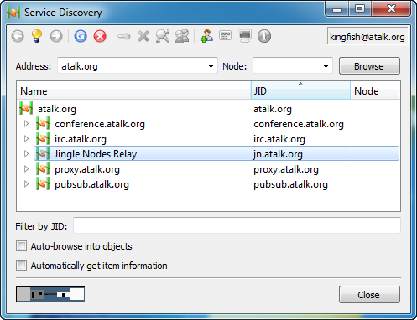
ingle Nodes Relay service is tested with ejabberd 26.04 but not working.

You can install PSI+ on Ubuntu using the following command:
- $ sudo apt install psi-plus
The following shows the aTalk debug log during system testing for jingle nodes support:
- 09:45:30.342 D SENT (0):
- <iq to='jn.atalk.sytes.net' id='FSK92-9' type='get'>
- <services xmlns='http://jabber.org/protocol/jinglenodes'>
- </services>
- </iq>
- 09:45:30.353 D RECV (0):
- <iq xml:lang='en-US' to='swan@atalk.sytes.net/atalk-1gbtrh3' from='jn.atalk.sytes.net' type='result' id='JXZZL-2'>
- <query xmlns='http://jabber.org/protocol/disco#info'>
- <identity category='proxy' type='relay' name='Jingle Nodes Relay'/>
- <feature var='http://jabber.org/protocol/jinglenodes'/>
- <feature var='http://jabber.org/protocol/jinglenodes#channel'/>
- </query>
- </iq>

Auto-Launch Jingle Nodes Relay
To make Jingle Nodes Relay as running service when the server starts; create a script file e.g. “jnodes” to launch Jingle Nodes Relay; “jnodes” has been created in the “jnsapi_erlang” svn directory. After downloaded the source, you need to modify jnodes and update the below line in the file:
- export home=/home/<username>
where <username> = actual default user login home directory
Perform the following steps to auto-launch Jingle Nodes Relay on system power up.
- $ sudo cp ./jnodes /etc/init.d/
- $ sudo chmod +x /etc/init.d/jnodes
- $ sudo update-rc.d jnodes defaults

Ejabberd Module Jinglenodes installation
Note: Ejabberd module plugin revision 156 was tested not working with ejabberd 2.1.11 as of 14/02/2013. The module plugin option is not fully working. It responses to the service discovery but failed on the following on “jinglenode#channel” request:
- <iq id="UYoXs-507" to="jinglenodes@home.com" from="cmeng@home.com/jitsi-nnuust" type="get"><channel xmlns='http://jabber.org/protocol/jinglenodes#channel' protocol='udp' /></iq>
- <iq from='jinglenodes@home.com' to='cmeng@home.com/jitsi-nnuust' type='error' id='UYoXs-507'><channel xmlns='http://jabber.org/protocol/jinglenodes#channel' protocol='udp'/><error code='503' type='cancel'><service-unavailable xmlns='urn:ietf:params:xml:ns:xmpp-stanzas'/></error></iq>
Hence the installation procedure is listed here for future reference when it becomes available.
Download the source file using svn:
- svn checkout http://jinglenodes.googlecode.com/svn/trunk/ejabberd_mod_jinglenodes ejabberd_mod_jinglenodes
Enter the ejabberd_mod_jinglenodes directory and perform the following steps:
- $ ./autogen.sh --prefix=/usr
- $ sudo make install
You should notice one of the statements during installation as below i.e. copy the two compiled beam modules to the ejabberd ebin directory.
- /usr/bin/install -c -m 644 mod_jinglenodes.beam udp_relay.beam '/usr/lib/ejabberd/ebin'

Ejabberd JingleNodes Configuration Setup
Proceed to configure ejabberd for Jingle Nodes support as below in the /etc/ejabberd/ejabberd.cfg modules setup section:
%% jinglenodes module setup

Jitsi-videobridge Component
Note: This section has been obsoleted. The videobridge/Jitsi-meet supports have been removed since aTalk v6.0.0 release dated 05/21/2026.
{mod_jinglenodes, [
{host, "jinglenodes.@HOST@"},
{public_ip, "atalk.org"},
{purge_period, 5000},
{relay_timeout, 60000}
]},
Jitsi-videobridge is an XMPP server component that allows for multi-user video communication. Unlike the expensive dedicated hardware videobridge, Jitsi-videobridge does not mix the video channels into a composite video stream, but only relays the received video channels to all call participants. Therefore, while it does need to run on a server with good network bandwidth, CPU horsepower is not that critical for performance.
You can find more information from the documentation in jitsi-videobridge ./doc directory source.

Jitsi-videobridge client & implementation
To organize a Jitsi-videobridge conference, open the “Tools” menu of the main Jitsi client window and select “Create a video bridge…”. If the option is grey and inactive, then your XMPP server does not currently have a Jitsi-videobridge service attached to it.
During a video call, the conference organizer sets up a call through a videobridge, controls and uses the videobridge with the COLIBRI protocol (COnferences with LIghtweight BRIdging). COLIBRI is an open XMPP extension protocol designed by the Jitsi development team. It allows the conference organizer to allocate channels for everyone, add or remove participants; and generally remain informed of the call state. All this happens transparently for the user. You can find information on how the COLIBRI protocol works in the COLIBRI XEP.
In addition to XMPP, Jitsi-videobridge can also be controlled through a HTTPS and a REST version of COLIBRI.
Jitsi-videobridge is powered by libjitsi and is distributed under the terms of the LGPL.

Ejabberd & Jitsi-videobridge component installation
Jitsi has packages for Debian/Ubuntu; follow installation instruction as below:
- $ sudo echo 'deb https://download.jitsi.org stable/' >> /etc/apt/sources.list.d/jitsi-stable.list
- $ sudo wget -qO - https://download.jitsi.org/jitsi-key.gpg.key | sudo apt-key add -
- $ sudo apt update
- $ sudo apt -y install jitsi-videobridge
Note: Installation will automatically be updated whenever there is a new release; it may also update any existing configuration files in use to its default values.
Alternatively you can clone the git repo and run the JVB from source using maven.
- $ sudo mvn compile exec:java -Dexec.args="--host=$HOST --domain=$DOMAIN --port=$PORT --secret=$SECRET" -Djava.library.path=$JVB_home/lib/native/linux-64 -Djava.util.logging.config.file=$JVB_home/lib/logging.properties -Dnet.java.sip.communicator.SC_home_DIR_NAME=.jitsi-videobridge
- HOST="Your XMPP server hostname/IP address goes here."
- DOMAIN="The JVB component name goes here."
- PORT="the component port of your XMPP server goes here."
- SECRET="The secret or password for the JVB component."
- JVB_home="The path to your JVB clone."

Jitsi-videobridge source build
Jitsi-videobridge source release support source build and Ubuntu deb installation package creation. Below gives a brief description of the steps for deb package creation.

Maven tool installation
- Install the following required tools maven3, debhelper & dpkg-dev for deb package creation. Download the latest maven version e.g. 3.6.0. Refer to the site for more info: https://www.howtoforge.com/tutorial/ubuntu-apache-maven-installation
- $ sudo apt purge maven maven2 maven3; to remove any old maven installation if any
- $ wget http://www-eu.apache.org/dist/maven/maven-3/3.6.0/binaries/apache-maven-3.6.0-bin.tar.gz
- $ tar -xf apache-maven-3.6.0-bin.tar.gz
- $ mv apache-maven-3.6.0/ /opt/apache-maven/
- $ cd /etc/profile.d/
- $ gedit maven.sh and paste the following:
- # Apache Maven Environment Variables
- # MAVEN_HOME for Maven 1 - M2_HOME for Maven 2
- export M2_HOME=/opt/apache-maven
- export MAVEN_HOME=/opt/apache-maven
- export PATH=${M2_HOME}/bin:${PATH}
- $ chmod +x maven.sh
- $ source maven.sh
- $ Verfiy installation with mvn –version and mvn --help
- $ sudo apt install debhelper dpkg-dev
- Refer to the following site on maven-ant-task support setup using “Declaring a typedef”. This allows you to run ant build from within eclipse.
- https://maven.apache.org/ant-tasks/installation.html
- Download “maven-ant-tasks-2.1.3.jar” from site below and save it to jitsi-videobridge source sub-directory e.g. ./lib-maven. This is required for the deb package build.
- Avoid saving to default ./lib as its contents will get clear and re-initialize during ant build
- http://www.eu.apache.org/dist/maven/ant-tasks/2.1.3/binaries/

Jitsi-videobridge build.xml modifications
Fetch the jitsi-videobridge sources from jitsi online repository, either:
- Download a snapshots of the source from https://download.jitsi.org/jitsi-videobridge/src/ OR
- Clone the latest source from its repository i.e.
$ git clone https://github.com/jitsi/jitsi-videobridge.git
Import jitsi-videobridge source directory into eclipse as maven project.
- At times you may need to execute ‘Maven|Update Project…’ from the project context menu.
- You need to modify the jitsi-videobridge build.xml to include below scripts
- <project name="jitsi-videobridge" xmlns:maven-artifact="antlib:org.apache.maven.artifact.ant">
- <path id="maven-ant-tasks.classpath" path="lib-maven/maven-ant-tasks-2.1.3.jar"/>
- <typedef resource="org/apache/maven/artifact/ant/antlib.xml"
- uri="antlib:org.apache.maven.artifact.ant"
- classpathref="maven-ant-tasks.classpath" />
- Update build.xml deb release version number using the latest nightly build
- <!-- jitsi-videobridge version number - use last nightly release-->
- <condition property="label" value="1093">
- <not>
- <isset property="label"/>
- </not>
- </condition>
- Update two resources files to change relevant parameters to reflect the actual ejabberd xmpp virtual host. These parameters are used to create /etc/jitsi/videobridge/config file during package installation/update:
- ### ./resources/install/debian/postinst file
- #JVB_HOSTNAME_IN="$RET"
- JVB_HOSTNAME_IN="atalk.org"
- JVB_PORT=5275

- OLD_JITSI_CONFIG="/usr/share/jitsi-videobridge/.sip-communicator/sip-communicator.properties"
- NEW_JITSI_CONFIG="/etc/jitsi/videobridge/sip-communicator.properties
- # cmeng - do not override if $NEW_JITSI_CONFIG exist. $OLD_JITSI_CONFIG is used in live mode
- if [ ! -f $NEW_JITSI_CONFIG ] && [ -f $OLD_JITSI_CONFIG ]; then
- mv $OLD_JITSI_CONFIG $NEW_JITSI_CONFIG
- ln -s $NEW_JITSI_CONFIG $OLD_JITSI_CONFIG
- elif [ ! -f $NEW_JITSI_CONFIG ]; then
- # if sip-communicator.properties file is missing create it
- # as jvb will search for it and if cannot create it will fail starting
- touch $NEW_JITSI_CONFIG
- ln -s $NEW_JITSI_CONFIG $OLD_JITSI_CONFIG
- fi

- ### ./resources/install/debian/templates file
- Default: atalk.org
- Modify ./resources/install/debian/init.d file in source directory; some scripts have been added to support execute jitsi-videobrige in live mode with command:
$ sudo –u jvb /etc/init.d/jitsi-videobridge live.
Note: $OLD_JITSI_CONFIG is used in live mode execution
- DEAMON_DIR=/usr/share/jitsi-videobridge

- live() {
- if [ -f $PIDFILE ]; then
- echo "$DESC seems to be already running, we found pidfile $PIDFILE."
- exit 1
- fi
- echo -n "Starting Live for $DESC: (note: you must start with sudo -u jvb ...)\n $DAEMON_OPTS\n"
- cd $DEAMON_DIR
- ./jvb.sh $DAEMON_OPTS
- }

- case "$1" in
- live)
- live
- ;;
- Update mvn library by cd to the project directory and execute the following:
- mvn -U clean package -DskipTests

Jitsi-videobridge deb build process
- From within eclipse: execute ‘Run As-> Ant Build…” and select ant script below for update lib dependencies jars, and released source zip or deb package creation respectively:
- copy-runtime-dependencies-from-maven
- deb-src [from import resources/install/build-debian.xml]
- deb-64 [from import resources/install/build-debian.xml]
- The release deb package can be found in ./release/jitsi-videobridge_xxx_1_amd64.deb, tagged with the specified version number _xxx_ as specified above.
- Use the deb installer to install the newly generated deb package

Jitsi-videobridge service configuration
- Edit the ejabberd configuration file /etc/ejabberd/ejabberd.yml, find the relevant section that starts with ‘listen’ and add the following:
- -
- port: 5275
- module: ejabberd_service
- hosts:
- "jitsi-videobridge.atalk.org":
- password: "xxxxx"
Note that the hosts: ‘jitsi-videobridge’ part is mandatory and the rest of the domain (atalk.org) has to match the domain passed to the Jitsi-videobridge when launch. If any of these is changed, everything seems to work fine, but when a conference starts only the focus is audible / visible. The port number could be different, but must follow JVB_PORT setting in /etc/jitsi/videobridge/config file.
- Edit the configuration file /etc/jitsi/videobridge/config, check and update the relevant information is matching xmpp server settings. e.g.:
- # sets the XMPP domain (default: none)
- JVB_HOSTNAME=atalk.org
- # sets the hostname of the XMPP server (default: domain if set, localhost otherwise)
- JVB_HOST=
- # sets the port of the XMPP server (default: 5275)
- JVB_PORT=5275
- # sets the shared secret used to authenticate to the XMPP server
- JVB_SECRET=xxxxx
- Two addition parameters are also required in order to work in jitsimeet environment
- # extra options to pass to the JVB daemon
- JVB_OPTS=--apis=rest,xmpp
- AUTHBIND=yes
The domain JVB_HOSTNAME used should be one of the virtual hosts hosted by ejabberd; only jabber clients that are connected to this virtual host will be able to use the videobridge service. Jitsi-videobridge xmpp protocol interface exchanges e.g. <iq /> stanza with ejabberd server uses this specified domains.
Note: Jitsi-meet uses the jitsi-videobridge service as specified in its config parameter i.e. bridge: 'jitsi-videobridge.atalk.org', via help from focus@atalk.org for Jitsi-videobridge session setup; hence this can be independent of the jitsi-meet actual hosted machine (URL link) e.g. domain: 'atalk.org'.

Jitsi-videobrige sip-communicator.properties setup
Jitsi-videobridge uses /etc/jitsi/videobridge/sip-communicator.properties, if defined to override its startup configuration settings.
Jitsi-videobridge pings ejabberd xmpp server every 10 seconds for channel keep-alive. If you have both jitsi-videobridge and xmpp services on the same machine; you may disable the ping function. If Jitsi-videobridge server is placed behind a firewall, two additional NAT settings must be specified i.e.: NAT_HARVESTER_LOCAL_ADDRESS & NAT_HARVESTER_PUBLIC_ADDRESS.
Jitsi-meet service load balancing is done by the jicofo component by selecting the least loaded videobridge instance from those machines detected during startup. To support this feature, Jitsi-videobridges are constantly publishing its load statistics to PubSub XMPP service via pubsub node i.e. sharedStatsNode, and Jicofo has to be subscribed to those stats.
- # Override default to enable video
- net.java.sip.communicator.service.media.DISABLE_VIDEO_SUPPORT=false

- # Disable Ping on same machine
- org.jitsi.videobridge.PING_INTERVAL=-1

- # The port to which the <tt>TcpHarvester</tt> will bind. 443 is used by atalk web service
- org.jitsi.videobridge.TCP_HARVESTER_PORT=4443

- # NAT setting if run behind firewall
- org.ice4j.ice.harvest.NAT_HARVESTER_LOCAL_ADDRESS=192.168.1.8
- org.ice4j.ice.harvest.NAT_HARVESTER_PUBLIC_ADDRESS=115.66.84.204

- # Do not check for SRTP Replay by MitM
- org.jitsi.impl.neomedia.transform.srtp.SRTPCryptoContext.checkReplay=false

- # The property that specifies entities authorized to operate the bridge.
- # i.e. allow all users on atalk.org to use the videobridge
- org.jitsi.videobridge.AUTHORIZED_SOURCE_REGEXP=.*@atalk.org/.*

- # Load balancing statistics: see statistics.md; set for 10 min interval
- org.jitsi.videobridge.ENABLE_STATISTICS=true
- org.jitsi.videobridge.STATISTICS_INTERVAL=600000
- org.jitsi.videobridge.STATISTICS_TRANSPORT=pubsub
- org.jitsi.videobridge.PUBSUB_SERVICE=pubsub.atalk.org
- org.jitsi.videobridge.PUBSUB_NODE=sharedStatsNode

Ejabberd PubSub Configuration
PubSub create-note request from external component requires admin access right and mod_pubsub configuration setup in ejabberd.yml:
- admin:
- user:
- - "jitsi-videobridge.atalk.org"

- mod_pubsub:
- force_node_config:
- ## Jitsi-videobrige statistic for load balancing
- "sharedStatsNode":
- access_model: open

Starting Jitsi-videobridge Service

Jitsi-videobridge daemon
During jitsi-videobridge initial installation, it is configured as daemon by the script /etc/init.d/jitsi-videobridge that uses parameters defined in /etc/jitsi/videobridge/config. The scripts command options are listed below:
- $ sudo /etc/init.d/jitsi-videobridge start|stop|live|status|reload
Live mode execution is possible if live scripts have been added to ./resources/install/debian/init.d. Start jitsi-videobridge in live mode displays all debug messages in terminal console for easy debug & verification of config settings. Please ensure you specified “–u jvb” option when during live mode.
- $ sudo -u jvb /etc/init.d/jitsi-videobridge live
To make sure that the correct config settings as daemon service are being used. Do the following:
- $ sudo ln -s /etc/jitsi/videobridge/sip-communicator.properties /usr/share/jitsi-videobridge/.sip-communicator/sip-communicator.properties

Jitsi-videobridge Remote Debug
Jitsi-videobridge is executed in JVM. Following steps outline the method to perform remote debug.
- Edit /usr/share/jitsi-videobridge/lib/videobridge.rc and uncomment VIDEOBRIDGE_DEBUG_OPTIONS. You may change suspend=y if you want jitsi-videobridge to wait for remote-debugger to be attached before proceed.
- # Uncomment the next line to enable the remote debugging of the video bridge
- VIDEOBRIDGE_DEBUG_OPTIONS="-Xdebug
-Xrunjdwp:transport=dt_socket,server=y,suspend=n,address=8000"
- From within eclipse, select your project, right click and select “Debug As|Debug Configurations". Enter parameters as shown below:
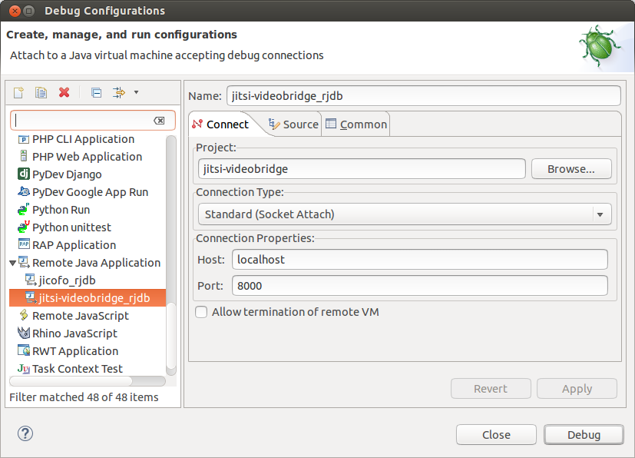
- Check “Display in favorite menu|Debug” option in Common Tab. Click “Close” to complete.
- Restart jitsi-videobridge.
- From eclipse tool bar, click “Debug” pull down menu, select jitsi-videobridge_rjb to start remote debug.

Jitsi-videobridge manual start
Note: Following is given as reference only. Use it with care as it may uses config different from the system setup above.
Being an XMPP component, Jitsi-videobridge can run on a separate machine, as well as on the same machine as the XMPP server itself. So, you basically may just download the zip archive to some folder and unpack it. If you install jitsi-videobridge via repository deb package, the default installed directory is /usr/share/jitsi-videobridge.
Enter the extracted folder and run jvb.sh (or jvb.bat if on Windows). You don’t even have to be root/administrator to do that. With the configuration defined, starting Jitsi-videobridge from the console would look like this:
- $ ./jvb.sh --secret=xxxxx –host=localhost --domain=atalk.org --port=5275
You may need to issue “sudo /etc/init.d/jitsi-videobridge stop” to stop current running daemon service. The general synopsis of the command is:
jvb.sh [OPTIONS], where options can be:
- --secret=SECRET sets the shared secret used to authenticate to the XMPP server
- --domain=DOMAIN sets the XMPP domain (default: host, if host is set, none otherwise)
- --min-port=MP sets the min port used for media (default: 10000)
- --max-port=MP sets the max port used for media (default: 20000)
- --host=HOST sets the hostname of the XMPP server (default: localhost)
- --port=PORT sets the port of the XMPP server (default: 5275)
Note: The jitsi-videobridge will attempt to connect to the xmpp server using the specified domain ip as given by the jitsi documentation. (cmeng – not true, it always default to localhost)

Jitsi-meet Installation & Setup
Note: This section has been obsoleted. The videobridge/Jitsi-meet supports have been removed since aTalk v6.0.0 release dated 05/21/2026.
Jitsi Meet is an open-source WebRTC JavaScript application that uses Jitsi-videobridge to provide high quality, scalable video conference. You can see Jitsi-meet in action video here at the session #482 of the VoIP Users Conference.
Jitsi-meet allows for very efficient collaboration. It allows users to stream their desktop or only some windows. It also supports shared document editing with Etherpad and remote presentations with Prezi.
- https://github.com/jitsi/jitsi-meet
- https://github.com/jitsi/jitsi-meet/blob/master/doc/quick-install.md
- https://github.com/jitsi/jitsi-meet/blob/master/doc/manual-install.md
- https://github.com/jitsi/jicofo
- https://github.com/jitsi/jigasi
Jitsi-meet setup requires the installation of the following components. See respective sections for the details of the individual components:
- Jitsi-videobridge
- Jitsi Conference Focus (jicofo)
- Jitsi-meet web application
- Jitsi Gateway to SIP – Jigasi – optional
- Apache SSL, RewriteRule and Reverse Proxy setup
Jitsi-meet earlier official documentation provides instructions on the setup using nginx and prosody. However the latest information on the following link: How to Install Jitsi Meet on your own Linux Server seems to have automate and allow the setup of Jitsi-meet based on nginx, apache and jetty. Personally has not tried this, so uncertain its effectiveness.
Note: The web & xmpp services equivalent for nginx & prosody are apache & ejabberd respectively. All jitst-meet components etc are assumed to be installed on the same machine.
Please take note of the following:
- Jitsi-meet creates a new user account during first jitsi-meet WebRTC lauch, and login using anonymous authentication method.
- focus@atalk.org, an admin account login via jicofo service, is required by jitsi-meet as focus agent. The account uses an authentication method: i.e.
<auth mechanism="DIGEST-MD5" xmlns="urn:ietf:params:xml:ns:xmpp-sasl"></auth>
- Due to these differences in login authentication nature of the two accounts, each jabberd user requires its own virtual host for login; This is because ejabberd cannot supports anonymous and authentication method on the same virtual host.
- atalk.org – secure host for authenticated user focus login.
- atalk.org – public host for jitsi-meet users login

Jitsi-meet Supporting Components Installation
This section describes the setup of apache, ejabberd xmpp services and the jitsi-meet components. All services are deployed and resided on the same physical machine.

Jitsi-videobridge Installation
See section 14. Jitsi-videobridge Component for installation and setup. Its remote debug method also apply to Jicofo application.

Jitsi Conference Focus (jicofo) Installation
Install JDK and ant etc if missing:
- $ sudo apt install default-jdk ant
- $ sudo apt install authbind
- When installing jitsi-meet to work with jitsi-videobridge, is best to use JVM >= 1.8.
- $ sudo add-apt-repository ppa:webupd8team/java
- $ sudo apt update
- $ sudo apt install oracle-java8-installer
- $ java -version
- java version "1.8.0_171"
- Java(TM) SE Runtime Environment (build 1.8.0_171-b11)
- Java HotSpot(TM) 64-Bit Server VM (build 25.171-b11, mixed mode)
Clone source from Github repo:
- git clone https://github.com/jitsi/jicofo.git
Update both the Maven tools and jicofo build.xml as per steps outlines in section 14.3.
- Update build.xml deb release version number to the latest nightly build e.g.
- <!-- jicofo version number - use last nightly release-->
- <condition property="label" value="1.0-440">
- <not>
- <isset property="label"/>
- </not>
- </condition>
- Update ./resources/install/debian/postinst file to change relevant parameters. These parameters are used to create /etc/jitsi/jicofo/config file during package installation/update:
- # try to get host from pre-installed jitsi-videobridge config file
- . /etc/jitsi/videobridge/config
- JICOFO_HOSTNAME="$JVB_HOSTNAME"
- JICOFO_PORT=5347
- #JICOFO_AUTH_DOMAIN="auth.$JICOFO_HOSTNAME"
- JICOFO_AUTH_DOMAIN="$JICOFO_HOSTNAME"
- JICOFO_AUTH_USER="focus"

- OLD_JITSI_CONFIG="/usr/share/jicofo/.sip-communicator/sip-communicator.properties"
- NEW_JITSI_CONFIG="/etc/jitsi/jicofo/sip-communicator.properties
- # cmeng - do not override if $NEW_JITSI_CONFIG exist. $OLD_JITSI_CONFIG is used in live mode
- if [ ! -f $NEW_JITSI_CONFIG ] && [ -f $OLD_JITSI_CONFIG ]; then
- mv $OLD_JITSI_CONFIG $NEW_JITSI_CONFIG
- ln -s $NEW_JITSI_CONFIG $OLD_JITSI_CONFIG
- elif [ ! -f $NEW_JITSI_CONFIG ]; then
- # if sip-communicator.properties file is missing create it
- # as jicofo will search for it and if cannot create it will fail starting
- touch $NEW_JITSI_CONFIG
- ln -s $NEW_JITSI_CONFIG $OLD_JITSI_CONFIG
- fi
- Like jitsi-videobridge section, .resources/install/debian/init.d, .resources/install/linux-64/jicofo.sh & ./lib/jicofo.rc have been updated or created to support live mode and remote debug. Reference to the actual modified files in the release directories.
From within eclipse, execute ‘Run As-> Ant Build…”: copy all dependent libraries from maven, then selects ant scripts as below for released source or deb package creation respectively:
- copy-runtime-dependencies-from-maven
- deb-src [from import resources/install/build-debian.xml]
- deb-64 [from import resources/install/build-debian.xml]
Alternatively build distribution package using ant commands from terminal. Replace {os-name} with one of: 'lin', 'lin64', 'macosx', 'win', 'win64'.
- cd jicofo
- ant dist.{os-name}
After jicofo installation, update ejabberd & Jitsi jicofo service configurations.
- Edit the configuration file etc/ejabberd/ejabberd.yml, find the relevant section that starts with ‘listen’ and add the following:
- -
- port: 5347
- module: ejabberd_service
- access: all
- shaper: fast
- hosts:
- "focus.atalk.org":
- password: "xxxxxx"
- Edit the configuration file /etc/jitsi/jicofo/config, update the relevant information (matching with ejabberd xmpp server relevant settings). e.g.:
- # Jitsi Conference Focus settings
- # sets the host name of the XMPP server
- JICOFO_HOST=localhost

- # sets the XMPP domain (default: none)
- JICOFO_HOSTNAME=atalk.org

- # sets the secret used to authenticate as an XMPP component
- JICOFO_SECRET=xxxxxx

- # sets the port to use for the XMPP component connection
- JICOFO_PORT=5347

- # sets the XMPP domain name to use for XMPP user focus logins
- JICOFO_AUTH_DOMAIN=atalk.org

- # sets the username to use for XMPP user logins
- JICOFO_AUTH_USER=focus

- # sets the focus password to use for XMPP user logins
- JICOFO_AUyyy

- # extra options to pass to the jicofo daemon
- JICOFO_OPTS=""
Run jicofo with options [start|stop|reload|status]:
- $ sudo /etc/init.d/jicofo start
If the live mode scripts have been added to ./resources/install/debian/init.d, you can launch jicofo in live mode displays log messages in terminal for easy debug. Please ensure you specify “–u jicofo” option to ensure the correct config settings of the daemon service are being used.
- $ sudo –u jicofo /etc/init.d/jicofo live

Jicofo Ping and Other settings
Jicofo is configured by default to ping the xmpp server every 10 seconds for channel keep-alive; it also updates disco#info every 30 seconds. If you run jicofo and xmpp server on the same server; you may disable the ping PING_INTERVAL in /etc/jitsi/jicofo/sip-communicator.properties. You may also change the disco#info interval as shown below i.e. SERVICE_REDISCOVERY_INTERVAL
- org.jitsi.jicofo.PING_INTERVAL=-1
- org.jitsi.jicofo.HEALTH_CHECK_INTERVAL=-1

- # Re-discover interval = 10 * 60 * 1000 (10 minutes)
- org.jitsi.jicofo.SERVICE_REDISCOVERY_INTERVAL=600000

- org.jitsi.jicofo.auth.URL=XMPP:jitsi-meet.atalk.org
- # Do not check for domain certificate
- org.jitsi.jicofo.ALWAYS_TRUST_MODE_ENABLED=true

- # For load balancing
- org.jitsi.focus.pubsub.ADDRESS=pubsub.atalk.org
- org.jitsi.jicofo.STATS_PUBSUB_NODE=sharedStatsNode

Jitsi-meet WebRTC
The following section describes the deployment of Jitsi-meet WebRTC based on web server apache and xmpp ejabberd server. The default installed directory is assumed to be /usr/share/jitsi-meet, i.e. same as the default used in deb installation.

Jitsi-meet WebRTC Deployment with pre-compiled CSS & Lib
Follow the method given below if you do not want to perform a source build installation.
Clone source from github repo:
- $ git clone https://github.com/jitsi/jitsi-meet.git
Copy source to apache web document directory:
- $ sudo cp –R ./jitsi-meet /usr/share/
Note: jitsi-meet repository contains other files specifically for prosody and nginx. No attempt has been made to remove the unused files at this moment.
To ensure lib functions compatibility with the cloned source, you need to download the latest nightly built deb e.g. jitsi-meet_1.0.xxxx_1_all.deb; use an archive manager to extract to the following two directories and their contents to /usr/share/jitsi-meet. The contents are the compiled css/libs required by index.html during launching:
- /usr/share/jitsi-meet/css/all.css
- /usr/share/jitsi-meet/libs/*
- sudo chmod +x ./index.html => chage +x for include support
Edit the /usr/share/jitsi-meet/config.js file to reflect actual environment setup:
- /* jshint -W101 */
- var config = {
- // configLocation: './config.json', // see ./modules/HttpConfigFetch.js
- hosts: {
- // domain: 'jitsi-meet.example.com',
- domain: 'atalk.org',

- // muc: 'conference.jitsi-meet.example.com', // FIXME: use XEP-0030
- muc: 'conference.atalk.org',

- // anonymousdomain: 'guest.example.com',
- // authdomain: 'jitsi-meet.example.com', // defaults to <domain>

- // bridge: 'jitsi-videobridge.jitsi-meet.example.com', // FIXME: use XEP-0030
- bridge: 'jitsi-videobridge.atalk.org',

- // jirecon: 'jirecon.jitsi-meet.example.com',
- // call_control: 'callcontrol.jitsi-meet.example.com',

- //focus: 'focus.jitsi-meet.example.com', // defaults to 'focus.jitsi-meet.example.com'
- focus: 'focus.atalk.org'
- },

- // Note: cmeng- you may uncomment getroomnode and modify the actual roomName used in conference
- // getroomnode: function (path) { return 'someprefixpossiblybasedonpath'; },
- // useStunTurn: true, // use XEP-0215 to fetch STUN and TURN server
- // useIPv6: true, // ipv6 support. use at your own risk
- useNicks: false,
- bosh: '//atalk.org/http-bind', // FIXME: use xep-0156 for that
- // The name of client node advertised in XEP-0115 'c' stanza
- clientNode: 'http://atalk.sytes.net/jitsimeet',
- // The real JID of focus participant - can be overridden here
- focusUserJid: 'focus@atalk.org',
- //defaultSipNumber: '', // Default SIP number
- …..

Jitsi-meet Patches
A script file /usr/share/jitsi-meet/jvb_jms script has been created to generate/update jitsi-videobridge config and sip-communicator.properties for use with jitsi-meet service. Refer to local released source directory.

Jitsi-meet WebRTC Deployment with Source Build
Jitsi-meet uses Browserify. If you want to make changes in the code, you need to install Browserify. Browserify requires nodejs. In Ubuntu 22.04, use Synaptic Package Manager to install both nodejs and npm default. Follow steps below to update both the tools to nodejs v11.x and npm v3.7.2.
- Refer to the site: https://github.com/nodesource/distributions for more info on nodejs update.
- curl -sL https://deb.nodesource.com/setup_11.x | sudo -E bash -
- sudo apt install -y nodejs
- Follow steps below to update npm v3.7.2.
- $ sudo npm -g install npm@latest
- If found missing during npm install, may need to install browsefiy and react etc:
- $ sudo npm install -g browserify
- sudo npm install -g react
- sudo npm install -g fsevents
Note: If your /usr/share/jisti-meet directory is accessible without root, then issue all below commands without the $ sudo
- $ cd jitsi-meet
- $ npm install
To build the Jitsi-meet application, just execute make command (the process takes a while to display any message, so be patient). On completion, just copy selected or all the generated files to your installed directory e.g. /usr/share/jitsi-meet. Note: need only all.css as it includes all other css’s, and may omit the following directories: android, debian, doc and ios
- $ sudo make
During make process, you may experience some missing commands in ./node_modules/.bin. Create the missing command links in .bin directory as below in particular
- $ ln –s ../browerfly/bin/cmd.js browerify
- $ ln –s ../clean-css/bin/cleancss cleancss

Working with the library sources (lib-jitsi-meet)
By default the lib-jitsi-meet library is built from its git repository sources. The default dependency path in package.json is: "lib-jitsi-meet": "jitsi/lib-jitsi-meet".
To work with local copy you must download the source to e.g. “/usr/share/jitsi-meet/lib-jitsi-meet” and change the path to: "lib-jitsi-meet": "./lib-jitsi-meet".
Before “make” the project, you must force it to take the local “./lib-jitsi-meet” sources; as 'npm update' will not do it automatically.
- $ npm install lib-jitsi-meet –force
To build the jitsi-meet application using local “./lib-jitsi-meet”, just type
- $ npm install
- $ make

Jitsi-meet Apache Setup
Default apache installation on Ubuntu 22.04 is version 2.4.29. If your version (e.g. with Ubuntu 14.04) does not fully support the RewriteRule features. Follow the steps given below to upgrade apache to latest 2.4.x release e.g. 2.4.37.
Adding apache PPA to your system, ref site: https://launchpad.net/~ondrej/+archive/ubuntu/apache2
You can update your system apache2 with unsupported packages from this untrusted PPA by adding ppa:ondrej/apache2 to your system's Software Sources.
- sudo add-apt-repository ppa:ondrej/apache2
- sudo apt update
Jitsi-meet requires both ssl and reverse-proxy web services. Starting with Chrome version 47, it no longer supports getUserMedia on non-secured Domains. It is no longer possible to access the video and audio from a Web camera in Web applications which are being loaded in non-secure mode; it throws error: “getUserMedia() no longer works on insecure origins”. Hence access to jitsi-meet application must use a secure connection such as https:.

Create Apache SSL certificate
- Create Let’s Encrypt CA certificate
- Refer to section 8.1 on how to generate letsencrypt CA certificate.
- Create self-signed SSL certificate
- Refer to below links on how to create a self-signed SSL certificate;
- https://www.digitalocean.com/community/tutorials/how-to-create-a-self-signed-ssl-certificate-for-apache-in-ubuntu-16-04
- http://www.liquidweb.com/kb/how-to-create-a-self-signed-ssl-certificate-on-ubuntu/
- $ sudo mkdir /etc/apache2/ssl
- $ sudo openssl req -x509 -nodes -days 10000 -newkey rsa:2048 -keyout /etc/apache2/ssl/atalk.sytes.net.key -out /etc/apache2/ssl/atalk.sytes.net.crt
- Command definitions:
- openssl: This is the basic command line tool provided by OpenSSL to create and manage certificates, keys, signing requests, etc.
- req: This specifies a subcommand for X.509 certificate signing request (CSR) management. X.509 is a public key infrastructure standard that SSL adheres to for its key and certificate management. Since we want to create a new X.509 certificate, this is what we want.
- -x509: This option specifies that we want to make a self-signed certificate file instead of generating a certificate request, as would normally happen.
- -nodes: This option tells OpenSSL that we do not wish to secure our key file with a passphrase. Having a password protected key file would get in the way of Apache starting automatically as we would have to enter the password every time the service restarts.
- -days 10000: This specifies that the certificate we are creating will be valid for ~30 years.
- -newkey rsa:2048: This specifies that we want to generate a new certificate and a new private key at the same time. We did not create the private key that is required to sign the certificate in a previous step, so we need to create it along with the certificate. The rsa:2048 portion tells it to make an RSA key that is 2048 bits long.
- -keyout: This parameter names the output file for the private key file that is being created.
- -out: This option names the output file for the certificate that we are generating.
- Following is an example what will be the information requested during ssl certificate generation.
- Country Name (2 letter code) [AU]:SG
- State or Province Name (full name) [Some-State]:Singapore
- Locality Name (eg, city) []:Singapore City
- Organization Name (eg, company) [Internet Widgits Pty Ltd]:atalk.sytes.net
- Organizational Unit Name (eg, section) []:Department of atalk
- Common Name (e.g. server FQDN or YOUR name) []:atalk.syte.net
- Email Address []:your_email@gmail.com

Apache SSL, RewriteRule and Reverse Proxy Configuration & Setup
To support atalk.sytes.net/atalk web service and jitsi-meet, you must have both alias and rewrite rule setup as shown in this section.
Note: Apache2 mod_rewrite execution order has precedence over mod_alias irrespective of their orders appear in the configuration files. Here's where the documentation explainations:
http://httpd.apache.org/docs/2.4/developer/hooks.html#hooking-order
Here is where mod_rewrite defines its calling order (line 5109):
svn.apache.org/viewvc/httpd/httpd/trunk/modules/mappers/mod_rewrite.c?view=markup#l5109
That mod_rewrite defines itself as hook_first and mod_alias defines itself as hook_middle is why rewrite directives happen before redirect directives. mod_info provides a much more readable way to see the priority of each module for each hook:
Translate Name:
- 00 mod_rewrite.c
- 10 mod_alias.c
- 30 core.c

Jitsi-meet sites-available Setup
You need to update /etc/apache2/sites-available/default-ssl.conf - add/modify these lines:
- <VirtualHost *:443>
- ServerName atalk.sytes.net
- # Required by jitsi-meet to work properly; cannot use /var/www/atalk
- DocumentRoot /usr/share/jitsi-meet

- SSLEngine on
- SSLCertificateFile /etc/letsencrypt/live/atalk.sytes.net/fullchain.pem
- SSLCertificateKeyFile /etc/letsencrypt/live/atalk.sytes.net/privkey.pem
- Include /etc/letsencrypt/options-ssl-apache.conf

- # RewriteRule for jitsi-meet/atalk to work properly => must be enabled
- RewriteEngine on

- # Direct to atalk web page if none is specified
- RewriteCond %{REQUEST_URI} ^/$
- RewriteRule ^/$ /atalk [L,PT]

- # Direct to DocumentRoot for jisti-meet room format
- RewriteCond %{REQUEST_URI} ^/meet/([a-zA-Z0-9=\?]+)$
- RewriteRule ^/(.*)$ / [L,PT]

- # Reverse proxy setup for http-bind – jitsi-meet does not support SSL protocol
- <Location /http-bind>
- ProxyPass http://localhost:5280/http-bind
- ProxyPassReverse http://localhost:5280/http-bind
- AllowOverride all
- Require all granted
- </Location>
- </VirtualHost>
Refer to the links on Apache 2.4 documentation etc for more information:
- Apache HTTP Server Version 2.4 Documentation
- https://www.leaseweb.com/labs/2014/12/tutorial-apache-2-4-transparent-reverse-proxy
- https://www.digitalocean.com/community/tutorials/how-to-use-apache-http-server-as-reverse-proxy-using-mod_proxy-extension

Jitsi-meet conf-available Setup
You need to create a configuration file in /etc/apache2/conf-available/ directory, e.g. atalk.conf with the following contents to support both atalk and jitsi-meet services. Jitsi-meet share directory needs ServerSideIncludes (SSI); also chmod +x index.html.
See https://httpd.apache.org/docs/2.4/mod/mod_include.html
- # atalk default Apache configuration
- Alias /meet /usr/share/jitsi-meet
- Alias /atalk /var/www/atalk
- Alias /release /var/www/releases

- # link document root to sub-directory atalk if none is specified (need trailing /)
- # Temporary only as this affect jitsi-meet
- Alias / /var/www/atalk/

- <Directory /var/www/atalk/>
- Options FollowSymLinks
- DirectoryIndex index.html
- </Directory>

- <Directory /var/www/releases>
- Options FollowSymLinks
- </Directory>

- <Directory /usr/share/jitsi-meet/>
- Options FollowSymLinks Includes
- XBitHack on
- DirectoryIndex index.html
- </Directory>
Execute the following commands to enable jitsi-meet site & apache modules support; then restart apache2:
- $ sudo a2enconf atalk
- $ sudo a2ensite default-ssl
- $ sudo a2enmod include
- $ sudo a2enmod ssl rewrite proxy proxy_http
- $ sudo /etc/init.d/apache2 restart

Launch Jitsi-meet conference
Launch a web browser (Chrome, Chromium, Opera or fireFox) and enter in the URL bar the hostname (or IP address) e.g. Second URL (do not end with back slash) specifies the jitsimeet conference room name i.e jmconfroom etc:
- https://atalk.sytes.net/meet
- https://atalk.sytes.net/meet/jmconfroom
Confirm that you trust the self-signed certificate if use, of the newly installed Jitsi-meet host site.

Jitsi Gateway to SIP – Jigasi Installation
Jitsi Gateway to SIP: jigasi is a server-side application that links & allows regular SIP clients to join Jitsi-meet conferences hosted by Jitsi-videobridge.
https://github.com/jitsi/jigasi
Install Jigasi
- $ sudo apt -y install jigasi
OR:
- $ sudo wget https://download.jitsi.org/jigasi_1.0-1_amd64.deb
- $ sudo dpkg -i jigasi_1.0-1_amd64.deb
During the installation, you will be asked to enter your SIP account and password. This account will be used to invite the other SIP participants.

Reload Jitsi-meet
Launch again a browser with the Jitsi-meet URL and you'll see a telephone icon on the right end of the toolbar. Use it to invite SIP accounts to join the current conference.

Basic Jitsi-meet installation (nginx and prosody)
Jitsi-meet installation from deb will default to use both the prosody and nginx; the tools are equivalent of apache and ejabberd as in atalk.org. Therefore deb installation given here is for reference, and is not use in atalk.org (atalk.sytes.net) server setup.
Add the repository
- $ sudo echo 'deb http://download.jitsi.org/nightly/deb unstable/' >> /etc/apt/sources.list
- $ sudo wget -qO - https://download.jitsi.org/nightly/deb/unstable/archive.key | apt-key add -
Update the package:
- $ sudo apt update
Install Jitsi-meet
- apt -y install jitsi-meet
During the installation, you will be asked to enter the hostname of the Jitsi-meet instance. If you have a FQDN hostname for the instance already set up in DNS, enter it there. If you don't have a resolvable hostname, you can enter the IP address of the machine (if it is static or doesn't change).
This hostname (or IP address) will be used for virtual host configuration inside the Jitsi-meet and also, you and your correspondents will be using it to access the web conferences.

Jitsi-meet Uninstall
- $ sudo apt purge jigasi jitsi-meet jicofo jitsi-videobridge
Sometimes the following packages will fail to uninstall properly:
- jigasi
- jitsi-videobridge
When this happens, just run the uninstall command a second time and it should be ok.
The reason for failure is that sometimes, the uninstall script is faster than the process that stops the daemons. The second run of the uninstall command fixes this, as by then the jigasi or jvb daemons are already stopped.

Jitsi Client Source Build Setup
Jitsi clients support running on multiple OS platforms including Windows 7, Linux and mac etc.
Please refer to the following sites for information on jitsi and smack:
- https://github.com/jitsi/jitsi (5633)
- https://www.igniterealtime.org/builds/smack/docs/latest/documentation/debugging.html

Jitsi Project Setup
Jitsi compilation from source is using Eclipse IDE 2022-06. The source for jitsi building is based on the Tag 5633. Jitsi-5633 uses smack-4.4.5.
- Download from https://github.com/jitsi/jitsi.git for tag 5633 as zip file.
- launch and import project into eclipse as “Existing Projects into Workspace” as “jitsi-2.11” project

Jitsi scripts Update
You need to update the following scripts for compilation and debugging after source download. The required changes are for both Windows or linux variants build.
- Update \jitsi\build.xml.
- ……
- <property name='maxwarns' value='10000' />
- <property name='label' value='5633' />
- <property name='smack.debugEnabled' value='true' />
- <property name="smack.debuggerClass" value="org.jivesoftware.smack.debugger.ConsoleDebugger" />
- <!-- property name="smack.debuggerClass" value="org.jivesoftware.smack.debugger.LiteDebugger" / -->
- <!-- property name="smack.debuggerClass" value="org.jivesoftware.smack.debugger.SmackDebugger" / -->
- <property name='java.net.preferIPv6Addresses' value='true' />
- ….
- <!--DEBUG-JITSI -->
- <target name="debug" depends="deploy-os-specific-bundles"
- description="Starts jitsi and wait for debugger to connect on port 5432">
- ….
- <sysproperty key="smack.debugEnabled"
- value="${smack.debugEnabled}"/>
- <sysproperty key="smack.debuggerClass"
- value="org.jivesoftware.smack.debugger.ConsoleDebugger"/>
- ….
- </target>
- <!--RUN-JITSI -->
- <target name="run" depends="deploy-os-specific-bundles,load-properties"
- ….
- <sysproperty key="smack.debugEnabled"
- value="${smack.debugEnabled}"/>
- <sysproperty key="smack.debuggerClass"
- value="${smack.debuggerClass}"/>
- ….
- </target>java
- Note:
- label: the latest nightly build version and will be shown in jitsi About dialog e.g. Jitsi version 2.11.5633
- smack.debugEnabled: set to true to enable smack debugger
- smack.debuggerClass: the desired type of smack debugger interface. Refer to the site for more detail: https://www.igniterealtime.org/builds/smack/docs/latest/documentation/debugging.html
- ConsoleDebugger is selected to display smack xmpp Send/Receive messages on console, so as to be time-sync with jitsi application debug messages.
- Update \Jitsi\lib\logging.properties for more debug messages display on console
- - java.util.logging.ConsoleHandler.level = SEVERE
- + java.util.logging.ConsoleHandler.level = FINEST

- - net.java.sip.communicator.impl.protocol.irc.level = INFO
- + net.java.sip.communicator.impl.protocol.irc.level = FINEST
- ./resources/install/build.xml => disable changelog-${label}.txt fetch in the specified link
- <!-- cmeng: cannot find the linked file, Just ignore
- <get src="${link.update.changelog.prefix}/extended-changelog-${label}.txt"
- dest="changelog-${label}.txt" ignoreerrors="true"/>
- <loadfile property="latest.changelog"
- srcFile="changelog-${label}.txt" failonerror="false"/-->

- <!-- Load a default value if file with changelogs is missing -->
- <!-- cmeng: condition property="latest.changelog" value="Nightly builds">
- <not>
- <isset property="latest.changelog"/>
- </not>
- </condition>
- <replace file="${debianize.dir}/changelog"
- token="_CHANGES_"
- value="${latest.changelog}"/>
- <delete file="changelog-${label}.txt"/ -->
- Alternatively create a changelog file in the project root directory:
- e.g. changelog-5633.txt

Jitsi-Debian (Ubuntu)
This section describes the steps to compile and debug jitsi-linux from source. The required steps have been verified with eclipse running on Ubuntu 22.04.

Jitsi Project Installation & Setup
- Jitsi debian build requires the following changes to two files in jitsi/resources/install:
- # Update JAVA_HOME to point to the Java installed directory
- ./debian/rules.tmpl -> change export JAVA_HOME=/usr/lib/jvm/java-8-oracle
- # Prevent jitsi from auto update and installation error due to lib version for Ubuntu 22.04
- ./debian/control.tmpl -> Change to the following in section Depends: default-jre …
- Recommends: libappindicator1,
libavformat58 | libavformat-ffmpeg56,
libavcodec-extra58 | libavcodec58 | libavcodec-ffmpeg-extra56 | libavcodec-ffmpeg56,
libavfilter7 | libavfilter-extra7 | libavfilter-ffmpeg5,
libavutil56 | libavutil-ffmpeg54,
libswscale5 | libswscale-ffmpeg3

Jitsi Ubuntu deb-64 Build
To start source build:
- Right click on \jitsi\build.xml and select Run As | 2.Ant Build …. | deb-64 | run
- Be patient when build process execution is at jh_depends – it takes quite a while to process.
- The completed build deb are in ./release directory
Note: If you terminated a current build process prematurely, you may encounter problem during the next build. In this case, manually stop any running jitsi build processes. If necessary delete the jitsi\release\debian before restart the new build.

Jitsi Client Remote Debug
Jitsi is executed in JVM machine. Following steps outline the method to perform remote debug.
- Close any running jitsi
- From within eclipse, select jitsi project root, right click and select “Debug As | Debug Configurations | Remote Java Application | create new if necessary".
- Click “Connect” Tab and enter parameters as shown below i.e. set port value to 5432:
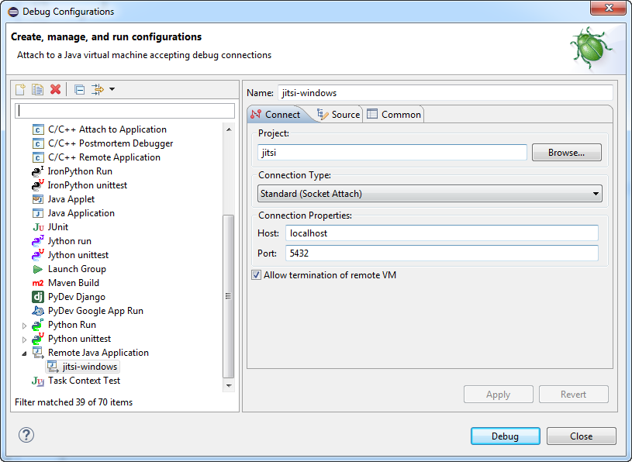
- Click “Common” Tab, and check “Display in favourite menu | Debug” option.
- Click “Close” to complete.
- Right click on \jitsi\build.xml and select => Debug As | 3.Ant Build …. | debug => Debug
- The eclipse console will display the following message on launch:
- Buildfile: /home/cmeng/ws_experiment/jitsi/jitsi-smack4.2/build.xml
- deploy-os-specific-bundles:
- debug:
- [java] Listening for transport dt_socket at address: 5432
- From the eclipse top menu, click on debug tool icon and select ‘jitsi-smack2.4’
You are now in java remote debug mode and the debug messages will be shown in the console window.

Jitsi Windows
This section describes the steps to compile and debug jitsi-windows from source. The required steps have been verified with eclipse running on Windows 7.
Please refer to the following sites for more information on Windows environment setup:
- http://mingw-w64.org/doku.php
- https://cygwin.com/install.html
- http://x.cygwin.com/docs/ug/setup-cygwin-x-installing.html
To allow jitsi compilation from source using eclipse IDE on windows 7, followings tools are required.
- Mingw-w64: an advancement of the original mingw.org project, created to support the GCC compiler on Windows systems. It has forked in order to provide support for 64 bits and new APIs.
- mingw-w64-install.exe from: https://sourceforge.net/projects/mingw-w64/
- Cygwin: a large collection of GNU and Open Source tools which provide functionality similar to a Linux distribution on Windows; and DLL (cygwin1.dll) which provides substantial POSIX API functionality.
- setup-x86_64.exe (64-bit installation) from
- https://www.cygwin.com/ following instruction in
- http://x.cygwin.com/docs/ug/setup-cygwin-x-installing.html
- Update path to include c:/cygwin64/bin in windows 7 system environment variables
- WiX: a set of tools that allows you to create Windows Installer-based deployment packages for your application. The WiX toolset is based on a declarative XML authoring model. You can use WiX on the command line by using the WiX tools or MSBuild.
- WiX Toolset (WiX v3.11.1 - Stable) from: http://wixtoolset.org/releases/

Jitsi Project Installation & Setup
You need to update the following source or script files for compilation. It is assumed that the default installed directories of the tools are as below:
- mingw-w64: C:\mingw\mingw64
- cygwin64: C:\cygwin
- WiX tool: C:\Program Files (x86)\WiX Toolset v3.10
- Update \Jitsi\resources\install\build.xml and make the following changes from (-) to (+) with all the occurrences in the files:
- - <property name="mingw.home" value="C:/mingw/x86" />
- + <property name="mingw.home" value="C:/mingw/mingw64/x86_64-w64-mingw32" />

- - <property name="mingw.home" value="C:/mingw/x64" />
- + <property name="mingw.home" value="C:/mingw/mingw64" />

- - executable="make.exe"
- + executable="c:/mingw/mingw64/bin/mingw32-make.exe"

- - <property name="wix.home" value="C:\Program Files\WiX" />
- + <property name="wix.home" value="C:/Program Files (x86)/WiX Toolset v3.10/bin" />
- Update \Jitsi\resources\install\installers.properties to reflect the actual (jre-…zip) java run time library location. Only zip format is accepted by the builder. You may download the latest jre library from e.g. http://www.oracle.com/technetwork/java/javase/downloads/jre8-downloads-2133155.html
- - windows.jre64.zip=C:\\Install\\jre-8u102-windows-x64.zip
- + windows.jre64.zip=C:\\Progra~1\\Java\\jre-8u102-windows-x64.zip
- Update \Jitsi\src\native\windows\run\Makefile
- - MINGW_home ?= C:/mingw
- + MINGW_home ?= C:/mingw/mingw64
- + CYGWIN_home ?= C:/cygwin64

- - target.dir := "$(TARGET_DIR)"
- - cygwin.target.dir := "$(TARGET_DIR)"
- + target.dir := $(TARGET_DIR)
- + cygwin.target.dir := $(TARGET_DIR)

- $(cygwin.target.dir)/config.h:
- - -rm.exe -f ../../../../resources/install/windows/config.h
- - echo.exe -e '#define PRODUCTNAME "$(PRODUCTNAME)"\n#define COMPANYNAME "$(COMPANYNAME)"\n#define PRODUCTBUILDVERSION "$(PRODUCTBUILDVERSION)"\n#define PRODUCTBUILDVERSION_COMMA $(PRODUCTBUILDVERSION_COMMA)\n#define TARGET_BASENAME "$(TARGET_BASENAME)"\n#define TARGET_BASENAME_EXE "$(TARGET_BASENAME).exe"' > $(cygwin.target.dir)/config.h
- + $(CYGWIN_home)/bin/echo -e '#define PRODUCTNAME "$(PRODUCTNAME)"\n#define COMPANYNAME "$(COMPANYNAME)"\n#define PRODUCTBUILDVERSION "$(PRODUCTBUILDVERSION)"\n#define PRODUCTBUILDVERSION_COMMA $(PRODUCTBUILDVERSION_COMMA)\n#define TARGET_BASENAME "$(TARGET_BASENAME)"\n#define TARGET_BASENAME_EXE "$(TARGET_BASENAME).exe"' > $(cygwin.target.dir)/config.h
- Update \Jitsi\src\native\windows\setup\Makefile
- - MINGW_home ?= C:/mingw
- + MINGW_home ?= C:/mingw/mingw64
- + CYGWIN_home ?= C:/cygwin64

- - target.dir := "$(TARGET_DIR)"
- - cygwin.target.dir := "$(TARGET_DIR)"
- + target.dir := $(TARGET_DIR)
- + cygwin.target.dir := $(TARGET_DIR)

- - ARCH = $(shell $(CC) -dumpmachine | sed.exe -e s/x86_64-.*/x64/ -e s/i.86-.*/x86/ -e s/mingw32/x86/)
- + ARCH = x64 # x86 for 32-bit (above shell script return empty string in windows)

- $(cygwin.target.dir)/config.h:
- - -rm.exe -f ../../../../resources/install/windows/config.h
- - echo.exe -e '#define PRODUCTNAME "$(PRODUCTNAME)"\n#$(DEFINE_PACKAGECODE)\n#$(DEFINE_PACKAGESIZE)\n#define PRODUCTBUILDVERSION "$(PRODUCTBUILDVERSION)"' > $(cygwin.target.dir)/config.h
- + $(CYGWIN_home)/bin/echo -e '#define PRODUCTNAME + "$(PRODUCTNAME)"\n#$(DEFINE_PACKAGECODE)\n#$(DEFINE_PACKAGESIZE)\n#define PRODUCTBUILDVERSION "$(PRODUCTBUILDVERSION)"' > $(cygwin.target.dir)/config.h
- Update \Jitsi\src\native\windows\setup\cleansweep\Makefile
- - MINGW_home ?= C:/mingw
- + MINGW_home ?= C:/mingw/mingw64
- + CYGWIN_home ?= C:/cygwin64

- - target.dir := "$(TARGET_DIR)"
- - cygwin.target.dir := "$(TARGET_DIR)"
- + target.dir := $(TARGET_DIR)
- + cygwin.target.dir := $(TARGET_DIR)

- $(cygwin.target.dir)/config.h:
- - -rm.exe -f ../../../../../resources/install/windows/config.h
- - echo.exe -e '#define PRODUCTNAME "$(PRODUCTNAME)"\n#$(DEFINE_PACKAGECODE)' > $(cygwin.target.dir)/config.h+ # -rm.exe -f ../../../../resources/install/windows/config.h
- + $(CYGWIN_home)/bin/echo -e '#define PRODUCTNAME "$(PRODUCTNAME)"\n#$(DEFINE_PACKAGECODE)' > $(cygwin.target.dir)/config.h

Jitsi Wix-64 Build
The ant build “build-installation-wix-64” will create i.e. jitsi-x.x.xxx-x64.exe installation file.
- Right click on \jitsi\build.xml and select Run As | 2.Ant Build …. | build-installation-wix-64| run
Note: If you terminated a current build process prematurely, you may encounter problem during the next build. In this case, manually stop any running jitsi build processes. If necessary delete the jitsi\release\windows before restart the new build.

Jitsi Client Remote Debug
Jitsi is executed in JVM machine. Following steps outline the method to perform remote debug.
- Close any running jitsi windows
- From within eclipse, select jitsi project root, right click and select “Debug As | Debug Configurations". Click “Connect” Tab and enter parameters as shown below i.e. set port value to 5432:
- Click “Common” Tab, and check “Display in favourite menu | Debug” option.
- Click “Close” to complete.
- Right click on \jitsi\build.xml and select Run As | 2.Ant Build …. | make | run
- Right click on \jitsi\build.xml and select Debug As | 2.Ant Build …. | debug | run
- The eclipse console will display the following message:
- Jitsi build.xml [Ant Build] C:\Program Files\Java\jdk1.7.0_xx\bin\javaw.exe (Mar3, 2016, 3:06:08 PM)
- Buildfile: D:\workspace\Jitsi\build.xml
- deploy-os-specific-bundles:
- debug:
- [java] Listening for transport dt_socket at address: 5432
- From the eclipse top menu, right click on debug tool icon and select ‘jitsi-windows’
- You are now in java remote debug mode and the debug messages will be shown in the console window.

Jabber Mail Component
The information in this section based on working with ejabberd 2.1.11 is only for reference.
Jabber Mail Component - JMC provides the ejabberd server service to check email from POP3 and IMAP4 server and retrieve them (completely) or just a notifications of new emails.
Refer to the following site for more information:
- http://www.ejabberd.im/jmc
- http://www.ejabberd.im/jmc-user
- https://github.com/dax/jcl
- https://github.com/dax/jmc
- https://github.com/dax/jmc/wiki/Configuration-file-documentation
- https://github.com/dax/jmc/wiki/Command-line-options

Python Environment Setup
JMC package is implemented using Python. You need to setup Python environment and associated packages on the system that you intend to perform source compilation and run jmc. Install python 2.7 libraries and the relevant packages as below:
- Python2.7
- Python2.7-dev
- python-all-dev
- python-libxml2
- libxml2
- libxml2-dev
- python-setuptools
- python-distutils-extra
XMPP & Jabber implementation for Python:
- python-pyxmpp
- python-mysqldb
- python-pysqlite2
- python-sqlobject
- python-xmpp
- python-dnspython
- python-dns
- python-m2crypto

JMC installation
Refer to the site https://github.com/dax/jmc for installation instruction and to download the relevant installation files from the two sites below.
- https://github.com/dax/jcl
- https://github.com/dax/jmc
You can install jmc using the downloaded deb packages (preferred method) or from source built the downloaded files. You need to install jcl before jmc due to jmc dependency on libraries from jcl.

Debian package Installation
Get the two JCL and JMC debian packages from the download sites:
- https://github.com/dax/jcl/downloads
- https://github.com/dax/jmc/downloads
Select the deb package and right click; select “Open with GDebi Package installer” to install OR
- $ sudo apt sudo dpkg -i python-jcl_0.1rc2_all.deb python-jmc_0.3rc3_all.deb

Source Installation
Get JCL and JMC sources from Git or download the zip files. Unzip and go to the relevant directory where setup.py is, and issue the following command to install:
- $ sudo python setup.py install
For the jmc installation on Ubuntu, you need to modify the setup.py file and change runner_file_name parameter as follow:
- runner_file_name =
full_prefix + "/local/lib/python" + python_version + "/dist-packages/jmc-0.3rc3-py2.7.egg/jmc/runner.py"

Ejabberd Configuration Setup
To configure ejabberd for Jabber Mail Component, see explanation in the Ejabberd Installation and Operation Guide:
Edit the /etc/ejabberd/ejabberd.cfg file. In the section that says: '{listen,' add the two lines below:
{5347, ejabberd_service, [{host, "jmc.home.com",
[{password, "jmc6333"}]}]
Ensure the host syntax is entered exactly as shown above. The “jmc.home.com” and password need to be the same as those defined in jmc.conf in section 17.4. This is to ensure a successful communication channel setup between ejabberd and jmc over port 5347. The “jmc.home.com” is for jmc server identification and has not relationship to the virtual host supported by ejabberd.

JMC Configuration Setup
Edit /etc/jabber/jmc.conf jabber section according to the ejabberd server configuration. For help on other options, see configuration documentation https://github.com/dax/jmc/wiki/Configuration-file-documentation. See section 17.5.1.
Additional parameters (for Debian install) can be passed through command line options; refer to the site for more information: https://github.com/dax/jmc/wiki/Command-line-options
Edit /etc/jabber/jmc.conf as follow for MySQL support:
- [jabber]
- server: localhost
- port: 5347
- secret: jmc6333
- service_jid: jmc.home.com
- language: en

- [db]
- #Mysql config
- type: mysql
- host: jmc:jmc9881@localhost
- name: /jmc.db
- db_url: %(type)s://%(host)s%(name)s
Note: The syntax for [db] “host” parameter is <mysql username>:<mysql password>@<host access>. The parameter for “name” is the MySQL JMC database name. See section 17.5.1.
The parameters “secret” and “service_jid” defined in jmc.conf must be the same as defined in ejabberd.cfg in section 17.3, i.e. the parameters for “password” and “host” respectively.

JMC MySQL Database Schema
You need to create MySQL database for jmc. You can either let jmc to auto create the table (preferred method) or do it manually for some other reason.

JMC Auto-Created MySQL Database Tables
To make jmc to auto-create the jmc database e.g. jmc.db, you first need to create the jmc.db (with empty table) and its access password using phpmyadmin:
- Create an empty table database i.e. jmc.db
- mysql localhost user account e.g. jmc with password jmc9881.
After the jmc.db and MysSQL user creation, you may want to verify that the created jmc.db is accessible by issuing the following mysql command, and receive the correct response with mysql> from a terminal:
- $ mysql -D jmc.db -ujmc -p
- Enter password: jmc9881
- -----
- mysql>
If everything is OK, you can proceed to start the jmc service.
As the start you may want to issue the command below to confirm there is no error in starting the jmc process. You need to enable debug to see the message i.e. db_url: %(type)s://%(host)s%(name)s?debug=1&debugThreading=1.
- $ sudo python /usr/bin/jmc -c /etc/jabber/jmc.conf
You should see the table being created as shown below. Then issues “CTRL-C” to stop the jmc process.
- dspl-styrax@dspl-n50:~$ sudo python /usr/bin/jmc -c /etc/jabber/jmc.conf
- 1:MainThread/Query : DESCRIBE user_table
- 1:MainThread/Query : CREATE TABLE user_table (
- id INT PRIMARY KEY AUTO_INCREMENT,
- jid TEXT,
- has_received_motd BOOL,
- child_name VARCHAR(255)
- )
- 1:MainThread/Query : DESCRIBE account
- 1:MainThread/Query : CREATE TABLE account (
- id INT PRIMARY KEY AUTO_INCREMENT,
- name TEXT,
- jid TEXT,
- status TEXT,
- error TEXT,
- enabled BOOL,
- lastlogin DATETIME,
- user_table_id INT,
- child_name VARCHAR(255)
- )
- 1:MainThread/Query : ALTER TABLE account ADD CONSTRAINT account_user_table_id_exists FOREIGN KEY (user_table_id) REFERENCES user_table (id)
- 1:MainThread/Query : DESCRIBE presence_account
- 1:MainThread/Query : CREATE TABLE presence_account (
- id INT PRIMARY KEY AUTO_INCREMENT,
- chat_action INT,
- online_action INT,
- away_action INT,
- xa_action INT,
- dnd_action INT,
- offline_action INT,
- child_name VARCHAR(255)
- )
- 1:MainThread/Query : DESCRIBE legacy_j_id
- 1:MainThread/Query : CREATE TABLE legacy_j_id (
- id INT PRIMARY KEY AUTO_INCREMENT,
- legacy_address TEXT,
- jid TEXT,
- account_id INT,
- child_name VARCHAR(255)
- )
- 1:MainThread/Query : ALTER TABLE legacy_j_id ADD CONSTRAINT legacy_j_id_account_id_exists FOREIGN KEY (account_id) REFERENCES account (id)
- 1:MainThread/Query : DESCRIBE mail_account
- 1:MainThread/Query : CREATE TABLE mail_account (
- id INT PRIMARY KEY AUTO_INCREMENT,
- login TEXT,
- password TEXT,
- host TEXT,
- port INT,
- _ssl BOOL,
- _interval INT,
- store_password BOOL,
- live_email_only BOOL,
- lastcheck INT,
- waiting_password_reply BOOL,
- first_check BOOL,
- child_name VARCHAR(255)
- )
- 1:MainThread/Query : DESCRIBE imap_account
- 1:MainThread/Query : CREATE TABLE imap_account (
- id INT PRIMARY KEY AUTO_INCREMENT,
- mailbox TEXT,
- delimiter TEXT,
- child_name VARCHAR(255)
- )
- 1:MainThread/Query : DESCRIBE po_p3_account
- 1:MainThread/Query : CREATE TABLE po_p3_account (
- id INT PRIMARY KEY AUTO_INCREMENT,
- nb_mail INT,
- lastmail INT,
- child_name VARCHAR(255)
- )
- 1:MainThread/Query : DESCRIBE abstract_smtp_account
- 1:MainThread/Query : CREATE TABLE abstract_smtp_account (
- id INT PRIMARY KEY AUTO_INCREMENT,
- default_from TEXT,
- default_account BOOL,
- child_name VARCHAR(255)
- )
- 1:MainThread/Query : DESCRIBE global_smtp_account
- 1:MainThread/Query : CREATE TABLE global_smtp_account (
- id INT PRIMARY KEY AUTO_INCREMENT,
- login TEXT,
- password TEXT,
- host TEXT,
- port INT,
- tls BOOL,
- _ssl BOOL,
- store_password BOOL,
- waiting_password_reply BOOL,
- child_name VARCHAR(255)
- )
- 1:MainThread/Query : DESCRIBE smtp_account
- 1:MainThread/Query : CREATE TABLE smtp_account (
- id INT PRIMARY KEY AUTO_INCREMENT,
- child_name VARCHAR(255)
- )
- 1:MainThread/Select : SELECT user_table.id, user_table.jid, user_table.has_received_motd, user_table.child_name FROM user_table WHERE 1 = 1
- 1:MainThread/Select : SELECT account.id, account.name, account.jid, account.status, account.error, account.enabled, account.lastlogin, account.user_table_id, account.child_name FROM account WHERE 1 = 1
If you are faced with the following error message:
- IOError: [Errno 2] No such file or directory: '/var/run/jabber/jmc.pid'
Then perform $sudo mkdir /var/run/jabber to create the missing directory.
Please refer to section 17.6 for normal start and stop jmc service. Script python-jmc starts jmc with user id as jabber:root. If jmc fails to start (check using “$ps aux | grep jmc”), please check and ensure /var/run/jabber & /var/log/jabber directories and their files are given access rights to jabber:root.

JMC Manual-Created MySQL Database Tables
If for reason that you need to manually perform jmc database creation, the MySQL database schema is found in the unzip jmc sub-directory: sqlobject-history
Before import the database schema, you need to modify the Account_sqlite.sql & LegacyJID_sqlite.sql for MySQL 5.5 support as below:

Account_sqlite.sql
- -- user_table_id INT CONSTRAINT user_table_id_exists REFERENCES user_table(id),
- user_table_id INT,
- CONSTRAINT user_table_id_exists FOREIGN KEY(user_table_id) REFERENCES user_table(id),

LegacyJID_sqlite.sql
- -- account_id INT CONSTRAINT account_id_exists REFERENCES account(id) ,
- account_id INT,
- CONSTRAINT legacy_j_id_account_id_exists FOREIGN KEY(account_id) REFERENCES account(id),
Open the browser and start the phpmyadmin. Import the table structures into the jmc.db with all the latest schemes from jmc directories and update if any.
Note: you need to create those tables that are being referenced in FOREIGN KEY in other table creation before it is being reference to.

Start/Stop JMC
To start/stop JMC service, execute the commands below:
- $ sudo service python-jmc start/stop
For more help on jmc, issue the command below:
- jmc –help

JMC Password AES-128 Encryption
In jmc released packages: dax-jmc-8db8619.zip & dax-jcl-6893bcf.zip, both the pop3 and smtp mail accounts’ passwords are stored as plain text.
To support AES-128 encryption on both the mail accounts’ passwords stored in mySql database, you need to make the following changes to jmc/model/account.py.
After the modifications, copy the account.py to the jmc installed directory (overwrite) i.e.
- /usr/share/pyshared/jmc/model/account.py

Account.py Delta Modification
Modification: Global
- from Crypto.Cipher import AES
- from base64 import b64encode, b64decode

- # the block size for the cipher object; must be 16, 24, or 32 for AES-128, AES-196 & AES-256
- BLOCK_SIZE = 16
- SECRET_KEY = u'a1b2c3d4e5f6g7h8'
- IV = u'jmcdax12dsplabcd'

- # the character used for padding--with a block cipher such as AES, the value
- # you encrypt must be a multiple of BLOCK_SIZE in length. This character is
- # used to ensure that your value is always a multiple of BLOCK_SIZE
- PADCH = u'\u0000'

- # one-liner to sufficiently pad the text to be encrypted
- padstr = lambda s: s + (BLOCK_SIZE - len(s) % BLOCK_SIZE) * PADCH

- # one-liners to encrypt/encode and decrypt/decode a string
- # encrypt with AES, encode with base64
- encrypt_aes = lambda c, s: b64encode(c.encrypt(padstr(s)))
- decrypt_aes = lambda c, e: c.decrypt(b64decode(e)).rstrip(PADCH)

Modification: class MailAccount(PresenceAccount)
- class MailAccount(PresenceAccount):
- def _set_password(self, pwd):
- if pwd <> None:
- cipher = AES.new(SECRET_KEY, AES.MODE_CBC, IV)
- pwd_encrypted = encrypt_aes(cipher, pwd)
- self._SO_set_password(pwd_encrypted)

- def _get_password(self):
- cipher = AES.new(SECRET_KEY, AES.MODE_CBC, IV)
- pwd_encrypted = self._SO_get_password()
- return decrypt_aes(cipher, pwd_encrypted)

Modification: class GlobalSMTPAccount (PresenceAccount)
- class GlobalSMTPAccount(AbstractSMTPAccount):
- def _set_password(self, pwd):
- if pwd <> None:
- cipher = AES.new(SECRET_KEY, AES.MODE_CBC, IV)
- pwd_encrypted = encrypt_aes(cipher, pwd)
- self._SO_set_password(pwd_encrypted)

- def _get_password(self):
- cipher = AES.new(SECRET_KEY, AES.MODE_CBC, IV)
- pwd_encrypted = self._SO_get_password()

JMC Verification
If everything is setup properly and running, on PSI+, launching Service Discovery should have Jabber Mail Component listed as one of the services.
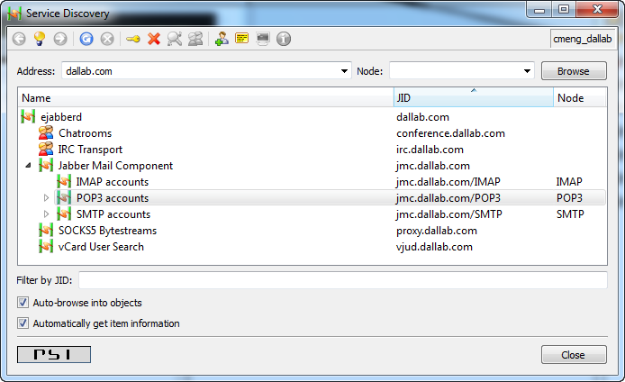

If you start ejabberd live, then you should see the following message on the ejabberd terminal window when you start jmc.
- =INFO REPORT==== 13-Feb-2013::13:22:32 ===
- D(<0.532.0>:ejabberd_receiver:323) : Received XML on stream = "\n"

- =INFO REPORT==== 13-Feb-2013::13:22:32 ===
- D(<0.532.0>:shaper:61) : State: {maxrate,1000,999.945093716751,
- 1360732935698802}, Size=1
- M=0.9999450967312854, I=17099.332

- =INFO REPORT==== 13-Feb-2013::13:22:32 ===
- I(<0.526.0>:ejabberd_listener:281) : (#Port<0.3382>) Accepted connection {{127,0,0,1},38817} -> {{127,0,0,1},5347}

- =INFO REPORT==== 13-Feb-2013::13:22:32 ===
- I(<0.583.0>:ejabberd_service:124) : ({socket_state,gen_tcp,#Port<0.3382>,<0.582.0>}) External service connected

- =INFO REPORT==== 13-Feb-2013::13:22:32 ===
- D(<0.582.0>:ejabberd_receiver:323) : Received XML on stream = "<?xml version=\"1.0\" encoding=\"UTF-8\"?>\n<stream:stream xmlns:stream=\"http://etherx.jabber.org/streams\" xmlns=\"jabber:component:accept\" to=\"jmc.home.com\" version=\"1.0\">"

- =INFO REPORT==== 13-Feb-2013::13:22:32 ===
- D(<0.582.0>:ejabberd_receiver:323) : Received XML on stream = "<handshake>43762c779e596695842774ec759101850a86c24a</handshake>"

- =INFO REPORT==== 13-Feb-2013::13:22:32 ===
- I(<0.583.0>:ejabberd_service:218) : Route registered for service "jmc.home.com"

LibreTranslate Installation

Native Installation (Using Pip)
Running LibreTranslate directly on your host machine without containerization, use Python 3.1.
see LibreTranslate Installation

Install System Dependencies
Install Python 3, pip, and a virtual environment package to isolate your installation:
- $ sudo apt install python3-pip python3

Install LibreTranslate via Pip
Upgrade pip and fetch the LibreTranslate PyPI package:
- $ pip install --upgrade pip
- $ pip install libretranslate

Run and Download Language Models
Launch the program with the instruction to pull the latest translation models:
- $ libretranslate --update-models
Open http://localhost:5000 in your web browser once the initialization process finishes.

Run as a Background System Service (Systemd)
To start automatically when your Ubuntu machine boots up, turn it into a system service.

Create the Service Configuration File
Open a new configuration file in your text editor:
- $ sudo nano /etc/systemd/system/libretranslate.service

Add Configuration Text
Paste the configuration layout below. Make sure to swap out your_username with your actual Ubuntu username. Create a working directory e.g. /tmp/libretranslate.
- Description=LibreTranslate Server
- After=network.target

- [Service]
- Type=simple
- User=your_username
- WorkingDirectory=/tmp/libretranslate
- ExecStart=/usr/local/bin/libretranslate --host 0.0.0.0 --port 5000
- Restart=always

- [Install]
- WantedBy=multi-user.target

Start and Enable the Service
Exit venv environment before proceed. Reload systemd, start the background process, and enable it to run permanently at system boot:
- $ sudo systemctl daemon-reload
- $ sudo systemctl enable libretranslate
- $ sudo systemctl start libretranslate

Check Status
Verify that your new background translation service is running perfectly:
- sudo systemctl status libretranslate // should see similar output as below.
- ● libretranslate.service - LibreTranslate Server
- Loaded: loaded (/etc/systemd/system/libretranslate.service; enabled; vendor preset: enabled)
- Active: active (running) since Tue 2026-08-04 09:03:16 +08; 43min ago
- Main PID: 647368 (libretranslate)
- Tasks: 15 (limit: 14190)
- Memory: 75.1M
- CPU: 3.239s
- CGroup: /system.slice/libretranslate.service
- └─647368 /usr/bin/python3 /usr/local/bin/libretranslate --host 127.0.0.1 --port 5000

Apache configuration
The LibreTranslate installation using pip install leads to the app to be installed in a sub-directory i.e. /usr/local/lib/python3.10/dist-packages/libretranslate/. This makes the apache configuration much complicated than I would have thought. Below is the actual configuration used by aTalk home server to make the app works when access via a browser i.e. https/atalk.sytes.net/translate
- <VirtualHost *:80>
- ServerName atalk.sytes.net
- Redirect "/" "https://atalk.sytes.net/"
- </VirtualHost>

- <VirtualHost *:443>
- ServerName atalk.sytes.net

- ErrorLog ${APACHE_LOG_DIR}/error.log
- CustomLog ${APACHE_LOG_DIR}/access.log combined

- SSLCertificateFile /etc/letsencrypt/live/atalk.sytes.net/fullchain.pem
- SSLCertificateKeyFile /etc/letsencrypt/live/atalk.sytes.net/privkey.pem
- Include /etc/letsencrypt/options-ssl-apache.conf

- # LibreTranslate full setup:
- # a. Redirect all static/js access to the correct installed subdir
- Alias /static /usr/local/lib/python3.10/dist-packages/libretranslate/static
- <Directory /usr/local/lib/python3.10/dist-packages/libretranslate/static>
- Options Indexes FollowSymLinks
- Require all granted
- </Directory>

- # b. Handling for others like js, frontend, languages, actual translate and site access;
- # Site access via the url /LibreTranslate. Do not use global define:
- # ProxyPass / http://localhost:5000/; this affects e.g. /phpmyadmin access
- ProxyPass /js http://localhost:5000/js
- ProxyPass /frontend http://localhost:5000/frontend
- ProxyPass /languages http://localhost:5000/languages
- ProxyPass /translate http://localhost:5000/translate
- ProxyPass /libretranslate http://localhost:5000/
- </VirtualHost>
To access the app from browser, enter:
- https://atalk.sytes.net
For aTalk translate support, enter:
- https://atalk.sytes.net/translate

Clustering
A XMPP domain is served by one or more ejabberd nodes. These nodes are run on different machines that are connected via network; and they must have the ability to communicate via port 4369. All the clustering nodes must use the same erlang cookie as the main node i.e. /var/lib/ejabberd/.erlang.cookie. This is needed for all the erlang interconnecting nodes to exchange information on xmpp connected users, s2s connections, registered services, etc. Please visit the links below for more information on erlang and clustering setup.
- http://www.ejabberd.im/interconnect-erl-nodes
- http://getdaddyg.wordpress.com/2010/05/05/ejabered-2-1-x-clustered-with-load-balancing-configuration-on-centos-5-4/

Clustering Node Setup
Once you have setup and configured ejabberd on the main machine named “cryptoserver”; you need to setup a second node e.g. “cryptosvr02” to make an ejabberd cluster. After completed the basic ejabberd setup on second node, perform the following steps (based on ejabberd v2.1.11):
- Remove the old ~/ejabberd database content; the local database gets created if you have earlier launched the ejabberd.
- Copy ~ejabberd/.erlang.cookie le from first node to second node. Change owner and access right of .erlang.cookie so it exactly matches as below:
Note: You must have the ‘-setcookie /var/lib/ejabberd/.erlang.cookie’ option added to all ‘erl’ commands below if you do not login as ejabberd daemon user.
On second node run the following commands as the ejabberd daemon user (or use –setcookie option), in the working directory of ejabberd i.e. /var/lib/ejabberd/:
- $ sudo erl -sname ejabberd \
-setcookie $(sudo cat /var/lib/ejabberd/.erlang.cookie) \
-mnesia dir ‘“/var/lib/ejabberd/”’ \
-mnesia extra_db_nodes “[‘ejabberd@cryptoserver’]”
-s mnesia
- -sname: ejabberd i.e. same as –name ejabbard@cryptosvr02 (second node)
- -mnesia dir: mnesia database on cryptosvr02
- -mnesia_extra_db_nodes “[‘…’]”: the main ejabberd node database, to which to make the cluster with.
- -s mnesia: launch the mnesia process
The above command starts mnesia on the second node serving the same database as ejabberd@cryptoserver. You can check this by running the command ‘mnesia:info().’.
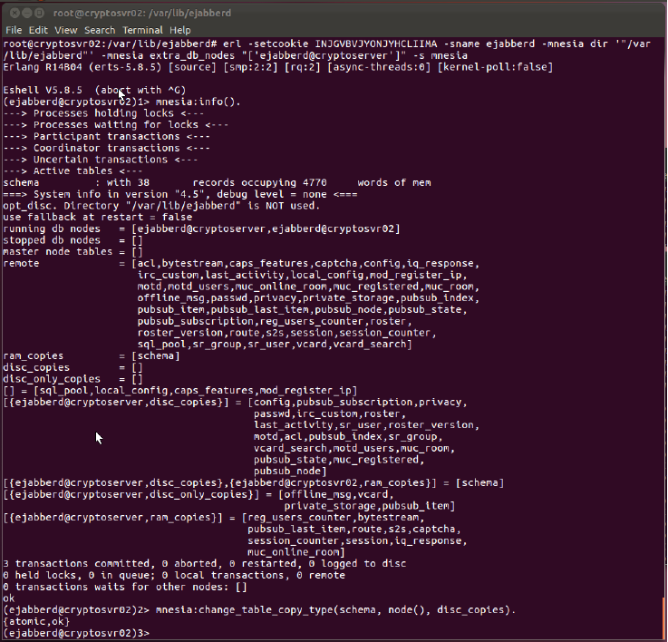
To see if the two nodes are in a cluster, scroll up to find a line "running db nodes" which must list the two nodes as running i.e.
- running db nodes = [ejabberd@cryptoserver, ejabberd@cryptosvr02]
If an incorrect .erlang.cookie value is used, will result in main node shown as stopped db nodes as follow:
- running db nodes = [ejabberd@cryptosvr02]
- stopped db nodes = [ejabberd@cryptoserver]
Double-check: you should see the second ejabberd node appears under Running Nodes in the Web Admin of the first ejabberd node as shown below:
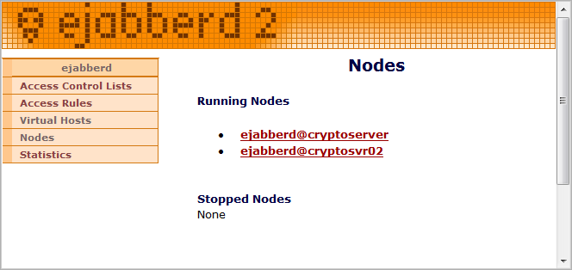

Synchronize Database
You need to synchronize the database on the second node with the database on the first node. Continue from previous session; enter the following command in the same ‘erl’ session to create local disc storage for the database.
- mnesia:change_table_copy_type(schema, node(), disc_copies).
Quit the Erlang shell with the command "q()." The second ejabberd node is now listed in Stopped Nodes; upon refreshes Nodes page in the first node's Web Admin.
Check using “$ sudo ls –l” command and change if necessary; so that the database files in /var/lib/ejabberd/ are owned by ejabberd:ejabberd i.e. giving full access right to ejabberd@cryptosvr02. Without the proper access right, ejabberd will fail to launch properly.
- $ sudo chown ejabberd:ejabberd *
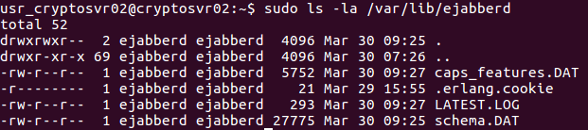

Configure Ejabberd Cluster Script
After verify the two nodes can work in a cluster, you need to modify the /usr/sbin/ejabberd shell script of the second node to start the ejabberd in cluster mode.
- $ sudo gedit /usr/sbin/ejabberd
In the “exec” section, after the line -mnesia dir \”$SPOOL\” \; insert a line with the following content i.e. -mnesia extra_db_nodes "['ejabberd@cryptoserver']"
- exec $ERL $SNAME $ERLANG_NODE \
- -pa $EBIN_DIR \
- -s ejabberd \
- -kernel inetrc \"$INETRC\" \
- -ejabberd config \"$CONFIG\" log_path \"$LOG\" \
- erlang_log_path \"$ERLANG_LOG\" \
- -sasl sasl_error_logger false \
- -mnesia dir \"$SPOOL\" \
- -mnesia extra_db_nodes "['ejabberd@cryptoserver']" \
- $ERLANG_OPTS $ERL_OPTIONS $ARGS "$@"
Now you can start the second ejabberd node in the normal way; mod_irc should be enabled only on one machine in the cluster.
- $ sudo /etc/init.d/ejabberd start

Cluster Node Database Replicas
In Web Admin of the first node, you should see the second node appears in Running Nodes, which means that both ejabberd nodes are running and active in one cluster; and the ejabberd cluster is now working.
To support fault tolerance operation, you need to replicate the relevant tables from the first node to the second node; and the table type e.g. ‘ram_copies’, ‘disc_copies’ or ‘disc_only_copies’ etc in the second nodes can be changed depending on requirements.
Replicating a table makes lookup in this table faster on this node. Writing, on the other hand, will be slower. And of course if machine with one of the replicas is down, other replicas will be used.
To change table replicas and types, launch Web Admin (Nodes > select node > Database) and click Submit at the bottom of the page to apply after the changes.
For more information about the parameters and functions, you can visit the official ejabberd guide [1] and the official erlang site [8]. A good tutorial for a Linux setup can be found on sysmonblog [9].
- http://www.process-one.net/en/ejabberd/guide_en
- http://www.process-one.net/en/ejabberd/guide_en#htoc79
- http://dev.esl.eu/blog/2008/09/30/set-up-clustering-in-ejabberd/
- http://www.nabble.com/problems-in-clustering-ejabberd-via-tutorial-on-official-site- td22475081.html
- http://www.trapexit.org/forum/viewtopic.php?p=43930
- http://lists.jabber.ru/pipermail/ejabberd/2005-March/000883.html
- http://www.process-one.net/en/ejabberd/guide_en#webadmin
- http://erlang.org/
- http://sysmonblog.co.uk/2008/06/ot-installing-ejabberd-on-debian-ubuntu.html

Multi-Node Ejabberd Clustering Database Setup Considerations
Here are the general guidelines on how to configure the database in a cluster.
Table configuration:
- Inference #1: If the master is RAM&disc, then the slave should be
- RAM&disc if you want it available when slave starts up alone
- RAMcopy if you don't
- Inference #2: If the master is RAMcopy, then the slave should be
- RAM copy (instead of Remote Copy) so that the feature works on the slave when the master is down.
- Remote copy: if the feature only works if the master is up
- Inference #3: If the master is DiscOnly, then the slave should be:
- Remote copy: if the feature only works if the master is up
- There is a possible synchronization problem if we try to set the slave to DiscOnly (needs to be confirmed)
- Consider changing both master and slave to RAM&disc
These rules boil down to the following configuration for the locations of the mnesia tables of a “normal” ejabberd install:
Table Name | Master | Slave | Notes
acl | RAM and disc copy | RAM and disc copy | changed slave from RAM copy to RAM and disc copy due to Inference1
caps_feature | RAM copy | RAM copy | changed slave from Remote copy to RAM copy due to Inference2
config | RAM and disc copy | RAM and disc copy | changed slave from RAM copy to RAM and disc copy due to Inference1
disco_publish | Disc only copy | Remote copy | need to research changing both to RAM and disc copy
http_bind | RAM copy | RAM copy | changed slave from Remote copy to RAM copy due to Inference2
http_poll | RAM copy | RAM copy | changed slave from Remote copy to RAM copy due to Inference2
iq_response | RAM copy | RAM copy | OK
local_config | RAM and disc copy | RAM and disc copy | changed slave from RAM copy to RAM and disc copy due to Inference1
motd | Disc only copy | Remote copy | need to research changing both to RAM and disc copy
motd_users | Disc only copy | Remote copy | need to research changing both to RAM and disc copy
muc_online_room | RAM copy | Remote copy | leaving slave as Remote copy since muc features aren't clustered  need to research muc clustering
muc_registered | Disc only copy | Remote copy | leaving slave as Remote copy since muc features aren't clustered  need to research muc clustering
muc_room | Disc only copy | Remote copy | leaving slave as Remote copy since muc features aren't clustered  need to research muc clustering
route | RAM copy | RAM copy | OK
s2s | RAM copy | RAM copy | OK
schema | RAM and disc copy | RAM and disc copy | OK
session | RAM copy | RAM copy | OK
user_caps | RAM and disc copy | RAM and disc copy | changed slave from Remote copy to RAM and disc copy due to Inference1
user_caps_resources | RAM and disc copy | RAM and disc copy | changed slave from Remote copy to RAM and disc copy due to Inference1

The below table items are stored in mySQL database, so the above criteria does not apply.
last_activity | Disc only copy | Remote copy | need to research changing both to RAM and disc copy
offline_msg | Disc only copy | Disc only copy | leave both as disc only since this database has a risk of growing very large  we should test to make sure that offline messages are delivered in outage scenarios
privacy | Disc only copy | Disc only copy | need to research possible consistency issue due to Inference3
private_storage | Disc only copy | Remote copy | need to research changing both to RAM and disc copy
pubsub_node | Disc only copy | Remote copy | need to research changing both to RAM and disc copy
roster | RAM and disc copy | RAM and disc copy | changed slave from Disc only copy to RAM and disc copy due to Inference1
vcard | Disc only copy | Remote copy | leaving slave as Remote copy due to Inference3  we should retest the consistency issues
vcard_search | Disc only copy | Remote copy | leaving slave as Remote copy due to Inference3  we should retest the consistency issues

Master Host / Cluster Node Database
Below tables show side by side comparison between the master host and cluster node database type when it is first setup.
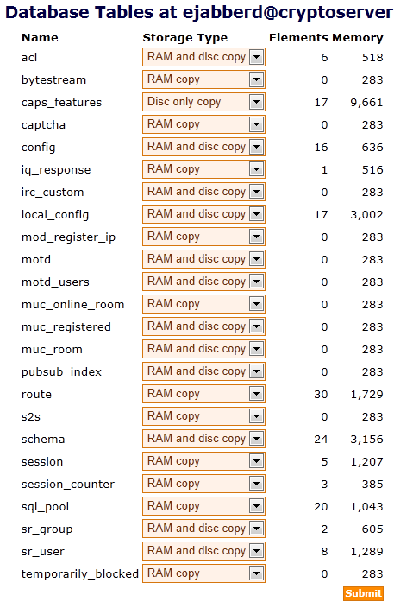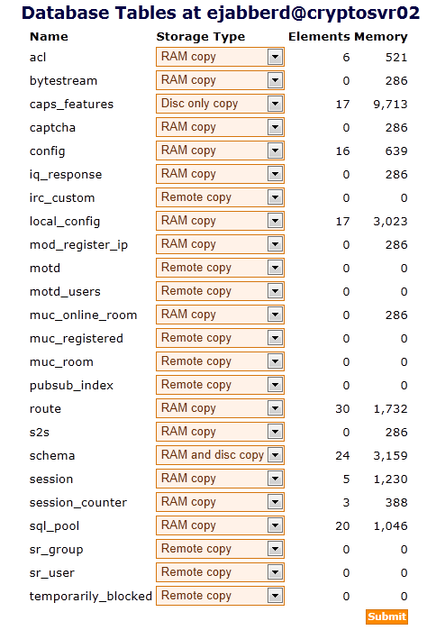

Topology and Hardware Setup
Following gives a typical ejabberd clustering with load balancing setup using three systems: Two of these will be used as the XMPP servers and the other will be used to host the MySQL data.
It does not require much space for the two XMPP servers installation as most of the data will be stored into back-end MySQL server. In front of the XMPP server will have a Cisco CSS 11503 load balance (See section 21 to use proxy as load balance). See section 21 for Reverse Proxy Installation for load balancing. Ubuntu Server will be installed on all three servers, and for the database server, MySQL is installed. The naming convention for these servers will be xmpp1.test.dev and xmpp2.test.dev for the XMPP servers and db01.test.dev for the MySQL.
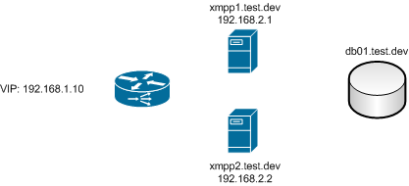

Cluster Remote MySQL Access
If the main node is using both the Mysql and mnesia database for xmpp services, you must confirm the second node has access to the MySQL database on the first node.
On the main node, create a user account that it will be used to access the MySQL database on the first node from the second node.
During testing, it was found that for MySQL version 5.5, the host must be specified using the actual IP i.e. 192.168.1.134 instead of the node name i.e. cryptosvr02. Otherwise following error occurs when trying to access MySQL.
- ERROR 1130 (HY000): Host 'cryptosvr02.local' is not allowed to connect to this MySQL server
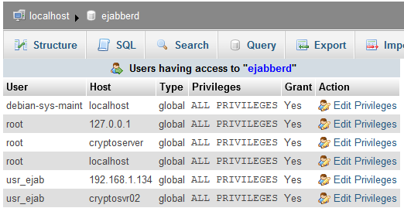
If MySQL access is configured correctly, you should be able to access the main MySQL from the second nodes as shown in the figure.
Note: Even the access to MySQL database failed, the second ejabberd node will still appear under Running Nodes in the Web Admin of the first ejabberd node (see section 19.1), if there is no problem with the mnesia database access.
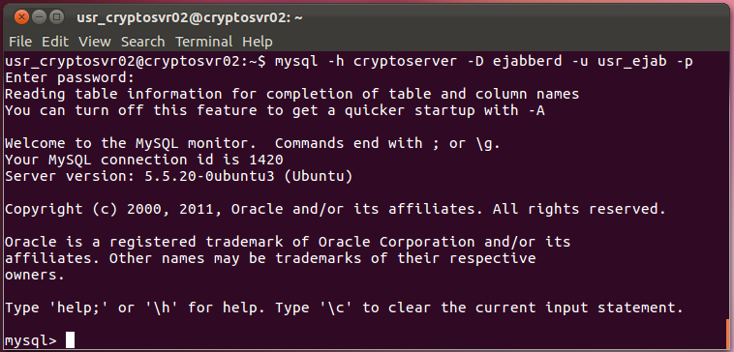

Install JLogger (Messages Logger)
Note: Jlogger is not being deployed in home XMPP server. Information herein is for reference only.
JLogger is a highly customization jabber transport for logging messages passed over jabber server. It has different kind of filters and possibilities to save captured messages. It consists of two parts: JLogger (transport that logs messages) and JLogger-Web (front-end with web interface).
Both projects are available on github:
- JLogger: https://github.com/und3f/jlogger
- JLogger-Web: https://github.com/und3f/jlogger-web
Refer to the following for more information:
- http://www.ejabberd.im/node/4943
- https://metacpan.org/release/JLogger

Install Cpanminus
The application cpanminus is a script to get, unpack, build and install modules from CPAN and does nothing else. The cpanm tool is required to install JLogger. You can refer to the following site for more information on how to install cpanminus:
- https://metacpan.org/module/App::cpanminus#INSTALLATION
Open a terminal and enter the following command:
- $ sudo apt install cpanminus
Following site provides more information on CPAN:
- http://twiki.org/cgi-bin/view/TWiki/HowToInstallCpanModules

Install JLogger
The cpanm JLogger installation will attempt to check and install any missing tools that are required for the compilation and installation of the JLogger. However there still exist some tools that require user action.
Followings are some of the required tools that you should install before installing JLogger. The list may not be exhausted.
- $ sudo apt install libanyevent-xmpp-perl
- $ sudo apt install libxml-parser-perl
- $ sudo apt install libidn11-dev
- $ sudo apt install libpg-perl
- $ sudo apt install libplack-perl
To install JLogger enter the following command.
- $ sudo cpanm -S JLogger
You may refer to the following file for any missing tool and proposed corrective action if any:
- ~/.cpanm/build.log

Install database schema
Go to the following site and download the database.mysql.sql file.
- https://github.com/und3f/jlogger/tree/master/schema
Open the browser and start the phpmyadmin. Create a database ‘jlogger.db’.
Import the table structures into the ‘jlogger.db’ database with scheme from the downloaded file ‘database .mysql.sql’.

Configure JLogger Service
Refer to the sites for more info on JLogger Configuration.
- https://metacpan.org/release/JLogger

Ejabberd.cfg
Edit ejabberd.cfg and add this line to the 'modules' section:
- {mod_service_log, [{loggers, ["jlogger.jabber.myserver.com"]}]},
Add this to 'listen' section to make ejabberd listen for JLogger connections:
- {5526, ejabberd_service, [
- {ip, {127, 0, 0, 1}},
- {access, all},
- {hosts,
- ["jlogger.jabber.myserver.com"],
- [{password, "jl9881"}]}
- ]},

JLogger.yaml
Create a configuration file "/etc/jlogger.yaml" with example from the following site:
- https://raw.github.com/und3f/jlogger/master/config.yaml.example
Configure it according to the server settings. Following setting is using MySQL database for storage.
- transport:
- JLogger::Transport::AnyEvent:
- host: logger.localhost
- port: 5526
- secret: jl9881
- storages:
- - JLogger::Storage::DB
- source: dbi::database=jlogger.db
- username: root
- password: home9881
- filters:
- - JLogger::Filter::FieldRegexp:
- fields:
- from: "^user@home.com"
- to: "^user@home.com"

Start JLogger
Setup the up init.d script and auto start the service on system power-up.
- $ sudo wget https://raw.github.com/und3f/jlogger/master/script/jlogger.init.d -O /etc/init.d/jlogger
- $ sudo chmod +x /etc/init.d/jlogger
- $ sudo /etc/init.d/jlogger start
- $ sudo update-rc.d jlogger defaults

Install JLogger-Web
Get latest JLogger-Web from the site with the command:
- $ sudo git clone git://github.com/und3f/jlogger-web.git
- $ sudo mv jlogger-web /var/www/
- $ sudo cd /var/www/jlogger-web
- $ sudo git submodule update --init
Install ObjectDB2:
- $ sudo cpanm -S https://github.com/vti/object-db2/tarball/master
Install JLogger::Web dependencies
- $ sudo cpanm -S --installdeps .
Create config file and edit it
- $ sudo cp jlogger-web.yaml{.example,}
- $ sudo gedit jlogger-web.yaml
And modify to the following:
- domain: 'localhost'
- database:
- source: 'dbi:mysql:dbname=jlogger.db'
- username: root
- password: home9881
Start JLogger::Web
- $ sudo ./script/jlogger-web.pl

Configure EJabberd
Edit ejabberd.cfg and add the below line to the 'modules' section:
- $ sudo gedit /etc/ejabberd/ejabberd.cfg
- {mod_service_log, [{loggers, ["jlogger.localhost"]}]},
Add the following to 'listen' section to make ejabberd listen for JLogger connections:
- {5526, ejabberd_service, [
- {ip, {127, 0, 0, 1}},
- {access, all},
- {hosts,
- ["jlogger.localhost"],
- [{password, "jl9881"}]}
- ]},

Reverse Proxy
A reverse proxy is a type of proxy server that retrieves resources on behalf of a client from one or more servers. These resources are then returned to the client as though they originated from the reverse proxy itself. While a forward proxy acts as an intermediary for its (usually nearby) associated clients and returns to them most resources accessible on the Internet, a reverse proxy acts as an intermediary for its (usually nearby) associated servers and only returns resources provided by those associated servers.

Uses of Reverse Proxies
- Reverse proxies can hide the existence and characteristics of the origin servers.
- Encryption / SSL acceleration: when secure web sites are created, the SSL encryption is often not done by the web server itself, but by a reverse proxy that is equipped with SSL acceleration hardware.
- Load balancing: the reverse proxy can distribute the load to several web servers, each web server serving its own application area. In such a case, the reverse proxy may need to rewrite the URLs in each web page (translation from externally known URLs to the internal locations).
- Serve/cache static content: A reverse proxy can offload the web servers by caching static content like pictures and other static graphical content.
- Compression: the proxy server can optimize and compress the content to speed up the load time.
- Spoon feeding: reduces resource usage caused by slow clients on the web servers by caching the content the web server sent and slowly "spoon feeding" it to the client. This especially benefits dynamically generated pages.
- Security: the proxy server is an additional layer of defence and can protect against some OS and Web Server specific attacks. However, it does not provide any protection to attacks against the web application or service itself, which is generally considered the larger threat.
- Extranet Publishing: a reverse proxy server facing the Internet can be used to communicate to a firewalled server internal to an organization, providing extranet access to some functions while keeping the servers behind the firewalls. If used in this way, security measures should be considered to protect the rest of your infrastructure in case this server is compromised, as its web application is exposed to attack from the Internet.

HAProxy
Both TCP and HTTP protocol supports are required by home XMPP server. HAProxy is a free, very fast and reliable solution offering high availability, load balancing, and proxy for TCP and HTTP-based applications. It is particularly suited for web sites crawling under very high loads while needing persistence or Layer7 processing. Supporting tens of thousands of connections is realistic with today’s hardware. Its mode of operation makes its integration into existing architectures very easy and riskless, while still offering the possibility not to expose fragile web servers to the Net:
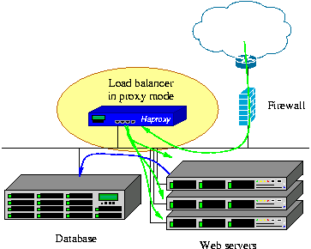

HAProxy Installation
The HAProxy application can be installed via “Ubuntu Software Center”. HAProxy version 1.4.15-1 is available on Ubuntu Precision 12.0 OS. The latest stable version is 1.4.20 released on 10 Mar 2012; and 1.5-dev7 is in development.

HAProxy Configuration
Following are the configuration file setting for the HAProxy server supporting home XMPP server, and may need further tuning. The HAProxy configuration is file is in /etc/haproxy/haproxy.cfg
- global
- log 127.0.0.1 local0
- log 127.0.0.1 local1 notice
- maxconn 4096
- user haproxy
- group haproxy
- daemon

- defaults
- log global
- mode http
- option tcplog
- option dontlognull
- retries 3
- option redispatch
- Maxconn 2000
- timeout connect 5s
- timeout client 300s
- timeout server 300s

- listen web-service 0.0.0.0:80
- # cookie SERVERID rewrite
- Rspidel ^Set-cookie:\ IP= # do not let this cookie tell our internal IP address
- server app1 192.168.1.114:80

- listen xmpp-proxy
- bind 0.0.0.0:5222
- bind 0.0.0.0:5223
- bind 0.0.0.0:5269
- bind 0.0.0.0:5280
- mode tcp
- balance roundrobin
- server server-xmpp 192.168.1.114
- server server-xmpp 192.168.1.137
The command below is to start HAProxy. Other available commands are [start | restart | stop | status]
- $ sudo /etc/init.d/haproxy start
